Salway Ash CE VA Primary School
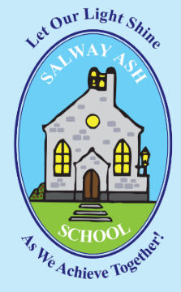

Positive Behaviour & Relationships Policy

Approved by: | The Governing Body | Date: September 2026
Last reviewed on: | September 2026
Next review due by: | September 2027

1. Values and Vision
At Salway Ash CE VA Primary School our vision is to:
- provide a safe and supportive environment where children, staff, parents, governors all work in partnership with the local community to attain high standards, achieving academic, creative, spiritual, social and emotional fulfilment.
- develop pupils who are kind and considerate towards one another and want to make a positive contribution to the world around them
- provide a secure, caring Christian ethos that enables us to grow together, learn together and inspire each other.
Central to achieving this are our Christian values of compassion, respect, hope, joy and perseverance.
At Salway Ash, our approach to managing behaviour is rooted in the belief that children learn best when they feel safe, calm, happy and supported to regulate their emotions. We aim to create a positive and nurturing environment where valued behaviour is promoted and all adults work collaboratively to support every child.

2. Legislation, statutory requirements and statutory guidance
This policy is based on legislation and advice from the Department for Education (DfE) on:
- Behaviour in schools: advice for headteachers and school staff
- Searching, screening and confiscation: advice for schools
- The Equality Act 2010
- Keeping Children Safe in Education
- Suspension and permanent exclusion from maintained schools, academies and pupil referral units in England, including pupil movement
- Restrictive interventions, including the use of reasonable force, in schools
- Supporting pupils with medical conditions at school
- Special Educational Needs and Disability (SEND) Code of Practice
- Sharing nudes and semi-nudes: advice for education settings working with children and young people
In addition, this policy is based on:
- Section 175 of the Education Act 2002, which outlines a school’s duty to safeguard and promote the welfare of its pupils
- Sections 88 to 94 of the Education and Inspections Act 2006, which requires schools to regulate pupils’ behaviour and publish a behaviour policy and written statement of behaviour principles, and gives schools the authority to confiscate pupils’ property
- DfE guidance explaining that maintained schools must publish their behaviour policy online
- DfE guidance explaining that academies should publish their behaviour policy and anti-bullying strategy
3. Roles and responsibilities
The governing body is responsible for:
- Reviewing and approving the written statement of behaviour principles (appendix 1)
- Reviewing this behaviour policy in conjunction with the headteacher
- Monitoring the policy’s effectiveness
- Holding the headteacher to account for its implementation

The headteacher is responsible for:
- Reviewing this policy in conjunction with the governing body
- Giving due consideration to the school’s statement of behaviour principles (appendix 1)
- Approving this policy
- Ensuring that the school environment encourages positive behaviour
- Ensuring that staff deal effectively with difficult, detrimental or dangerous behaviour
- Monitoring that the policy is implemented by staff consistently with all groups of pupils
- Ensuring that all staff understand the behavioural expectations and the importance of maintaining them
- Ensuring that all pupils understand the behavioural expectations
- Providing new staff with a clear induction into the school’s behavioural culture to ensure they understand its rules and routines, and how best to support all pupils to participate fully
- Offering appropriate training in behaviour management, and the impact of special educational needs and disabilities (SEND) and mental health needs on behaviour, to any staff who require it, so they can fulfil their duties set out in this policy
- Ensuring this policy works alongside the safeguarding policy to offer pupils both consequences and support when necessary
- Ensuring that the data from the behaviour log is reviewed regularly, to make sure that no groups of pupils are being disproportionately impacted by this policy (see section 13.1)

Staff are responsible for:
- Creating a calm and safe environment for pupils
- Establishing and maintaining clear boundaries of acceptable pupil behaviour
- Implementing the behaviour policy consistently
- Communicating the school’s expectations, routines, values and standards through teaching behaviour and in every interaction with pupils
- Modelling expected behaviour and positive relationships
- Providing a personalised approach to the specific behavioural needs of particular pupils
- Considering their own behaviour on the school culture and how they can uphold school rules and expectations
- Recording behaviour incidents promptly (which may either be in a class book or on MyConcern for more serious incidents) The headteacher will support staff in responding to behaviour incidents.
- Challenging pupils to meet the school’s expectations

Parents and carers, where possible, should:
- Get to know the school’s behaviour policy and reinforce it at home where appropriate
- Support their child in adhering to the school’s behaviour policy
- Accepting and supporting the schools therapeutic thinking approach to behaviour
- Liaising about matters which affect their child’s happiness, progress and behaviour by keeping the school well informed about situations at home that could affect their child’s behaviour in school.
- Discuss any behavioural concerns with the class teacher promptly
- Take part in any pastoral work following detrimental behaviour (for example: attending reviews of specific behaviour interventions)
- Raise any concerns about the management of behaviour with the school directly, whilst continuing to work in partnership with the school
- Take part in the life of the school and its culture

Pupils will be made aware of the following during their induction to the school:
- They will be taught about valued behaviour at Salway Ash CE VA Primary School and that by
attending the school they understand these ambitions
- They will be recognised and celebrated for valued behaviour
- This policy remains relevant beyond school, for example on the way to and from school, on trips
and visits, as well as in the community when they can be identified as a member of the school
- They will be asked regularly for their views about valued and detrimental behaviour to support the
evaluation, improvement, and implementation of this policy
- Some pupils will need more teaching and support than others, in order to secure valued behaviour
and reduce detrimental behaviour
- All adults are expected to implement this policy consistently
- How to raise concerns or ask for support.
4. Therapeutic Thinking principles
Our behaviour policy is underpinned by the principles of Therapeutic Thinking. Therapeutic Thinking is a school based and led approach, recommended by Dorset Council, that focuses on understanding and teaching behaviour and supporting children’s emotional wellbeing and mental health. It promotes an inclusive culture and is informed by best practice in behaviour support.
The philosophy behind Therapeutic Thinking focuses on understanding children’s behaviour as a form of communication. It encourages adults to consider the experiences and emotions that may be influencing a child’s behaviour and to respond in ways that support positive change.
Therapeutic Thinking uses a range of tools and strategies to help analyse behaviour so that we can better understand an individual child’s needs. This enables staff to plan effectively for the child, their class and the wider school community, ensuring responses are supportive, consistent and inclusive.
What is Therapeutic Thinking?
When we use a therapeutic approach:
• we analyse behaviour rather than judge or moralise about it;
• we look for the underlying causes linked to feelings and experiences rather than relying solely on behaviourist theory.
• we model therapeutic practices with all children, staff, parents and visitors;
• we use carefully chosen language and shared scripts that focus on positive outcomes and resolution rather than emotional reactions.
The Therapeutic Thinking approach challenges the traditional use of rewards and sanctions that may encourage children to behave positively only in order to receive something in return. Instead, the approach supports children to develop independence and self-discipline, helping them to understand and manage their behaviour for themselves.
Our aim is for children to develop the skills and understanding needed to behave positively and make good choices, even when adults are not directly managing the situation
At Salway Ash CE VA Primary School, we believe that:
• Positive experiences create helpful feelings.
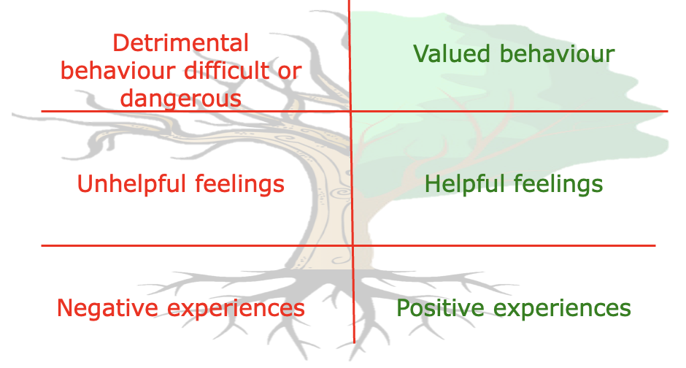
• Helpful feelings create valued behaviour

This policy should be read alongside the school’s Anti-Bullying Policy and Safeguarding Policy.
5. School Rules & Expected conduct
We regularly review our school rules and they are on display in the entrance hall. Our policy is based on the positive reinforcement of these child-friendly rules, which are regularly discussed and referred to with the children.
- Ready
- Respectful
- Safe
The Daily Routine
At the start of the day the children should walk quietly into school, put bags and coats away tidily and follow their class routine.
When working in their classrooms everyone should use “indoor voices”, so that it does not get too noisy. We have all come to school to work hard so we should do it ourselves and help others to do so.
Worship and reflection times are a special, quiet time, when everyone should sit quietly and show respect for the person leading.
Tidying up times are vital to keep our school looking good and to keep equipment accessible and in good order. All children need to be taught how to tidy up and they should gradually assume more responsibility. Adults are important role models.
Adults in School
Our school rules and values remind us to treat each other as we would like to be treated. Teaching Assistants, Midday Supervisors, Teachers and other staff should be shown the same respect. It is important that visitors, such as parent helpers, are made to feel welcome. The adults in school are expected to set an example.
Going Out Of School
Good behaviour is also important outside school for reasons of safety and the image of our school. The importance of good behaviour will be emphasised before leaving school and the children will be reminded of particular safety issues. Any parent helpers will need to know who is in their group and will be provided with more information about the activities that are planned including a full risk assessment.
School uniform should be worn on most excursions. Children should sit at all times on the bus with adults suitably positioned for supervision purposes.
Everyone needs to remember that our school rules and values apply out of school too. Politeness is vital.

Playtime and Lunchtime
These parts of the day can be great fun, with plenty of opportunities to play with friends, but they can be distressing for some if we are not careful.
The children must walk in and out of school. Once they have gone out they should only come in with permission from an adult. Children should not be left unsupervised for any significant amount of time in the classrooms. As the children come in, they may need to be reminded to talk quietly again and to leave the cloakrooms tidy.
Outside, children will be able to play in the play area or on the field at the discretion of the adults on duty. The older children will often have responsibilities for setting up games appropriate for the younger children.
Fruit is promoted at morning break and problems with litter are kept to a minimum. Staff on playground duty may need to remind children that everyone walks in quietly. Year 6 pupils have the responsibility of leading the younger children in safely and quietly.
Every class has a box for wet playtimes, containing a range of equipment that can be used. ICT equipment is not available, unless supervised by an adult.
The success of playtime and lunchtime relies on the children playing with care and consideration for others. Adults and playground leaders should set a good example by joining in with games and teaching the children new games. Any problems that arise will be discussed carefully with the children involved before being referred to the class teacher or Headteacher if necessary.
Children who are unable to play reasonably can be asked to remain with an adult on duty, have equipment removed or ultimately be sent in to the Headteacher.
Pupils are expected to:
Behave in an orderly and self-controlled way
Show respect to members of staff and each other
In class, make it possible for all pupils to learn
Move quietly around the school
Treat the school buildings and school property with respect
Wear the correct uniform
Accept sanctions when given
Refrain from behaving in a way that brings the school into disrepute, including when outside school or online
Where appropriate and reasonable, adjustments may be made to routines within the curriculum to ensure all pupils can meet behavioural expectations in the curriculum.
6. The Behaviour Curriculum
We would like the children of Salway Ash Primary School to behave as responsible thoughtful and caring individuals who are able to learn effectively and develop their self-esteem so that they may reach their full potential. Our Christian values of compassion, respect, hope, joy and perseverance are central to this. Through explicitly taught, modelled and practiced behaviour, we aim to foster a positive and respectful learning environment where all members of the school community can flourish.
We manage the development of internal discipline using an approach based on self-direction and self-motivation.
We have adopted private levels of praise and we have no public methods of tracking behaviour that risk creating negative feelings.

We teach behaviour through:

• Building trusting relationships with children. The more we know about the child, the more therapeutic we can be;
• Role modelling – we have to show them how to ‘play nicely’ by playing alongside them;
• Consistency in approach (not equality);
• Routines – but with flexible thinking referring to individual’s needs;
• Prioritising valued behaviour;
• Planning alternatives to detrimental behaviour;
• Positive reinforcement;
• Feedback and recognition, not just celebrating the things that are expected;
• Comfort and forgiveness– understanding and know that we will do it differently tomorrow;
• Ignoring (unsocial and low-level behaviours, giving time for these to stop)
• Positive language (tell children what you want to see)
• Restorative practice – follow up the behaviour, its impact and consequences at the appropriate time.

All staff are expected to acknowledge, promote and consolidate valued behaviours with the
children. There are several ways in which staff can achieve this.

External discipline is controlling behaviour; internal discipline is teaching behaviour. To create change we need to understand, not simply suppress, the behaviour. We manage the development of internal discipline to gradually replace external discipline – using an approach based on self-direction and self-motivation to replace control measures such as bribery, punishment and control. We have no public methods of tracking behaviour that risk creating negative feelings – children cannot publicly see the judgement of staff and we have adopted private levels of praise. Predominantly children expect feedback and verbal recognition or support.

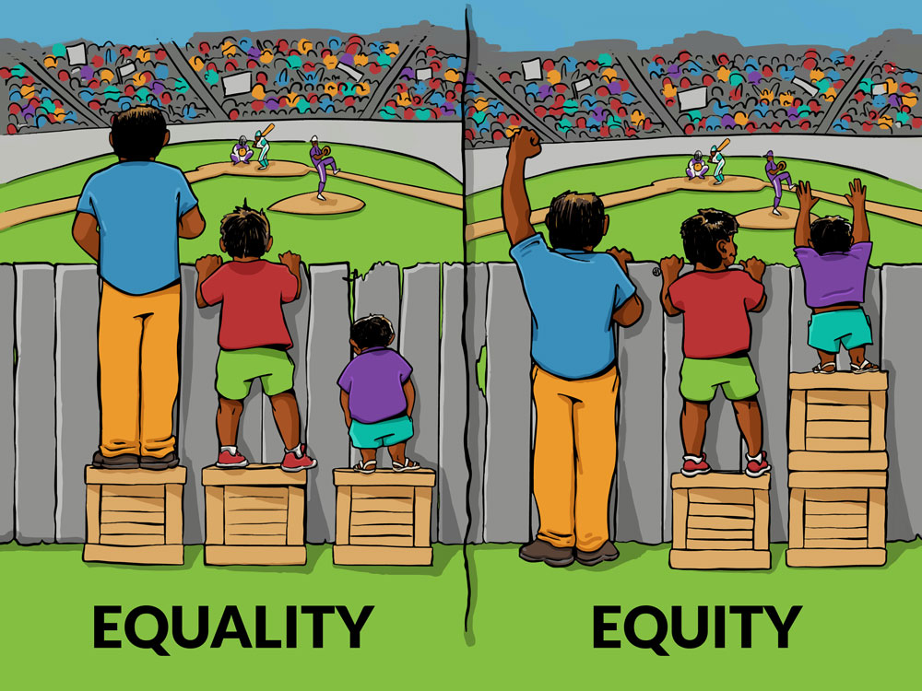
At Salway Ash CE VA Primary School we believe in Equity to ensure equality.

Equality is treating everybody the same. Equality aims to promote fairness, but it can only work if everyone starts from the same place and needs the same help.

Equity is giving everyone what they need to achieve success. At Salway Ash School we advocate for each child to receive the resources, experiences, appropriate interventions and support in their learning to achieve their full potential.

Equity ≠ Equality.

7. Valued Behaviour
Valued behaviour at Salway Ash Primary School is defined as behaviour, which is positive, helpful and values social acceptance. Valued behaviour is characterised by a concern for the rights, feelings and welfare of other people. Valued behaviour benefits other people or society. For example:

• Positive relationships and interaction with peers and adults (tone of voice; body language);
• Acknowledgement of own feelings, using positive language to support their needs (‘I need help’; ‘I’m finding this tricky’; ‘I felt cross when I got that wrong’);
• Identify, understand and accept mistakes as learning opportunities, and using a growth mindset to persevere and challenge themselves to complete the task;
• Identify, reflect and repair anti-social behaviour choices;
• Respects the right of themselves and others to learn and their responsibility to ensure their behaviour choices don’t negatively impact upon this.

8. Unsocial Behaviour
At Salway Ash School unsocial behaviour is defined as where children are unwilling or unable to behave socially in the company of others, but not to the detriment of themselves or others. For example:
• Not seeking to associate with others but not to the detriment of self or others.
• Not choosing to behave sociably in the company of others, but not to the detriment of self or others.
• Not doing as instructed or dictated, but not to the detriment of self or others.

We must listen to quiet unsocial behaviour with as much understanding as we do loud demanding behaviour. Children may choose to communicate with quiet non-compliance. It’s a natural communication style of intuitively quiet people.

Some children may communicate distress, uncertainty or disengagement through quiet non-compliance or withdrawal. Staff should interpret unsocial behaviour as a communication of negative feelings, therefore differentiating or supporting to meet the needs of pupils.

All staff are responsible for addressing unsocial behaviour. No unsocial behaviour should need the Headteacher’s support unless it is persistent and disruptive, therefore becoming detrimental behaviour.

9. Detrimental Behaviour
At Salway Ash School detrimental behaviour is defined as behaviour that causes harm to an individual, a group, to the community or to the environment. Behaviour like this is likely to cause injury, harassment, alarm or distress.

Difficult behaviour: Behaviour that is detrimental, but not dangerous. Difficult behaviour should be acknowledged in terms of context (e.g. Child A continually shouting out is difficult within a group teaching activity).

Dangerous behaviour: Behaviour which is detrimental and will predictably result in imminent injury or harm. This includes harm to self or others, damage to property or behaviour that would be considered criminal if the person was the age of criminal responsibility, such as racist abuse. The behaviour described as dangerous will be supported by evidence of severity and frequency of outcomes e.g. 3 children required first aid for minor bruising as a result of Child A’s kicking, (except for a first instance that was not predicted). In the table below are some examples of difficult and dangerous behaviour.

Difficult Detrimental Behaviours | Dangerous Detrimental Behaviours
- Calling out during lessons  - Distracting others from learning (banging, making noises)  - Ripping up work  - Poor attitude/Rudeness to others  - Inappropriate use of language  - Lack of respect of school equipment  - Lack of respect for others and their possessions | - Bullying  - Sexual Comments  - Vandalism  - Theft  - Smoking  - Fighting

All staff are responsible for addressing detrimental behaviour. Only very frequent and persistent detrimental behaviours will require additional intervention. Responses to detrimental behaviour may include using scripted language to positively rephrase, limit choice or disempower the behaviour to facilitate a change in the behaviour. Educational consequences are also recorded.

Restorative Practice
After any detrimental behaviour has happened an in-depth de-brief with the child will take place as soon as regulation is restored (this could be the next day), in order to understand why the detrimental behaviour occurred. Staff may use comic strip conversations, puppets or small world toys as tools to help the child communicate.

Staff will then implement protective and educational consequences following any detrimental behaviour. This will be clearly explained to the child setting out expectations and what will happen next:

Protective consequences: Removal of a freedom to manage harm e.g. staying in at lunchtime to keep others safe.

Educational consequences: The learning, rehearsing or teaching so the freedom can be returned e.g., games with a small group to learn how to take turns.

Both protective and educational consequences will support staff as they are a map to follow but can be adapted and personalised for individual children. For example, for a child who disrupts games at playtime, a plan would be put in place or an intervention to support developing prosocial behaviours when playing games.

When addressing behaviour mistakes, adults will seek to:
- Take an enquiring and empathic approach, understanding that behaviour does not exist in isolation and seeking to identify wider factors (friendships, home life, sleep and diet) as part of an effective solution.
- Act intentionally when communicating by recognising environment, body language and tone as important.
- Actively listen and encourage the person to talk by asking open questions, supporting, summarising.
- Implement strategies to cultivate responsibility
- using calm language
- regulating their own emotions
- repairing relationships
- avoiding public shaming
- maintaining dignity

Risk management plan
Staff will follow the Therapeutic Thinking approach to manage the risks of detrimental behaviour. If detrimental behaviours are regularly repeated by a child, a therapeutic thinking plan will be created. This will involve creating a Risk Reduction Plan. The plan will be put in place to support staff in managing risks and to support the child in changing their behaviour. This will advise staff on how to predict and prevent behaviours, use appropriate strategies to calm and regulate the child, helping them to recognise better prosocial ways to deal with uncomfortable situations. Appendix 2 highlights the graduated response to supporting behaviour that will be adopted.

Bullying
Bullying is defined as the repetitive, intentional harming of 1 person or group by another person or group, where the relationship involves an imbalance of power.
Bullying is, therefore:
- Deliberately hurtful
- Repeated, often over a period of time
- Difficult to defend against
Bullying can include:
TYPE OF BULLYING | DEFINITION
Emotional | Being unfriendly, excluding, tormenting
Physical | Hitting, kicking, pushing, taking another’s belongings, any use of violence
Prejudice-based and discriminatory, including:  - Racial  - Faith-based  - Gendered (sexist)  - Homophobic/biphobic  - Transphobic  - Disability-based | Taunts, gestures, graffiti or physical abuse focused on a particular characteristic (e.g. gender, race, sexuality)
Sexual | Explicit sexual remarks, display of sexual material, sexual gestures, unwanted physical attention, comments about sexual reputation or performance, or inappropriate touching
Direct or indirect verbal | Name-calling, sarcasm, spreading rumours, teasing
Cyber-bullying | Bullying that takes place online, such as through social networking sites, messaging apps or gaming sites

Further information about the school’s approach to preventing and dealing with incidents of bullying can be found in our anti-bullying policy.

Removal from classrooms
Staff will only remove pupils from the classroom once other strategies have been attempted, unless the behaviour is so extreme as to warrant immediate removal. Removal can be used to restore order if the pupil is being unreasonably disruptive and allow the pupil behaving disruptively to continue their learning in a managed environment. The length of time children spend outside of the classroom is dependent on the behaviour displayed, the level of disruption that has been delayed and whether the pupil is ready to return to the classroom. We will consider an alternative approach to behaviour management for pupils who are frequently removed from class, such as enhanced in class support and resources, movement breaks and additional interventions.
10. Off-site misbehaviour
Sanctions may be applied where a pupil has misbehaved off-site when representing the school. This means misbehaviour when the pupil is:
- Taking part in any school-organised or school-related activity (e.g. school trips)
- Travelling to or from school
- Wearing school uniform
- In any other way identifiable as a pupil of our school
Sanctions may also be applied where a pupil has misbehaved off-site, at any time, whether or not the conditions above apply, if the misbehaviour:
- Could have repercussions for the orderly running of the school
- Poses a threat to another pupil
- Could adversely affect the reputation of the school
Sanctions will only be given out on school premises or elsewhere when the pupil is under the lawful control of a staff member (e.g. on a school-organised trip).
Online misbehaviour
The school can issue behaviour sanctions to pupils for online misbehaviour when:
- It poses a threat or causes harm to another pupil
- It could have repercussions for the orderly running of the school
- It adversely affects the reputation of the school
- The pupil is identifiable as a member of the school
Sanctions will only be given out on school premises or elsewhere when the pupil is under the lawful control of a staff member.

11. Mobile phones
Salway Ash is a mobile-phone free school for children and pupils are not permitted to bring a phone into school without the prior agreement of the headteacher under exceptional circumstances. In these rare instances, phones must be handed in to the school office where they will be locked securely until the end of the day.

12. SEND and reasonable adjustments

Recognising the impact of SEND on behaviour

The school recognises that pupils’ behaviour may be impacted by a special educational need or disability (SEND).

When incidents arise, we will consider them in relation to a pupil’s SEND, although we recognise that not every incident will be connected to their SEND. Decisions on whether a pupil’s SEND had an impact on an incident will be made on a case-by-case basis.

When dealing with incidents from pupils with SEND, especially where their SEND affects their behaviour, the school will balance their legal duties when making decisions about enforcing this
policy. The legal duties include:
- Taking reasonable steps to avoid causing any substantial disadvantage to a disabled pupil caused by the school’s policies or practices (Equality Act 2010)
- Using our best endeavours to meet the needs of pupils with SEND (Children and Families Act 2014)
- If a pupil has an education, health and care (EHC) plan, the provisions set out in that plan must be secured and the school must co-operate with the local authority and other bodies.

As part of meeting these duties, the school will anticipate, as far as possible, all likely triggers of misbehaviour, and put in place support to prevent these from occurring.

Any preventative measures will take into account the specific circumstances and requirements of the pupil concerned.
- Short, planned movement breaks for a pupil with SEND who finds it difficult to sit still for long
- Adjusting seating plans to allow a pupil with visual or hearing impairment to sit in sight of the teacher
- Adjusting uniform requirements for a pupil with sensory issues or who has severe eczema
- Training for staff in understanding conditions such as autism
- Use of separation spaces (sensory zones or nurture rooms) where pupils can regulate their emotions during a moment of sensory overload

Adapting consequences for pupils with SEND

When considering a behavioural consequence for a pupil with SEND, the school will take into account:

- Whether the pupil was unable to understand the rule or instruction?
- Whether the pupil was unable to act differently at the time as a result of their SEND?
- Whether the pupil is likely to behave aggressively due to their particular SEND?

If the answer to any of these questions is yes, it may be unlawful for the school to sanction the pupil for the behaviour.

The school will then assess if it is appropriate to use a sanction and if so, whether any reasonable adjustments need to be made to the sanction.

Considering whether a pupil displaying detrimental or dangerous behaviour may have unidentified SEND

The school’s special educational needs co-ordinator (SENCO) may evaluate a pupil who exhibits challenging behaviour to determine whether they have any underlying needs that are not currently being met.

Where necessary, support and advice will also be sought from specialist teachers, an educational psychologist, medical practitioners and/or others, to identify or support specific needs.

When acute needs are identified in a pupil, we will liaise with external agencies and plan support programmes for that child. We will work with parents to create the plan and review it on a regular basis.

Pupils with an education, health and care (EHC) plan
The provisions set out in the EHC plan must be secured and the school will co-operate with the local authority and other bodies.
If the school has a concern about the behaviour of a pupil with an EHC plan, it will make contact with the local authority to discuss the issue. If appropriate, the school may request an early review of the EHC plan.

13. Restrictive interventions, including use of reasonable force
Our approach to restrictive interventions follows the DfE’s latest guidance on restrictive interventions.
Restrictive interventions are used to prevent, restrict, or subdue movement of the body or part of the body of a pupil. It describes both physical and non-physical actions aimed to restrain pupils in different ways.
Our staff understand that any form of force or restraint carries a risk of physical and psychological harm, so we always avoid using these measures where possible.
Reasonable force
Reasonable force covers a broad range of actions used by staff that involve a degree of physical contact to restrain pupils, using no more force than is needed for the least amount of time, the application of which will depend on the circumstances.
All members of staff have a legal power to use reasonable force in certain situations, to prevent a pupil from:
- Hurting themselves or others
- Committing a criminal offence
- Damaging property
- Causing disorder among pupils, in or out of lessons
Reasonable force must:
- Always be used as a last resort
- Be used in a way that maintains the safety and dignity of all concerned
- Never be used as a form of punishment
- Never involve restraining a pupil in a way that affects their airway, breathing or circulation, for example by covering their nose and/or mouth or applying pressure to their neck or abdomen
- Never be used if the pupil is on the ground. If a pupil is unintentionally held on the ground, staff should release their hold or move into a safer position as quickly as possible
When considering using reasonable force, staff should, in considering the risks, carefully recognise any specific vulnerabilities of the pupil, including SEND, mental health needs or medical conditions.
Please see our use of reasonable force policy for more information.
Seclusion
Seclusion is a non-disciplinary intervention that keeps a pupil confined to a place away from others and prevents them from leaving, for the safety of that pupil and/or others.
We only use seclusion as a safety measure when a pupil is experiencing high levels of emotional or behavioural dysregulation. Seclusion is not used as a threat or punishment and is not a disciplinary response to deliberate or wilful misbehaviour.
During seclusion:

- The pupil will be secluded in a safe place that does not feel threatening or intimidating to them e.g. a wellbeing room
- The pupil will be supervised at all times, by at least 1 member of staff
- As soon as the immediate risk of harm has reduced, the pupil will be allowed to leave.
Recording and reporting requirements
Staff have a legal duty to record and report all:
- Significant incidents involving force
- Seclusion incidents
- Restraint incidents
Please refer to our use of reasonable force policy for more information.
14. Safeguarding
The school recognises that:
- Changes in behaviour may be an indicator that a pupil is in need of help or protection
- Specific circumstances, such as being a young carer, looked-after child, or living in a vulnerable household, can significantly affect behaviour
We will consider whether a pupil’s behaviour may be linked to them suffering, or being likely to suffer, significant harm.
Where this may be the case, we will follow our child protection and safeguarding policy, and consider whether pastoral support, an early help intervention or a referral to children’s social care is appropriate.
Please refer to our child protection and safeguarding policy for more information.

15. Child-on-child abuse
We recognise that children are capable of abusing their peers. Abuse will never be tolerated or passed off as “banter”, “just having a laugh” or “part of growing up”, as this can lead to a culture of unacceptable behaviours and an unsafe environment for pupils.
All child-on-child abuse is unacceptable and will be taken seriously.
Most cases of pupils hurting other pupils will be dealt with under this policy.
Where allegations raise safeguarding concerns, this will be managed under our safeguarding policy. Our safeguarding policy contains further information on how we prevent and manage incidents of child-on-child abuse.
16. Confiscation, searches, screening
Searching, screening and confiscation is conducted in line with the DfE’s latest guidance on searching, screening and confiscation.
Confiscation
Any prohibited items (listed in Appendix 3) found in a pupil’s possession as a result of a search will be confiscated. These items will not be returned to the pupil.
We will also confiscate any item that is harmful or detrimental to school discipline. These items will be returned to pupils after discussion with senior leaders and parents, if appropriate.
Searching a pupil
Searches will only be carried out by a member of staff who has been authorised to do so by the headteacher, or by the headteacher themselves.
Subject to the exception below, the authorised member of staff carrying out the search will be of the same sex as the pupil, and there will be another member of staff present as a witness to the search.
An authorised member of staff of a different sex to the pupil can carry out a search without another member of staff as a witness if:
  - The authorised member of staff carrying out the search reasonably believes there is risk that serious harm will be caused to a person if the search is not carried out as a matter of urgency; and
  - In the time available, it is not reasonably practicable for the search to be carried out by a member of staff who is the same sex as the pupil; or
  - It is not reasonably practicable for the search to be carried out in the presence of another member of staff
When an authorised member of staff conducts a search without a witness they should immediately report this to another member of staff, and ensure a written record of the search is kept.
If the authorised member of staff considers a search to be necessary, but is not required urgently, they will seek the advice of the headteacher, designated safeguarding lead (or deputy) or pastoral member of staff who may have more information about the pupil. During this time the pupil will be supervised and kept away from other pupils.
A search can be carried out if the authorised member of staff has reasonable grounds for suspecting that the pupil is in possession of a prohibited item or any item identified in the school rules for which a search can be made, or if the pupil has agreed.
An appropriate location for the search will be found. Where possible, this will be away from other pupils. The search will only take place on the school premises or where the member of staff has lawful control or charge of the pupil, for example on a school trip.
Before carrying out a search the authorised member of staff will:
  - Assess whether there is an urgent need for a search
  - Assess whether not doing the search would put other pupils or staff at risk
  - Consider whether the search would pose a safeguarding risk to the pupil
  - Explain to the pupil why they are being searched
  - Explain to the pupil what a search entails – e.g. I will ask you to turn out your pockets and remove your scarf
  - Explain how and where the search will be carried out
  - Give the pupil the opportunity to ask questions
  - Seek the pupil’s co-operation
If the pupil refuses to agree to a search, the member of staff can give an appropriate behaviour sanction.
If they still refuse to co-operate, the member of staff will contact the headteacher/designated safeguarding lead (or deputy), to try and determine why the pupil is refusing to comply.
The authorised member of staff will then decide whether to use reasonable force to search the pupil. This decision will be made on a case-by-case basis, taking into consideration whether conducting the search will prevent the pupil harming themselves or others, damaging property or from causing disorder.
The authorised member of staff can use reasonable force to search for any prohibited items identified in section 3, but not to search for items that are only identified in the school rules.
The authorised member of staff may use a metal detector to assist with the search.
An authorised member of staff may search a pupil’s outer clothing, pockets, possessions, desks or lockers.
Outer clothing includes:
  - Any item of clothing that is not worn immediately over a garment that is being worn wholly next to the skin or being worn as underwear (e.g. a jumper or jacket being worn over a t-shirt)
  - Hats, scarves, gloves, shoes, boots
Searching pupils’ possessions
Possessions means any items that the pupil has or appears to have control of, including:
  - Desks
  - Lockers
  - Bags
A pupil’s possessions can be searched for any item if the pupil agrees to the search. If the pupil does not agree to the search, staff can still carry out a search for prohibited items (listed in appendix 3) and items identified in the school rules.
An authorised member of staff can search a pupil’s possessions when the pupil and another member of staff are present.
If there is a serious risk of harm if the search is not conducted immediately, or it is not reasonably practicable to summon another member of staff, the search can be carried out by a single authorised member of staff.
Informing the designated safeguarding lead (DSL)
The staff member who carried out the search should inform the DSL without delay:
  - Of any incidents where the member of staff had reasonable grounds to suspect a pupil was in possession of a prohibited item as listed in section 3
  - If they believe that a search has revealed a safeguarding risk
All searches for prohibited items (listed in appendix 3), including incidents where no items were found, will be recorded in the school’s safeguarding system.
Informing parents
Parents will always be informed of any search for a prohibited item (listed in appendix 3). A member of staff will tell the parents as soon as is reasonably practicable:
  - What happened
  - What was found, if anything
  - What has been confiscated, if anything
  - What action the school has taken, including any sanctions that have been applied to their child
Support after a search
Irrespective of whether any items are found as the result of any search, the school will consider whether the pupil may be suffering or likely to suffer harm and whether any specific support is needed (due to the reasons for the search, the search itself, or the outcome of the search).
If this is the case, staff will follow the school’s safeguarding policy and speak to the designated safeguarding lead (DSL). The DSL will consider if pastoral support, an early help intervention or a referral to children’s social care is appropriate.
Strip searches
The authorised member of staff’s power to search outlined above does not enable them to conduct a strip search (removing more than the outer clothing) and strip searches on school premises shall only be carried out by police officers in accordance with the Police and Criminal Evidence Act 1984 (PACE) Code C.
Before calling the police into school, staff will assess and balance the risk of a potential strip search on the pupil’s mental and physical wellbeing and the risk of not recovering the suspected item.
Staff will consider whether introducing the potential for a strip search through police involvement is absolutely necessary, and will always ensure that other appropriate, less invasive approaches have been exhausted first.
Once the police are on school premises, the decision on whether to conduct a strip search lies solely with them. The school will advocate for the safety and wellbeing of the pupil(s) involved. Staff retain a duty of care to the pupil involved and should advocate for pupil wellbeing at all times.
Communication and record-keeping
Where reasonably possible and unless there is an immediate risk of harm, staff will contact at least 1 of the pupil’s parents to inform them that the police are going to strip search the pupil before strip search takes place, and ask them if they would like to come into school to act as the pupil’s appropriate adult. If the school can’t get in touch with the parents, or they aren’t able to come into school to act as the appropriate adult, a member of staff can act as the appropriate adult (see below for the role of the appropriate adult).
The pupil’s parents will always be informed by a staff member once a strip search has taken place. The school will keep records of strip searches that have been conducted on school premises, and monitor them for any trends that emerge.
Who will be present
For any strip search that involves exposure of intimate body parts, there will be at least 2 people present other than the pupil, except in urgent cases where there is risk of serious harm to the pupil or others.
One of these must be the appropriate adult, except if:
• The pupil explicitly states in the presence of an appropriate adult that they do not want an appropriate adult to be present during the search, and
• The appropriate adult agrees
If this is the case, a record will be made of the pupil’s decision and it will be signed by the appropriate adult.
No more than 2 people other than the pupil and appropriate adult will be present, except in the most exceptional circumstances.
The appropriate adult will:
  - Act to safeguard the rights, entitlement and welfare of the pupil
  - Not be a police officer or otherwise associated with the police
  - Not be the headteacher
  - Be of the same sex as the pupil, unless the pupil specifically requests an adult who is not of the same sex
Except for an appropriate adult of a different sex if the pupil specifically requests it, no one of a different sex will be permitted to be present and the search will not be carried out anywhere where the pupil could be seen by anyone else.
Care after a strip search

After any strip search, the pupil will be given appropriate support, irrespective of whether any suspected item is found. The pupil will also be given the opportunity to express their views about the strip search and the events surrounding it.
As with other searches, the school will consider whether the pupil may be suffering or likely to suffer harm and whether any further specific support is needed (due to the reasons for the search, the search itself, or the outcome of the search).
Staff will follow the school’s safeguarding policy and speak to the designated safeguarding lead (DSL). The DSL will consider if, in addition to pastoral support, an early help intervention or a referral to children’s social care is appropriate.
Any pupil(s) who have been strip searched more than once and/or groups of pupils who may be more likely to be subject to strip searching will be given particular consideration, and staff will consider any preventative approaches that can be taken.
17. Suspension and permanent exclusion
The school can use suspension and permanent exclusion in response to serious incidents or in response to persistent poor behaviour which has not improved following in-school consequences and interventions.
The decision to suspend or exclude will be made by the headteacher and only as a last resort.
Please refer to our suspensions and exclusions policy for more information.

18. Pupil transition
Inducting incoming pupils
The school will support incoming pupils to meet behaviour standards by offering an induction process to familiarise them with the behaviour policy and the wider school culture. This will involve meeting with adults working with the child in their current setting to discuss how best to support their induction.
Preparing outgoing pupils for transition
To ensure a smooth transition to the next year, pupils have transition sessions with their new teacher(s). In addition, staff members hold transition meetings.
To ensure behaviour is continually monitored and the right support is in place, information relating to pupil behaviour issues may be transferred to relevant staff at the start of the term or year.

19. Outside Agency Support
We are able to access, when necessary, the following agency support:
- Family Support Worker
If required, the school can refer to a family support worker, who will help with behaviour in the home.
- Behaviour Support Specialist
As part of the behaviour plan the school can ask for advice from a member of the Dorset Specialist Teacher Service. They will come in, observe the child during the school day and then help come up with strategies and targets. This comes under specialist support.
- Mosaic
Mosaic are a charity that support children with bereavement and behaviour that stems from it. They offer counseling in school time on a 1:1 basis and will make suggestions for class teachers.
20. Malicious allegations

Where a pupil makes an accusation against a member of staff and that accusation is shown to have been malicious, the Head Teacher will discipline the pupil in accordance with this policy. Please refer to our Safeguarding Policy for more information on responding to allegations of abuse. The Head Teacher will also consider the pastoral needs of staff accused of misconduct.

21. Training
As part of their induction process, our staff are provided with regular training on managing behaviour, including training on:
- The safe and lawful use of reasonable force and/or other restrictive interventions
- The needs of the pupils at the school
- How SEND, mental health needs and personal circumstances can impact behaviour
- Trauma-informed practice and behaviour management
Behaviour management will also form part of continuing professional development.

22. Monitoring arrangements
Monitoring and evaluating school behaviour
The school will collect data on the following:
- Behavioural incidents, including removal from the classroom
- Attendance, permanent exclusion and suspension
- Use of pupil support units, off-site directions and managed moves
- Incidents of searching, screening and confiscation
- Anonymous surveys for staff, pupils, governors, trustees and other stakeholders on their perceptions and experiences of the school behaviour culture
The data will be analysed every term by the headteacher.
The data will be analysed from a variety of perspectives including:
- At school level
- By age group
- At the level of individual members of staff
- By time of day/week/term
- By protected characteristic
The school will use the results of this analysis to make sure it is meeting its duties under the Equality Act 2010. If any trends or disparities between groups of pupils are identified by this analysis, the school will review its policies to tackle it.
Monitoring this policy
This behaviour policy will be reviewed by the headteacher and full governing body annually, or more, to address findings from the regular monitoring of the behaviour data (as per section 13.1). At each review, the policy will be approved by the Headteacher.
The written statement of behaviour principles (appendix 1) will be reviewed and approved by the governing body annually.

23. Links with other policies
This behaviour policy is linked to the following policies:
- Suspensions & Exclusions policy
- Child protection and safeguarding policy
- Use of reasonable force policy
- Anti-bullying policy

Appendix 1: written statement of behaviour principles
- Every pupil understands they have the right to feel safe, valued and respected, and to be able to learn free from the disruption of others
- All pupils, staff and visitors are free from any form of discrimination
- Staff and volunteers set an excellent example to pupils at all times
- Rewards, consequences and reasonable force are used consistently by staff, in line with the behaviour policy
- The behaviour policy is understood by pupils and staff
- The exclusions policy explains that exclusions will only be used as a last resort, and outlines the processes involved in suspensions and exclusions
- Pupils are helped to take responsibility for their actions
- Families are involved in behaviour incidents to foster good relationships between the school and pupils’ home life

The governing board also emphasises that violence or threatening behaviour will not be tolerated in any circumstances.

This written statement of behaviour principles is reviewed and approved by the governing body annually.

Strategies for Promoting Self-esteem and Encouraging, Recognising and Teaching Valued
Behaviour

At Salway Ash School, we believe in recognising good behaviour and developing every child’s confidence and self-esteem, along with their emotional literacy. Children need to feel secure and good about themselves in order to help them treat others with consideration and respect. We make every attempt to focus on the positive rather than the negative behaviour and class teachers use positive classroom management strategies. We treat every child with respect and encourage children to do likewise. We do not discriminate against any child on the grounds of gender, race, faith or disability.

Appendix 2

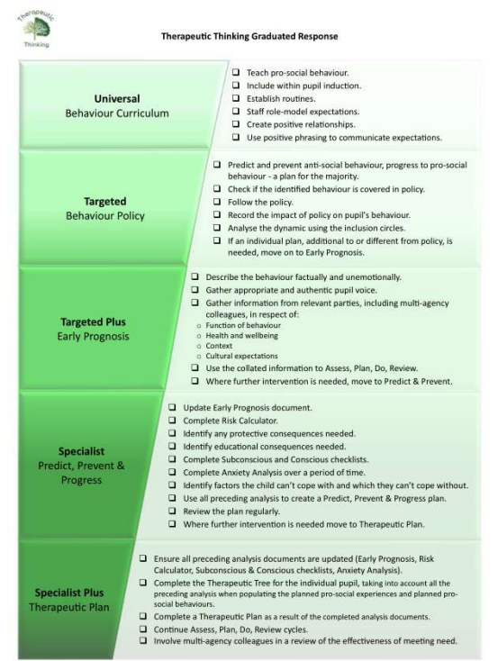
Appendix 3 – Prohibited items
- Knives or weapons
- Alcohol
- Illegal drugs
- Stolen items
- Tobacco and cigarette papers
- Fireworks
- Pornographic images
- Any article a staff member reasonably suspects has been, or is likely to be, used to commit an offence, or to cause personal injury to, or damage to the property of, any person (including the pupil)

