22nd September 2020

Dear Parents and Carers

Salway Ash has now had it’s first confirmed case of COVID 19 and on behalf of the governors I’m writing to remind everyone of the process and procedures that have been put in place in order to keep the school running as effectively as possible.

The case is an asymptomatic case amongst the teaching staff in Reception Class. The staff member and family isolated on the 11th of September and the results came back positive for one member whilst negative for the rest on 21st. Over the weekend of the 19th the other member of the Reception teaching staff had a member of their family show symptoms so they too isolated, they are now also waiting for a test result.

Back in the summer during the schools COVID-19 scenario planning it was decided by the Headteacher and the Governors that a bubble would each have two staff members so that if one showed symptoms and was waiting a test result there was always a backup. If both were isolating and awaiting a test result or there was a confirmed case in the bubble, then the bubble will close. There can be no inter-mixing of staff between bubbles in order to keep the rest of the school protected and to remain open. This includes the Headteacher as if they were involved in a bubble closure, then there is no leadership in school. Once the risk has been assessed by Public Health England / The Department of Education then an alternative teacher can be provided for that bubble if circumstances allow. We are sorry this will cause inconvenience to the families in that bubble but the bubble method is designed to allow the rest of the school to continue to operate.

As we head further into winter it’s essential that we follow what the Department for Education call a rapid response. Taking swift action where it may be that an outbreak has occurred. It’s likely that children will be asked to isolate if they are showing symptoms or bubbles are temporarily closed whilst people are tested. These processes and procedures are constantly being updated and reviewed and we will keep you updated with major changes as and when they occur. Following the guidance and balancing this with what’s possible for the school to deliver with staffing numbers and the complexity of trying to keep to the bubbles, is going to be difficult at times. But please be assured that the safety of the children and staff will always be our top priority.

As winter approaches and the virus is already growing again we all need to be ultra-vigilant in spotting any signs that our children have of showing symptoms. These include a raised temperature, a new or persistent cough or a loss of taste and smell. It’s going to be hard as parents to try and decipher in our children the difference between the normal coughs and colds, that they always get in winter with what is a potential COVID symptom. However it’s essential that even if you are in doubt isolate and test and let the school know.

We appreciate that there are many complex scenarios and protocols that have been emailed to you over the past six months. We have attached a Guidance for Childcare from Public Health England that helps explain the protocols that Salway Ash are adhering to.

Finally a word on Mrs Crew and the teaching staff. These are extraordinary times and it’s been an intense six months already. They are doing an incredible job at teaching our children in what are very challenging circumstances. They are creating an environment that is happy and enriching whilst at the same time having the worries and concerns that we all have during this pandemic and I’d like to thank them for all their hard work.

Keep well and thank you for your time.

Rob

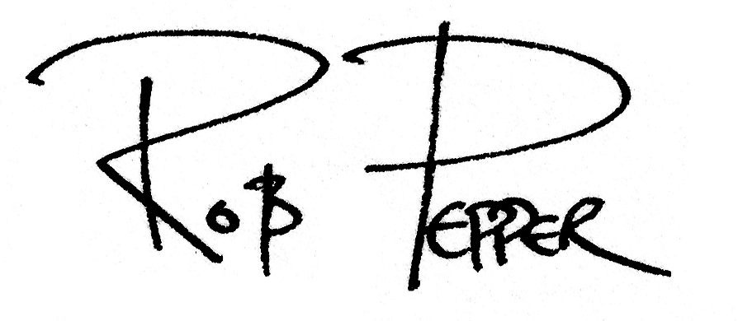

Rob Pepper
Chair of Governors on behalf of the Governing Body
Email: governors@salwayash.dorset.sch.uk

