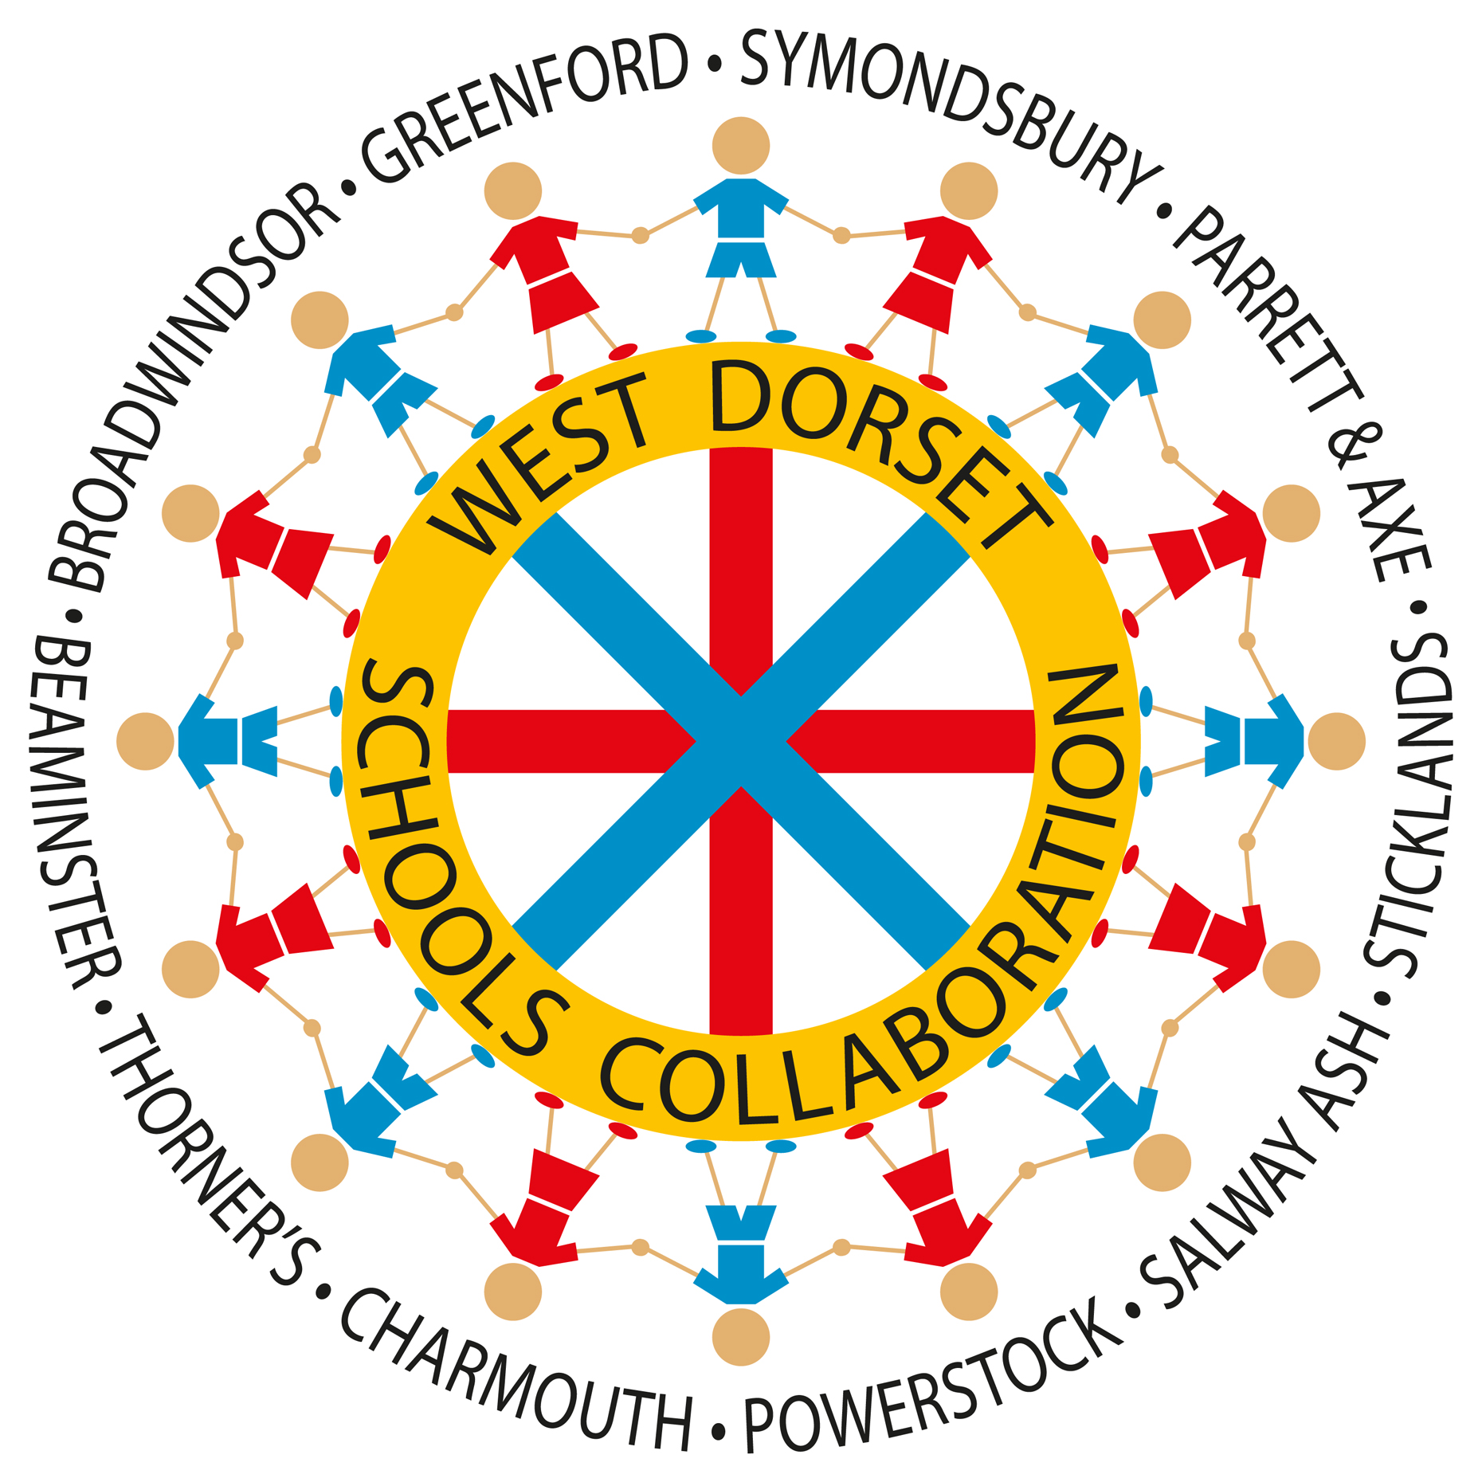

West Dorset Schools Collaboration

About Us

We are made up of the following ten schools: Beaminster School, Broadwindsor, Greenford, Parrett and Axe, Powerstock, Stickland’s, Salway Ash, Symondsbury, Thorner’s and Charmouth.

Our purpose is to enable every young person to experience excellent opportunities to learn.

We believe in the power of local schools collaborating together for the best of all our children.

We believe in the power of learning.

We believe that every young person has a talent that should be nurtured.

We believe that good relationships are built upon respect for themselves and each other.

We believe in equal opportunities for all regardless of ability, race, background, gender or religion.

Our Strategic Plan

- To secure high quality learning for all through;
- Promoting equality and wellbeing
- Working in close partnership to provide high quality learning opportunities
- Listening to the views of young learners and stakeholders in order to form future improvement plans
- Providing excellent transition arrangements
- Using Inset days and other specific times to provide high quality CPD and the sharing of good practice

- To ensure continuous improvement in learning with the aim of consistently raising standards through;
- Improving teaching through mastery in mathematics by enabling teachers and support staff to engage in high qulity CPD from a variety of providers, within and outside of Dorset
- Enabling teachers to regularly meet in phase and subject groups across schools
- Enabling teachers and support staff to have exchange visits within Collaboration schools in order to share good practice
- Enabling support staff to have training in specific targeted areas in order to improve provision for the children
- Providing opportunities for staff to engage in Lesson Study based research projects on a range of subjects
- Sharing academic data in order to prioritise key improvement areas

- To provide school to school support through;
- Enabling young learners to take part in a variety of sporting, musical, environmental and academic events
- Enabling staff and governors to discuss current issues and future opportunities
- Sharing good practice
- Enabling supervision opportunities for Headteachers and other staff
- Enabling governors to access locally based training

- To ensure best value for money through;
- Enabling Finance Officers to regularly meet and share best practice
- Providing locally based high quality training opportunities
- Collaborative procurement

