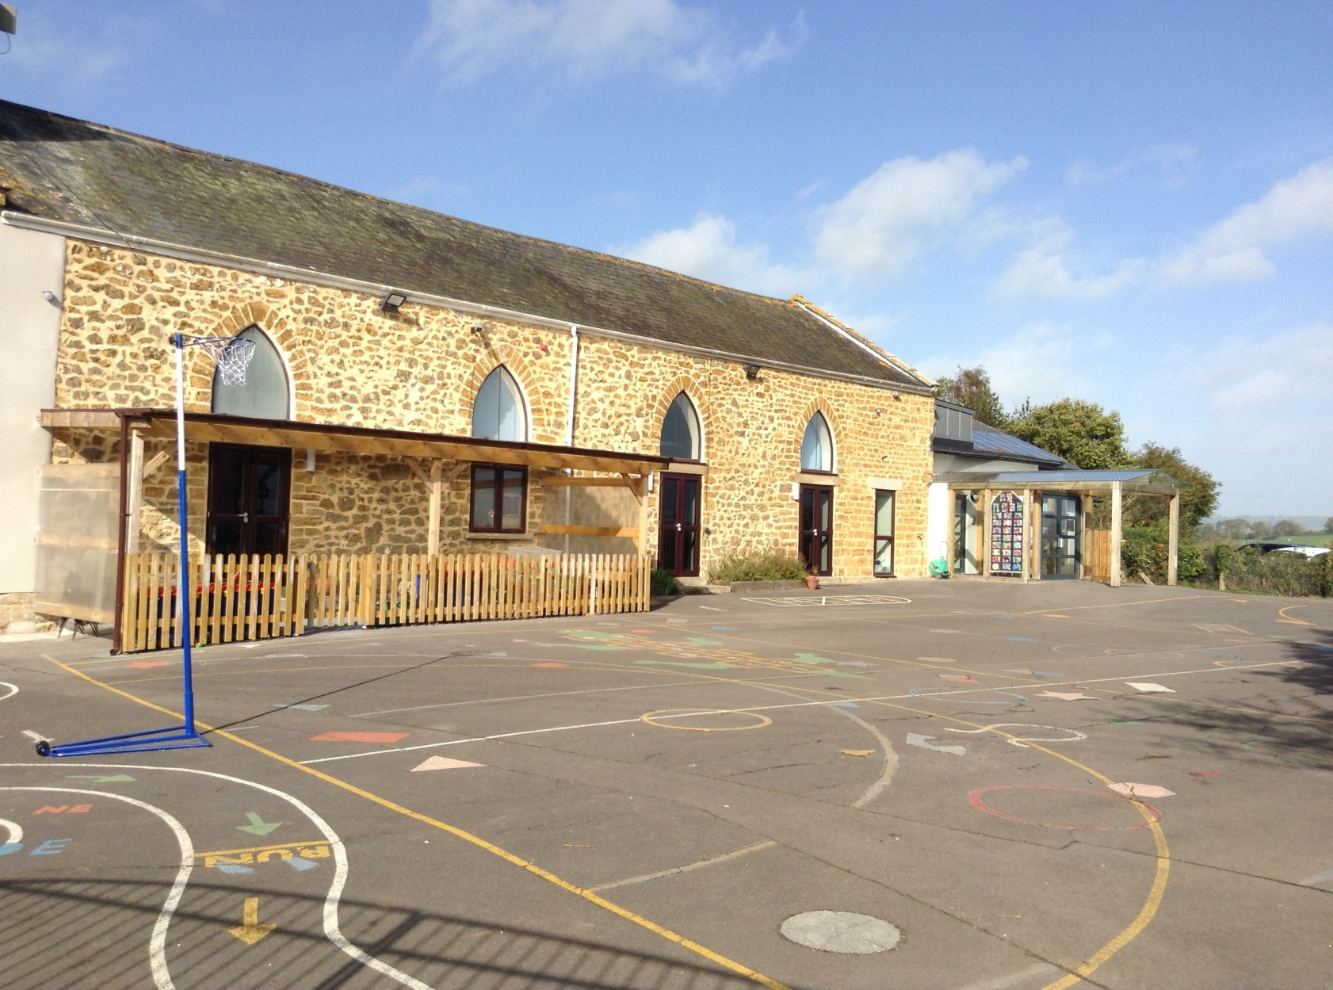

Salway Ash CE VA Primary School
School Development Plan 2017-2018

Salway Ash CE VA Primary School
School Development Plan 2017-2018
A plan for inspirational collaboration with the goal of higher achievement for all
Key Issue 1
Raise achievement in mathematics through improved teaching, learning and assessment of the mastery approach to mathematics
Success criteria:
- Lesson observations by middle and senior leaders judge the quality of teaching to be good or better on at least three occasions during the year with a special focus on the mastery approach.
- End KS2 girls’ attainment at higher standard raise from 0% to 33%.
- Raise percentage of year 6 cohort at ARE+ from 61% (end year 5) to 89%
- Raise percentage of children end KS2 reaching the higher standard from 19% to 53% (All children converting from 2A/3 to higher standard)
- Continuing to raise girls progress by the end of year 6, -3.53 (2016), -0.79 (2017)
- Percentage of Foundation Stage pupils achieving a Good Level of Development equal to or above national percentage and proportion of children achieving the overall mathematics ELG raised from 63% to 78%.
- A higher proportion of each year group attaining ARE+ and higher standard than each cohort attained in 2016/2017.

Actions | Key  Personnel | Monitoring | Timescale | Resources | Outcomes
 |  |  |  |  | Autumn  2017 |  |  | Spring  2018 |  | Summer  2018
Headteacher and subject leader to attend Jurassic Hub West Dorset Collaboration ‘What Does Mastery Look Like?’ presentation. | K.B. (Hub)  L.C.(Head)  E.S. (Sub.Lead) | L.C. and E.S. to take notes, discuss implications with collaboration Heads plan next steps in school | September | Jurassic Hub maths specialist (SLE) | Senior leaders clear on priorities for maths improvement and next steps.
Share ‘What Does Mastery Look Like?’ with other teaching staff. | L.C.and E.S to lead.  All teaching staff | Professional discussion around mastery and how it looks in school. | October | Staff meeting presentation | All staff agree on what the mastery approach could look like in school
Complete ‘Mastery in Mathematics: Self Evaluation’ as a staff group. | All teaching staff. | Staff meetings.  E.S. to lead and assimilate responses. | October  February  May | Mastery in Mathematics: Self Evaluation form | Staff are aware of areas of strength and next steps in the development of a mastery approach.  Initial next steps are clear. | Next steps identified last term are now complete. Further next steps identified |  |  | Next steps identified last term are now complete.  Any development steps for 2018/2019 identified.
E.S. to attend training and subject leader events organised by Jurassic Hub, West Dorset Collaboration and L.A. over the academic year | E.S. | E.S. to feedback to L.C.  Relevant information fed back to staff. | 27/09/17  (Jurassic Hub)  04/10/17 (L.A.)  On-going at least termly  INSET 02.01.18 | Time out from class.  Staff meeting time.  £200 | School development issues from training identified. | E.S. to meet with link Gov. E.F. to report progress and impact so far and future development points. |  |  | E.S. to produce a brief report for Govs and the HT outlining her work during the year and its impact on the standards and provision.
Staff with support of SLE and subject leader trial different teaching approaches needed to deliver the mastery approach successfully.  Evaluate trial results to develop school approach to the way we teach fluency, reasoning and problem solving including how we support pupils to ensure the vast majority move through objectives at the same time. | All staff  E.S. to lead approach | Staff given examples of White Rose maths teaching guidance  (Block 2 addition and subtraction) to trial with their class and then feedback experiences of teacher and children.  E.S. to evaluate NCETM materials for teaching mastery and share with staff.  E.S. to investigate other possible approaches. | 20/11/17.  White Rose feedback during staff meeting. | K.B. (SLE)  White Rose maths materials  NCETM materials. | E.S. identified trial approaches. Staff to have trialled and discussed at least two of these. | Any further approaches trialled. Approach to mastery for our school established and in place. |  |  | A higher proportion of each year group attaining ARE+ and higher standard than each cohort attained in 2016/2017.  End KS2 girls’ attainment at higher standard raise from 0% to 33%.  Raise percentage of year 6 cohort at ARE+ from 61% (end year 5) to 89%  Raise percentage of children end KS2 reaching the higher standard from 19% to 53% (All children converting from 2A/3 to higher standard)  Continuing to raise girls progress by the end of year 6, -3.53 (2016), -0.79 (2017)
E.S. with teaching colleague from school to attend ‘Teaching for Mastery (Primary): What makes an Excellent Lesson Design?’ Run by Jurassic Maths Hub.  Teachers work together to plan exemplar lessons (drawing on new mastery professional development materials produced by NCETM/Maths hubs) and in so doing improve lesson design across the school. | E.S. +colleague. | E.S. + one will develop understanding of key lesson design, become familiar with the mastery professional development materials, agree planning format, discuss and review progress and evaluate the project.  Schools work in pairs to plan and deliver lessons observe each other, with a focus particularly on the small steps required in teaching for mastery.  Evidence of working with new materials collated.  Regular feedback to other teaching staff. | 30th October  2nd January  23rd February  11th May | Cover for teachers out of the classroom £700  K.B.  Staff meetings.  Mastery professional development materials | Teachers have a deep understanding of the elements of effective lesson design.  ‘Planning for Mastery’ document created outlining the expected journey for maths planning.  Children more engaged in maths lessons.
Audit and buy new mathematics resources and use them effectively in lessons to support a mastery approach. This requires a concrete, pictorial to abstract approach. Store resources suitable for sharing centrally and key resources for mastery e.g. concrete equipment, in classrooms.  Monitor lessons to see if resources are being used effectively to support children’s mathematical understanding. | E.S. in consultation with other teaching staff. | E.S. L.C. E.F. (subject link Gov.) Learning walks.  Focus: Resources being used effectively to enhance teaching and learning. | Autumn onwards | £500  (Further funds if available) | Resources audit completed and recorded  Required resources ordered. |  | New resources in place and stored. |  | Monitoring outcomes show new resources in frequent use consistently across the school.
Track the attainment of children who were high attainers at the end of KS1 | S.L  E.S | Staff meetings  KS2 meetings | At the end of each term |  | Make a list of children who were high attainers at the end of KS1 (for each year group in KS2).  Check their progress - end of term. |  | Check their progress at the end of the term. |  | Check their progress at the end of the term.
Check that books of high attainers are being annotated with ‘GD’ to show where opportunities have been provided. | E.S. | Staff meetings  KS2 meetings | At the end of each term | Time out of class | Check that books are being annotated appropriately with ‘GD’ |  | Check that books are being annotated appropriately with ‘GD’ |  | Check that books are being annotated appropriately with ‘GD’
E.S. to carry out lesson observations of all class teachers with a focus on ‘The Mastery Approach’.  Staff to have the opportunity to observe each other, E.S. and visit other schools to observe approaches to mastery. | E.S.  All staff | Staff have feedback on strengths and areas for development in their mastery teaching.  Teachers discuss and share observed good practice. | Autumn and Spring terms. | Cover for observations in school and visits out to partner schools.  £500. | Opportunities for staff to observe other staff coordinated by E.S. | All teachers have observed at least one other teacher and shared good practice. |  |  | All teachers can list 5 aspects of their practice that have improved through these observations.  Lesson observations by middle and senior leaders judge the quality of teaching to be good or better on at least three occasions during the year with a special focus on the mastery approach.
Develop rich early mathematical opportunities at EYFS both adult led and child initiated. EYFS team to develop learning environment to inspire children to develop key mathematical skills including outdoor provision. H.C. (EYFS class teacher) to visit other settings, observe good practice, liaise with Early Years LA consultant in order to enhance CPD. | H.C.  E.S. | H.C. to feedback to E.S. and L.C. key elements of observed good practice and impact on EYFS learning environment. | Autumn and Spring terms. | Sheila O’Donnell  Time out for visits to other schools.  Cover.  £200 | E.S. and H.C. to audit present opportunities given to children to develop key maths skills. | H.C. to meet with link Gov. V.H. to report progress and impact so far and future development points.  EYFS planning clearly identifies opportunities to teach/promote key maths skills. |  |  | Monitoring outcomes judge the quality of provision for maths to be good or better.  78%+ of pupils attain GLD in the maths strand. This contribute to 78%+ overall GLD.

Key Issue 2
Develop middle leaders through collaborative working which enhances inspirational learning experiences across the school.

Success criteria:
- A higher proportion of each year group attaining ARE+ and higher standard than each cohort attained in 2016/2017 in reading, writing, maths and science.
- All subject leaders have liaised with staff from collaboration schools and/or specialist support to share good subject knowledge and practice with a focus on the mastery approach to teaching and learning.
- Subject leaders (on agreed subjects) have monitored the quality of provision across the school on at least three occasions during the year and prepared a brief report for governors. These reports state a qualitative judgement on teaching and learning, the achievement of pupils and pupil attitudes to learning, including impact from shared good practice visits.
- An agreed school assessment system implemented for targeted foundation subjects.
- EYFS results return to 2015/2016 outcomes of above national level for Good Level of Development.
- All pupils have the opportunity to be involved in at least two collaborative learning experiences with pupils from schools in the West Dorset Collaboration.

Actions | Key  Personnel | Monitoring | Timescale | Resources | Outcomes
 |  |  |  |  | Autumn  2017 | Spring  2018 | Summer  2018
Develop a collaboration plan of events which includes staff development, leadership activities and pupil opportunities. | All staff  L.C. to help coordinate | Staff to make contact with collaboration schools to draw up a timetable of events. | Fully in place by end of autumn | None | Partnership plan is in place. | Staff fed back to staff meetings positive outcomes from events | Impact to feed in to report to governors.  All pupils have the opportunity to be involved in at least two collaborative learning experiences with pupils from schools in the West Dorset Collaboration.
Support new English and Science SL and develop her role as a key school improvement member of staff. Give support in gathering information about standards and progress  HT to meet with SLs to discuss (where appropriate) skills that need developing and CPD opportunities required as part of performance management cycle.  Provide SLs with opportunities to network with leaders in other schools in order to become more effective in their roles (English, Maths, ICT, Geog ,Hist, Science, and EYFS). Firm up a clear understanding of standards in the subjects they lead and develop action plans to improve standards in their subjects.  Ensure SL role in the monitoring cycle plan is focused on measuring impact of teaching, learning and assessment against pupil outcomes.  Formal and more regular ‘drop in observations’ enable HT to make a clear judgement on the quality of teaching and learning in all year groups.  Literacy and Maths SLs ensure there is an emphasis on monitoring progress of all groups within cohorts (e.g. more able, upper prior attaining girls, SEND, PP) | All teaching staff subject leaders. | HT to monitor through performance management.  Feedback from staff regarding CPD.  SL’s action plans and reports.  Lesson observations .  Attainment and progress of pupils. | October onwards | Cover supervisors used where possible for short term supply cover to release teachers for visits and consultations.  Staff meetings.  Collaboration funds for CPD.  £400 | Monitoring timetable is in place.  HT has met with all SLs and established needs.  SLs have met with the person in the same role from another school. Development points noted and fed back to HT.  SLs fed back to other staff in staff meetings development points. | All SLs to have at least two opportunities to monitor their area. Brief written feedback to the HT, with school development points identified.  HT has held a further meeting with SLs providing support where needed.  An agreed school assessment system implemented for targeted foundation subjects.  Lesson observations by HT show the quality of teaching and learning to be at least good. | Subject leaders (on agreed subjects) have monitored the quality of provision across the school on at least three occasions during the year and prepared a brief report for governors. These reports state a qualitative judgement on teaching and learning, the achievement of pupils and pupil attitudes to learning, including impact from shared good practice visits.  SL action plans outline their impact on pupil outcomes, contributing to overall success criteria.
SLs meet with subject link Govs. with a clear focus on improving standards including a Learning Walk, book scrutiny and monitoring subject action plans.  Liaison through subject links will contribute to the termly newsletter to parents. | SLs  Govs  HT | Governors report back to FGB following learning walks and meetings with SLs. | November onwards. | Release time for learning walks and meetings with governors.  Cover supervisors to cover classes. | Governor plan developed and agreed during autumn meetings.  Any training needs identified and a plan agreed. | All link governors to have visited at least once in a monitoring role. | Link govs. reported back to FGB key findings from their monitoring visits.

