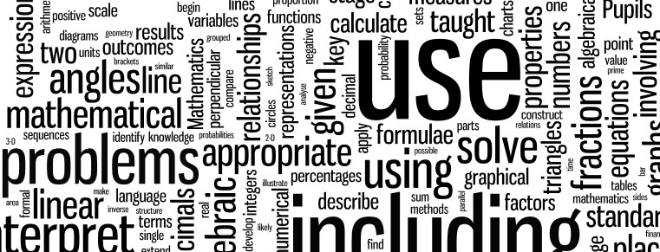
Salway Ash CE VA Primary School
Calculation Policy

Contents
Introduction 1
Addition and Subtraction EYFS 2
Addition and Subtraction KS1 3
Addition and Subtraction KS2 6
Multiplication and Division EYFS 7
Multiplication and Division KS1 8
Multiplication and Division KS2 10

Introduction
This framework details the key written methods of mathematical calculation to be taught. Its purpose is to promote a consistent and progressive approach to the teaching of mathematical calculation skills, in line with the expectations of the 2014 Maths curriculum. Although the main focus of this policy is on the progression to pencil and paper procedures it is important to recognise that the ability to calculate mentally underpins all calculation. Written calculation methods are not a replacement for mental calculation but structures to enable more complex calculations to be carried out efficiently. In every written method there is an element of mental processing. Written recording both helps children to clarify their thinking and supports and extends the development of more fluent and sophisticated mental strategies.
A sound understanding of the number system is essential for children to carry out calculations efficiently and accurately. Written methods of calculations are based on mental strategies. Each of the four operations builds on mental skills, learned in working with a range of manipulative equipment, which provide the foundation for jottings and informal written methods of recording. These mental skills lead on to more formal written methods of calculation. Strategies for calculation need to be supported by familiar models and images to reinforce understanding. When introducing a new strategy it is important to start with numbers that the child can easily manipulate so that they can understand the concept then, as competence increases, larger and more complex numbers can be tackled. Previous stages may need to be revisited to consolidate understanding when introducing a new strategy. The transition between stages should not be hurried as not all children will be ready to move on to the next stage at the same time, therefore, whilst the progression in this document is outlined by year group, it is inevitable within a class that children could be working at different stages. Progression should be based on attainment across the mathematics curriculum and not just in the calculation processes. Judgements of attainment should be based on evidence gathered in routine classroom assessments and tasks of the pupil’s competence and accuracy in applying methods learned.

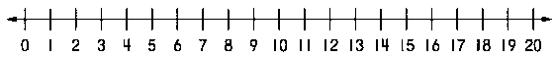

Addition & Subtraction

 | Addition | Subtraction
 | Children in EYFS should have a secure understanding of number names and values (conservation) before attempting to do any calculation work. The primary focus for all calculation work in the foundation stage centres around practical, concrete experiences to ensure that children have accurate model and images to secure understanding. Only then will children move onto visual models such as a numbered number line. Teaching will be focused upon single digits and move onto teen numbers and single digits as and when appropriate.
Year R | One more of a number using apparatus such as Numicon and moving onto two more.  Combining small sets of numbers through physical apparatus and Numicon in a real life context. Practical in first instances with adults modelling number sentences and associated vocabulary.  For example, ‘If there were five apples in one bag and three apples in another bag, how many apples would there be altogether?  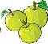  Counting up all objects in the first instance before counting on from the largest group.  Number lines - add two one digit numbers before moving on to adding one digit to two digit numbers. Learning of this alongside the concrete so that the children can make links between them.  +1 +1 +1  + =  Modelling of number sentences and vocabulary with children beginning to record themselves if appropriate.  7 + 3 = 10  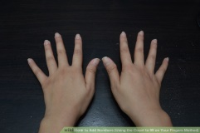 5 + 5 = 10  Moving on to children placing the larger number in their heads then counting on. | One less, two less, before subtracting one digit numbers in practical contexts.  Games such as skittles and target based activities will form the cornerstone of concrete, experiential learning of subtraction concepts. Taking away from a group physically.  For example, ‘If I start with 7 skittles and I knock over three, how many will I have left?’  Teacher modelling written number sentences and vocabulary.  7 – 3 = 4, with the 4 being physically moved away from the original set, leaving the four behind to count.  Moving onto number lines in the same way as addition, making sure that, initially, the link between the concrete and the visual remain.  7 – 3 = 4  -1 -1 -1  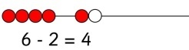

 | Addition | Subtraction
Year 1 | - count to and across 100 forwards, beginning with 0 or 1, or from any given number  - given a number, identify one more  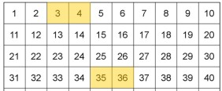  For example using a number square or concrete resources  - represent and use number bonds within 20  - represent number pairs to 10 using concrete resources,  for example Numicon, bead strings, counters, Dienes etc.  9  10 10  1  - use number pairs to 10 to work out number pairs to 20  - represent doubles up to double 10  For example, double 6 is the same as 12, supported with concrete resources.  - represent number bonds to make 3, 4, 5, 6, 7, 8, 9 in all ways using addition  7 + 2 = 9  - use number bonds to make 3, 4, 5, 6, 7, 8, 9, for example,  7 is the same as 4+3 and 5+2  7 4 + 3 5 + 2  - add one-digit and two-digit numbers to 20, including zero  - read, write and interpret mathematical statements involving addition (+) and equals (=) signs  For example 5 + 7 = (Supported by the use of concrete resources where appropriate).  Moving to a marked number line  +1 +1 +1 +1 +1 +1 +1  - solve missing number problems (using numbers up to 20)  Use fingers to add / count on a single digit number from any given number e.g.  22 + 5 = 22 + = 27 | - count to and across 100, backwards, beginning with 0 or 1, or from any given number  - given a number, identify one less  For example using a number square or concrete resources 4 - 1 = 3 36 – 1 = 35  - read, write and interpret mathematical statements involving subtraction (–) and equals (=) signs  For example 7 - 2 = 5  - represent and use number bonds and related subtraction facts within 20  For example, 10 - 8 = 2 and 10 – 2 = 8  - subtract one-digit and two-digit numbers to 20, including zero  Children use a variety of resources to model subtraction. As well as real life objects, children could use Numicon, Dienes, multilink etc. A number line could be used to show calculations.  - solve one-step problems that involve subtraction, using concrete objects and pictorial representations, and missing number problems such as 7 = ? – 9.  Children use balance scales to find out what to take away from 12 to make 7, or solve as an inverse. What needs to be added to 7 to make 12?  The difference between 13 and 8 is 5  Children explore the language of difference by comparing different amounts using physical resources such as Numicon, multilink.

 | Addition | Subtraction
Year 2 | - solve problems with addition  - using concrete objects and pictorial representations, including those involving numbers, quantities and measures  33 + 24 = 57 (Using Dienes cubes or equivalent) Children use Dienes or equivalent to model addition, including exchanging through 10s  - add numbers using concrete objects, pictorial representations, and mentally, including:  - a two-digit number and ones  - a two-digit number and tens  - two two-digit numbers 33 24  30 3 20 4 50 + 7 = 57  Adding two digit numbers mentally supported with jottings (leading to expanded column method)  - adding three one-digit numbers  For example, 7 + 4 + 9 is the same as 7 + 3 and 9 + 1 = 20 Adding three one-digit numbers looking for number patterns, supported with concrete resources and a number line.  - applying their increasing knowledge of mental and written methods  +1 +1 +1 +1 +1 +1 +1  +5 +2  5 10 12  Children begin to use written methods for calculation, for example the number line. Use of number should progress to become increasingly proficient, moving to a blank number line.  T U  - 6 Children record calculation  + 1 1 using formal written methods  4 7 including exchanging 10s  + supported with concrete  resources.  =  - recall and use addition facts to 20 fluently, and derive and use related facts up to 100  - show that addition of two numbers can be done in any order  10 + 7 is the same as 7 + 10  - recognise and use the inverse relationship between addition and subtraction and use this to check calculations and solve missing number problems. | - recall and use subtraction facts to 20 fluently, and derive and use related facts up to 100  - use number bonds to make 3, 4, 5, 6, 7, 8, 9 to work out subtractions  + = - =  For example, 5 + 3 = 8, therefore 8 – 3 = 5  - recall halves of even numbers up to 20  - subtract a two-digit number and ones  -1 -1 -1 - 1 -1 - 1 -1  18 – 7 completed using a number line, no bridging of tens.  - subtract a two-digit number and tens  -10 -10  47 57 67  67 – 20 completed counting back on a number line or by using a 100 square  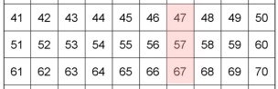  - subtract two two-digit numbers  -20 -3  23 43 46  46-23 using a number line. The language of ‘take away’ supports the concept of counting back.  +7 +10 +6  23 30 40 46  The same question can also be calculated counting forwards is  the language of difference is introduced.  - using concrete objects (including exchanging Tens & Units)  46 - =  46 – 24 completed using Dienes cubes (or equivalent), exchanging tens for units where necessary  - using pictorial representations  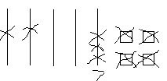  54 – 27 = 27 (indicated by the 2 tens and 7 left over from the exchange)  - subtract a two-digit number and ones  1 1  2 8 2 3 Children begin to explore representing  - 1 5 - 9 subtraction in a formal manner but should  1 3 1 4 still carry out calculations using resources.  - subtract a two-digit number and tens  - subtract two two-digit numbers (no bridging the tens, bridging the tens)

Progression
 | Addition | Subtraction
Year 3 | - add numbers with up to three digits, using formal written methods of columnar addition  4 5 Children continue to explore column addition,  + 2 2 following a clear progression. Children should  6 7 have access to Dienes or equivalent.  4 8 Exchanging units for10s  + 1 3  6 1  1  4 2 Exchanging tens for100s  + 9 3  1 3 5  1  7 4 8 Exchanging freely in both 10s and 100s  + 9 3  8 4 1  1 1  - solve problems, including missing number problems (such as 45 + = 67), using number facts, place value, and more complex addition and subtraction.  Throughout year 3 and 4, children’s use of formal addition and subtraction should be supported by the appropriate use of expanded methods. Number lines are also used as appropriate.  3 0 + 8  + 4 0 + 3  7 0 + 1 1  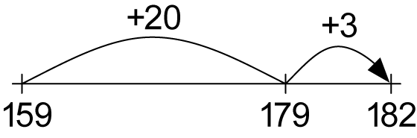 | - subtract numbers mentally, including:  - a three-digit number and ones  - a three-digit number and tens  - a three-digit number and hundreds  - subtract numbers with up to three digits, using formal written methods of columnar subtraction  Children continue to explore a range of subtraction calculations. Throughout the process they should have access to appropriate resources to support their learning but be encouraged to lay their work in formal columns. Questions should be progressive.  4 6 No exchanging  - 2 2  2 4  3 1  4 8 Exchanging 10s to units  - 9  3 9  4 3 6 3 digits with no exchanging  - 2 1 4  2 2 2  2 13 1  3 4 6 Exchanging 10’s to units & 100’s to tens.  - 2 6 7  0 7 9  - solve problems, including missing number problems, using number facts, place value, and more complex addition and subtraction.
Year 4 | - find 1000 more or less than a given number  For example, 1452 + 2000 = 3452  Children begin to work with numbers up to 1000, being able to count on in 1000’s using place value knowledge.  - add numbers with up to 4 digits using the formal written methods of columnar addition  1 7 4 8 Children are introduced to 4 digit column  + 1 2 9 3 addition and apply carrying skills to the  3 0 4 1 thousands column.  1 1 1  - solve addition two-step problems in context  - solve number and practical problems that involve all of the above and with increasingly large positive numbers | - find 1000 less than a given number  For example, 2452 – 1000 = 1452  Children apply their understanding of digit value to identify 1000 less with ease.  - count backwards through zero to include negative numbers  For example, 13 – 27.  Children understand that a negative answer cannot be calculated using formal method and use jottings and mental strategies to calculate an answer  -14 -13  -14 0 13  - subtract numbers with up to 4 digits using the formal written methods of columnar subtraction  3 1 5 1  4 1 6 6 Children introduced to calculations with up to 4  - 9 1 8 digits. Calculations should avoid exchanging through more than 1 column until a full  3 2 4 8 conceptual understanding is grasped.  - solve subtraction two-step problems in contexts

 | Addition | Subtraction
Year 5 | - add numbers mentally with increasingly large numbers  10573 + 3200 = 13773  Children use knowledge of place value to add large numbers mentally.  - add whole numbers with more than 4 digits, including using formal written methods (columnar addition)  4 6 3 6  + 2 5 4 8  7 1 8 4  1 1  6 6 Children use a formal written method to add  + 3 6 more than two digits (with carrying)  + 1 9  1 2 1  1 2  6 . 9 6 Children apply column addition to any numbers  + 2 5 . 4 including decimals, carrying across the decimal  3 2 . 3 6 place  1 1  - solve addition multi-step problems in contexts | - subtract numbers mentally with increasingly large numbers  64501 – 4300 = 60201  Children continue to apply place value knowledge to subtract numbers with increasing large numbers. Mental calculations can be supported with jottings and informal methods of calculation, including a number line.  - subtract whole numbers with more than 4 digits, including using formal written methods (columnar subtraction)  5 13 1  6 4 6 7 Children use a formal written method to subtract  - 2 6 8 4 numbers with up to four digits, exchanging freely  3 7 8 3 in all columns.  9  8 1 1  9 0 7 Children exchange through zero, in this case in  - 6 8 8 the ten’s column but could also be in others. 2 1 9  1 1  2 1 . 7 7 Children apply formal written method to  - 1 3 . 6 calculations involving decimals.  0 8 . 1 7  - solve subtraction multi-step problems in contexts, deciding which operations and methods to use and why.
Year 6 | - perform mental calculations, including with mixed operations and large numbers  - solve addition multi-step problems in contexts, deciding which operations and methods to use and why  Children consolidate skills and apply them to a variety of problem solving contexts. For some children, revisiting strategies along the calculation journey will be necessary to secure conceptual understanding.  Once the principles of standard column addition have been mastered, increasing the number of columns does not increase the difficulty. | - perform mental calculations, including with mixed operations and large numbers  - solve problems involving subtraction  Children consolidate and apply the skills learnt in a variety of problem solving contexts. For some children, revisiting the strategies and resources used along the calculation journey will be necessary to secure conceptual understanding.  Once the principles of standard column subtraction have been mastered, increasing the number of columns does not increase the difficulty.

Multiplication and Division

 | Multiplication | Division
 | Children in EYFS should have a secure understanding of number names and values (conservation) before attempting to do any calculation work. The primary focus for all calculation work in the foundation stage centres around practical, concrete experiences to ensure that children have accurate models and images to secure understanding. Recording of multiplication and division sentences can be modelled, if appropriate, but children should not be.
Year R | Children to solve one step problems practically using a range of apparatus. Teacher should model the concept of equal groups.  Children explore this in a range of numbers and contexts. For example, ‘If 5 children had two sweets each, how many sweets do the children have altogether?’  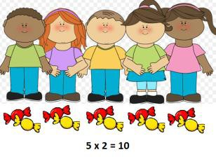  Children can represent their working with sweets, cubes or any similar resource.  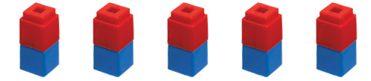  This could also be modelled using Numicon, if deemed appropriate.  Children will also be encouraged to group count in 2s, 5s and 10s when solving problems and will practise counting in these increments. | As with multiplication, children to solve simple, one-step problems using apparatus. Teacher should model the concept of sharing to the children and the idea of equal groups.  Children explore this in a range of numbers and contexts. For example, ‘If Tom had 12 strawberries and shared them between him and three friends, how many strawberries would they have each?’  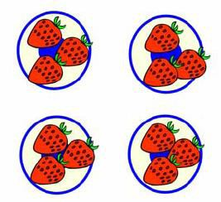  Children should be taught along the lines of the ‘one-for-you, one- for-you’ principle so that all objects are shared equally among the groups.  Children will also be taught to halve numbers up to 10 and then twenty. Children should be learn this using concrete examples in the first instance and share into two equal groups:  Children explore this in a range of numbers and contexts. For example, ‘John had 8 bananas. He gave half to his Mum. How many did his Mum get?’  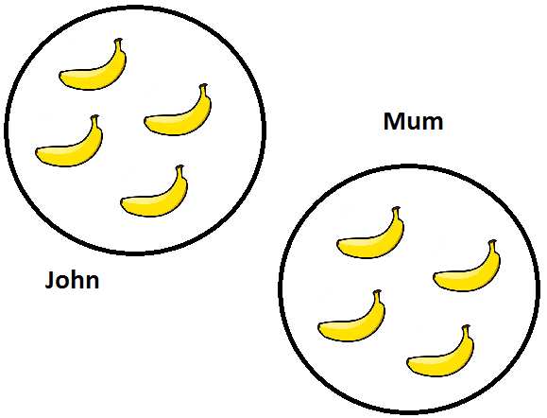

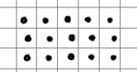
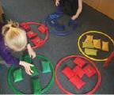
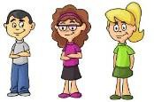
 | Multiplication | Division
 | Children should be exposed to the close links between multiplication and division, understand that times table facts can be used to support division as well as multiplication. Many of the National Curriculum targets addressed here relate to both multiplication and division simultaneously and therefore prove difficult to address separately.
Year 1 | - solve one-step problems involving multiplication, by calculating the answer using concrete objects  Children exploring multiplication using physical resources: For example, counting out groups of 5 into hoops.  - solve one-step problems involving multiplication, by calculating the answer using, pictorial representations and arrays with the support of the teacher.  Children explore this in a range of numbers and contexts. For example, ‘If 3 children each had 4 apples, how many apples are there altogether?’  3 x 4  Children use arrays to represent multiplication, for example, 3 groups of 5 (3 x 5).  3 x 5  3 x 5 3 groups of 5  Children represent arrays using physical resources such as Cuisenaire rods. The same calculation can be represented using Numicon or other concrete resources.  4 8 12  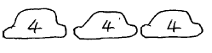 Children represent number pictorially and begin to find the final outcome by counting  3 x 4 with increasing efficiency. For example,  counting in groups of 4 instead of units.  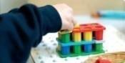  Children use a range of concrete resources as well as maths equipment to support their multiplication. Suggestions include:  - Numicon  - Cuisenaire  - Dienes  - Multilink | - solve one-step problems involving division, by calculating the answer using concrete objects, pictorial representations and arrays with the support of the teacher.  Children use resources to represent division.  12 For example, ‘If I had 12 sweets and divided them equally into 4  pots, how many sweets are in each pot?’  Children use pictorial representations to solve problems involving division; moving from actual pictures to representative jottings.  Share 8 apples between two children. How many do they each have? (Sharing real apples, moving to drawing apples, moving to jottings.)  16 children went to the park at the weekend, half that number went swimming. How many children went swimming?

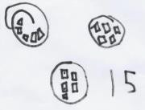
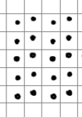
 | Multiplication | Division
Year 2 | - recall and use multiplication facts for the 2, 5 and 10 multiplication tables, including recognising odd and even numbers  Children begin to sport patterns. For example, all numbers in the 2 times  table are also even. (Numicon show this  really clearly).  Children use mental jottings to work out multiplication tables. For example, 3 x 5 = 15  Children explore doubles up to 10 x 2, supported with the use of resources such as Numicon or equivalent.  13  ₁₀ 3  Double 2 Double 5 20 6  Children begin to use partitioning to support doubling.  - calculate mathematical statements for multiplication and division within the multiplication tables and write them using the multiplication (×), division (÷) and equals (=) signs  - show that multiplication of two numbers can be done in any order (commutative).  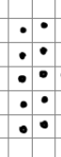  For example, 2 groups of 5 is worth the same as 5 groups of 2, represented using arrays, Numicon scales. This problem could also be represent using concrete resources and pictorial representations.  +2 +2 +2 +2  - solve problems involving multiplication, using materials, arrays, repeated addition, mental methods, and multiplication facts, including problems in contexts.  +2 +2 +2 +2 +2 +2  Repeated addition support through the use of a number line (6 x 2)  6 x 3 = 18  Repeated addition supported with the use of Numicon (or equivalent). The final answer of 18 resolved by counting and comparison. | - recall and use division facts for the 2, 5 and 10 multiplication tables, including recognising odd and even numbers  Children use resources to represent division. *Divisions link closely to 2, 5 and 10 times tables only as this is the year 2 focus.  For example, ‘If I had 20 cheerios and divided them equally into 5 pots, how many sweets are in each pot?’  - calculate mathematical statements for multiplication and division within the multiplication tables and write them using the multiplication (×), division (÷) and equals (=) signs  15 Children use pictorial representations to solve  problems involving division; moving from actual pictures to representative jottings.  Although sharing forms the start of conceptual understanding, children also explore the concept of group.  For example, 15 ÷ 5 is the same as asking how many groups of 5 are in 15. This understanding will help lead towards number line division. (In this case, supported with the use of Numicon scales)  20 ÷ 5 = 4 supported with the construction of an array.  Progression should lead to repeated addition. 5 10 15 20  (Shown below on a number line)  +5 +5 +5 +5  Children begin to explore number families for 2’s,5’s and 10 times tables, forming close links between multiplication and division.  2 x 7 = 14  7 x 2 = 14  14 ÷2 = 7  14 ÷ 7 = 2

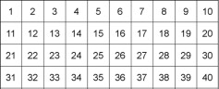
Progression
x | 10 | 4
3

x | 10 |  |  | 4
3 | 10 | 10 | 10 | 1 | X4

x | 10 | 4
3 | 30 | 12

x | 10 | 3
8 | 80 | 24

x | 30 | 5
8 | 240 | 40

 | Multiplication | Division
Year 3 | - recall and use multiplication and division facts for the 3, 4 and 8 multiplication tables  For example, circle all the numbers that are multiples of 4.  - write and calculate mathematical statements for multiplication using the multiplication tables that they know, including for two- digit numbers times one-digit numbers, using mental and progressing to formal written methods (at this stage grid method as a bridging method to short multiplication)  Children begin to see that 14 x 3 is the same as  (10 x 3) + (4 x 3)  introducing a simple grid method to lay out work.  x 20 3 Calculation supported by  4 mental understanding by  also physical resources.  TU x U calculation progression.  - Calculations to stay within the learnt times tables for year 3 (2, 3, 4, 5, 8, 10)  - Place value counters make a good bridge between  resources and written.  - Children find place value patterns, for example, 3 x 8 = 24 therefore  30 x 8 = 240  - solve problems, including missing number problems, involving multiplication, including positive integer scaling problems and correspondence problems in which n objects are connected to m objects.  Mark drives 18 miles to work every day and 19 miles back. He does this on Mondays, Tuesdays, Wednesdays, Thursdays and Fridays. How many miles does he travel to work and back in one week?  - use number lines as appropriate to aid understanding  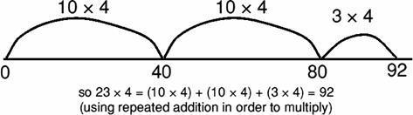 | - recall and use multiplication and division facts for the 3, 4 and 8 multiplication tables  For example: At Christmas, there are 28 chocolates in a tin and Tim shares them between himself and 3 other members of the family. How many chocolates will each person get?  - write and calculate mathematical statements for division using the multiplication tables that they know, including for two-digit numbers times one-digit numbers, using mental and progressing to formal written methods  Division moves away from sharing and instead begins to focus on the language of grouping. 39 ÷ 3 now reads, ‘How many groups of 3 in 39?’ and not, ’Share 39 into 3 pots’.  3 6 9 12 15 18 21 24 27 30 33 36 39  Children use repeated addition to solve problems using learnt times table facts. In this case they count 13 groups of 3.  34 ÷ 3 =  11r1  Children use Numicon to find how many groups of a number there are. Children lay out groups of 3 to reach the target number. Children identify simple remainders.  10 x 4 = 40  Children become increasingly efficient. In this case, the child realises that to solve 56 ÷ 4 they can begin by showing that 10 groups of 4 is 40 finding the final answer of 16 without using Numicon to cover the whole number 56.  10 x 4 2 x 4 2 x 4  0 40 48 56  Children progress to represent division problems on a blank number line (marked if necessary), jumping in efficient groups to the target number.  - solve problems, including missing number problems, involving division, including positive integer scaling problems and correspondence problems in which n objects are connected to m objects.  Miss West needs 28 paper cups. She has to buy them in packs of 6. How many packs does she have to buy?  Children solve problems in context, support with concrete and pictorial resources, including questions where the remainder needs interpreting.

Progression
 | Multiplication | Division
Year 4 | - recall multiplication and division facts for multiplication tables up to 12 × 12  - use place value, known and derived facts to multiply and divide mentally, including: multiplying by 0 and 1; dividing by 1; multiplying together three numbers  For example: 200 × 3 = 600 can also be written 600 ÷ 3 = 200  - recognise and use factor pairs and commutativity in mental calculations  39 × 7 = 30 × 7 + 9 × 7  Using the commutative law to partition 39 into its parts in order to multiply by 7.  2 x 6 x 5 = 10 x 6  Children recognise that three numbers multiplied together can be done in any order; using this to spot patterns in order to increase efficiency.  - multiply two-digit and three-digit numbers by a one-digit number using formal written layout  x 300 20 6 Grid method used for HTU x  TU calculations. At this  40 12000 800 240 stage a full conceptual  1 300 20 6 understanding is evident.  Children introduced to column multiplication as the next significant step from HTU x TU grid multiplication. Short multiplication is less conceptual as the digit value is maintained by the place value holder.  1 2 TU x U – no carry x 3  3 6  1 3 TU x U – carry into the tens x 7  1  4 1  2 1 4 HTU x U – carrying x 6 across all columns  1 2  1 2 8 4  - solve problems involving multiplying and adding, including using the distributive law to multiply two digit numbers by one digit, integer scaling problems and harder correspondence problems such as n objects are connected to m objects.  - continue to use a number line to aid understanding where needed | - recall multiplication and division facts for multiplication tables up to 12 × 12  Children should continue to apply times table facts in order to solve problems mentally, recognising the relationship between larger numbers. For example 240 ÷ 3 can be answered using 24 ÷3 as a root question.  - divide two-digit numbers by a one-digit number using the formal written method of short division, initially with no remainders, then with remainders. Interpret remainders appropriately for the context.  1 5 TU ÷ U no remainder  2  5 7 5  1 4 r 2 TU ÷ U including remainder  2  5 7 2  Solve word problems such as: An egg box holds 6 eggs. How many boxes are needed to hold 25 eggs?

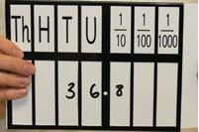
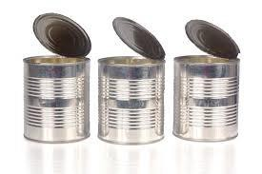
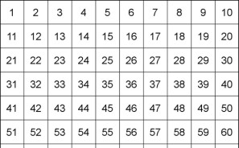
Progression
Progression
 | Multiplication | Division
Year 5 | - identify multiples and factors, including finding all factor pairs of a number, and common factors of two numbers  Children can find multiples within a range. For example, what is the biggest multiple of 4 between 50 and 60?  18 Children identify factor pairs for  1 18 numbers using times table facts and mental calculations.  2 9  3 6  - multiply numbers mentally drawing upon known facts  For example, 13 x 5 can be  13 x 5 calculated in two parts mentally. 10  x 5 added to 3 x 5.  10 x 5 3 x 5  - multiply whole numbers and those involving decimals by 10, 100 and 1000  For example, 3.68 x 10 supported with the use of a place value slider.  - multiply numbers up to 4 digits by a one- or two-digit number using a formal written method, including long multiplication for two-digit numbers  1 2 1 4 Children secure their previous understanding x 6 by moving to a ThHTU x U calculation.  1 2  7 2 8 4  Multiplying by a 2 digit number is the next biggest  conceptual jump. Questions should be simplified at first to  allow children to understand the need to hold a zero in the  units’ column.  1 4  X 3 2  2 8  1  4 2 0  4 4 8  Move on to HTU x U  Children apply their understanding regularly. For example David brought boxes of cans in packs of 24. If he brought 9 boxes of baked beans, 3 boxes of peas and 17 boxes of carrots, how many tins would he have in total? | - divide numbers mentally drawing upon known facts  - divide whole numbers and those involving decimals by 10, 100 and 1000  For example, 368 ÷ 10 supported with the use of a place value slider.  Children work backwards to show that 36.8 x 10 = 368  - divide numbers up to 4 digits by a one-digit number using the formal written method of short division and interpret remainders appropriately for the context  1 7 8 HTU ÷ U no remainder  3 3  4 7 1 2  1 2 3 r 5 HTU ÷ U including remainder  1 2  6 7 4 3  2 3 8 1 ThHTU ÷ U no remainder  1 2  3 7 1 4 3  6 0 7 r 5 ThHTU ÷ U including remainder  7 4 2 5 4  Children learn to show remainders as fractions.  8 7 r 4 = 87 ⅘  5 4 3 9  Children practice these division skills progressively and in a variety of contexts, securing a deep understanding of the processes. Children solve problems in context, interpreting the remainder appropriately.  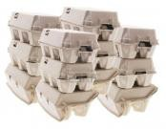  Egg boxes hold 6 eggs. A farmer collects 439 eggs. How many boxes can he fill?  Egg boxes hold 6 eggs. How many boxes must a restaurant buy to have 200 eggs?

Expanded Steps
 | Multiplication | Division
Year 6 | - perform mental calculations, including with mixed operations and large numbers  Use mental strategies to calculate in their heads, using jottings and/or diagrams where appropriate. For example, to calculate 24 × 15, they multiply 24 × 10 and then halve this to get 24 × 5, adding these two results together. They record their method as (24 × 10) + (24 × 5). Alternatively, they work out 24 × 5 = 120  (half of 24 × 10), then multiply 120 by 3 to get 360.  - identify common factors, common multiples and prime numbers  18 24  1 18 2 12  2 9 3 8  3 6 4 6  Recognising common factors using ‘factor trees’  Children can find common multiples within a range. For example, what numbers are both multiples of 3 and 7?  - multiply multi-digit numbers up to 4 digits by a two-digit whole number using the formal written method of long multiplication  2 1 . 4 Children should continue to secure their  x 6 understanding of column multiplication. Some  2  1 2 8 .4 children might explore decimal multiplication using a formal written method. This represents a substantial conceptual leap as the decimal numbers should not be lined up. The same pattern is followed and the decimal added after. In this question, children count 1 decimal place.  3 2 . 7  X 2 . 4  1 2  1 3 . 0 8  6 5 . 4 0  7 8 . 4 8  This question has two decimal places, so the answer also needs two decimal places. Refer back to grid method as necessary to aid understanding. | - perform mental calculations, including with mixed operations and large numbers  - divide numbers up to 4 digits by a two-digit whole number using the formal written method of long division, and interpret remainders as whole number remainders, fractions, or by rounding, as appropriate for the context  - divide numbers up to 4 digits by a two-digit number using the formal written method of short division where appropriate, interpreting remainders according to the context  1 4 . 6 Children taught to find a decimal answer  2 3  5 7 3 . 0 where the decimal resolves after 1 or 2  decimal places.  1 2 3 . 5  1 2 3  6 7 4 1 . 0  Children introduced to long multiplication to solve division problems involving 2 digit divisions. The progression of steps is detailed below.  0 How many 15s in 4? 0.  1 5 4 3 2  0 2 How many groups of 15 in 43? 2 (2 x 15 is  1 5 4 3 2 added to the bottom of the sum)  - 3 0  0 2 8 30 is subtracted from 43 to leave 13. The 2  1 5 4 3 2 units is dragged down to create 132. How  - 3 0 many groups of 15 go into 132?  1 3 2  0 2 8 8 groups of 15 go into 132 giving a total of  1 5 4 3 2 120. This is subtracted from 132 to leave  - 3 0 12.  1 3 2  - 1 2 0  1 2  0 2 8 . 8 In cases where a remainder is present  1 5 4 3 2 . 0 on the last digit, zeros are added and  - 3 0 the process repeated until the sum is  1 3 2 resolved. No questions involving more  - 1 2 0 than 2dp should be presented to the  1 2 0 children.  - 1 2 0  0

