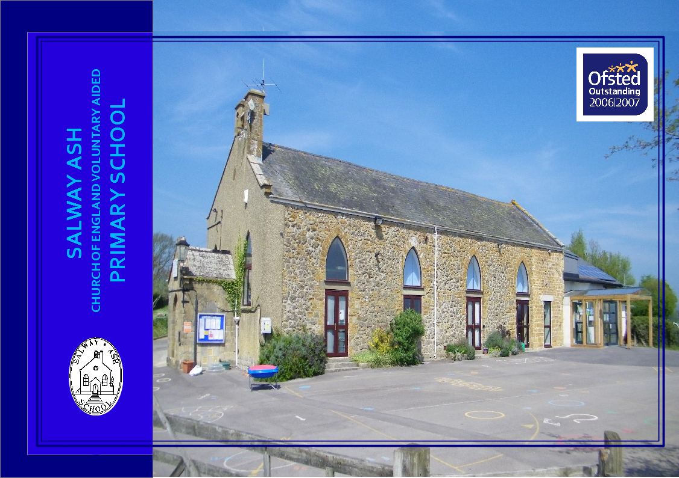

Salway Ash School, Salway Ash, Bridport, Dorset DT65JE 01308488302
www.salwayashschool.org office@salwayash.dorset.sch.uk

PROSPECTUS 2022/23
Introduction .......................................................... 3 | School uniform ..................................................... 15
The Governor’s mission statement ……………... 3 | School meals ......................................................... 16
The school curriculum .......................................... 4-9 | Transport ............................................................... 16
Homework ............................................................ 9 | Optional extras ...................................................... 17
School library ....................................................... 9 | Voluntary contributions ........................................ 17
Staff ……………………………………….......... 10 | Parents and Teacher Association ........................... 18
The Governing body .............................................. 11 | Health ................................................................... 18
Organisation of classes ......................................... 12 | Assessments and Results....................................... 19
Beaminster pyramid ............................................. 12 | Absence data .......................................................... 22
Times of school sessions ...................................... 12 | Exclusion data ........................................................ 22
Information and communications technology ...... 13 | Communications with the school ………………... 22
Pupils with disabilities and special needs …............ 14 | Admissions policy .................................................. 23
Parents’ appointments and reporting progress...... 14 | Home School Agreement ………………………… 31
Complaints Policy............................................................14 | School diary ............................................................ 32
Bullying policy ..................................................... 14 | Dorset Family Information Service................................ 33
School rules .......................................................... 15

INTRODUCTION

Leif Overment, Headteacher

Selecting a school that will provide the best education for your child is one of the most important decisions that we as parents have to make for our children.
This brochure is to provide you with information that will help you to make that choice.
You are also welcome to visit the school and see the children at work. I will be happy to answer any questions that you may have.

At Salway Ash we continually strive for outstanding results but will always place equal emphasis on helping to create happy, confident children. We have high expectations of our children and enjoy watching them live up to those expectations.

We look forward to welcoming you and giving you the opportunity to discover
why we are so proud of our school and all that it offers you and your child.

Let our Light Shine, As we achieve together!

Our aim at Salway Ash School is to:-
provide a supportive environment where children, staff, parents, governors and the local community all work together to attain high standards,
achieving academic, creative, spiritual, social and emotional fulfilment.
provide a secure, caring Christian ethos that enables us to grow together, learn together and inspire each other.

THE SCHOOL CURRICULUM
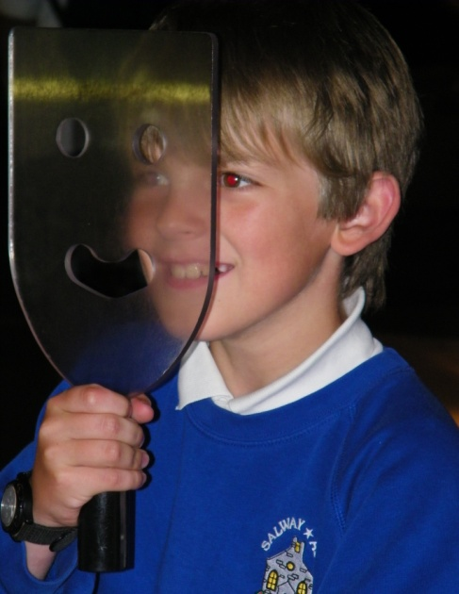
The Department for Education set out a new framework for the National Curriculum at Key Stages 1 and 2 from September 2014.
Teachers carefully plan work to cover all curriculum subjects in order to give as broad a base as possible. Throughout the year interesting and exciting work is produced by the children through following the National Curriculum and completing termly topics.

The core subjects of numeracy and literacy are taught on a daily basis throughout the school year and through other subjects.
Science is also a core subject and is taught weekly. Foundation subjects are: Art and Design, Computing, Design and Technology,
Geography, History, Music and Physical Education. A Foreign Language, in our school this is French, is also compulsory at
Key Stage 2. In addition, we are required to teach Religious Education to both Key Stages and Early Years Foundation Stage.
According to statutory requirements, children are formally tested (SATs) towards the end of Year 6 in English and Mathematics, and teacher assessed for Science.
They are also teacher assessed towards the end of Year 2 for English, Mathematics and Science.
Children are given a statutory Phonics screening test at the end of year 1 and a statutory times tables test at the end of year 4. Children in Reception complete the Reception Baseline Assessment in the first six weeks of their first term in school.
Although it is not a legal requirement, we are assessing all of our pupils throughout the year, in order to ensure excellent progress across all areas of the curriculum.

ENGLISH
Literacy is taught daily in each class often connected to a class topic. Our aim is to develop an understanding of the spoken and written word enabling children to express feeling and meaning clearly.

READING:
We recognise that some children will begin school having already acquired many reading skills. This will be valued and recorded by the teacher and will be built upon.
Children are taught to read in school through a systematic synthetic phonics programme. This is supplemented by other reading material at the appropriate level.
By the time the children have reached Years 3, 4, 5, and 6 they are well into the routine of selecting books and recording what they have read. They will then move on to 'free readers' when a good standard of fluency and comprehension has been reached. The school uses a software system called ‘Accelerated Reader’. This allows teachers and parents to keep track of pupil’s progress in reading comprehension, whilst also ensuring they regularly read books which are appropriate to their ability and age.

YOU HAVE AN IMPORTANT PART TO PLAY!
Set aside a time during the evening when you are able to devote your attention to helping your child to read.
Share the enjoyment of the story and boost your child’s confidence with constant praise for even the smallest achievement.

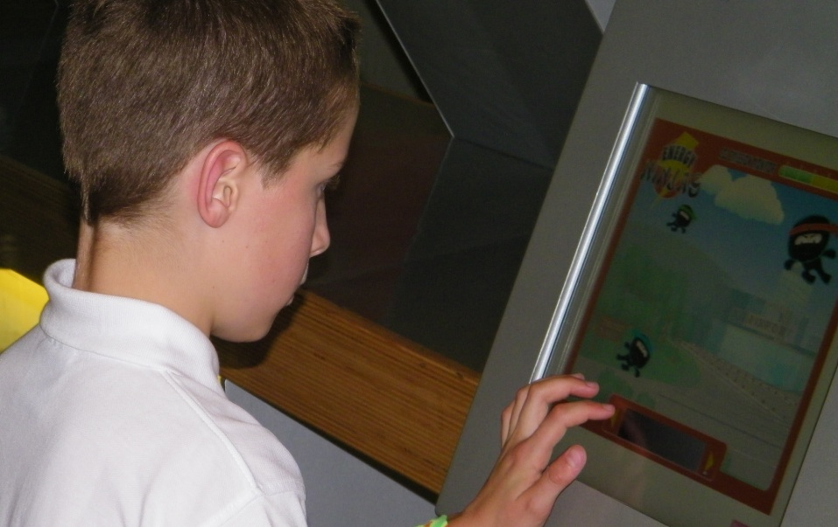
MATHEMATICS

Mathematics is taught on a daily basis. Each class has a clear programme of work,
which they follow according to the child’s level of ability.
We know that basic numeracy skills are the foundation for success at a later stage of development,
as such, a good mix of basic routine work and investigational skills are included in our lessons.

You can help us to help your child become competent with numeracy.
Help them enjoy using numbers in everyday life by familiarity with telling the time,
understanding money, number puzzles and games. Also regular practice with times tables is
essential.

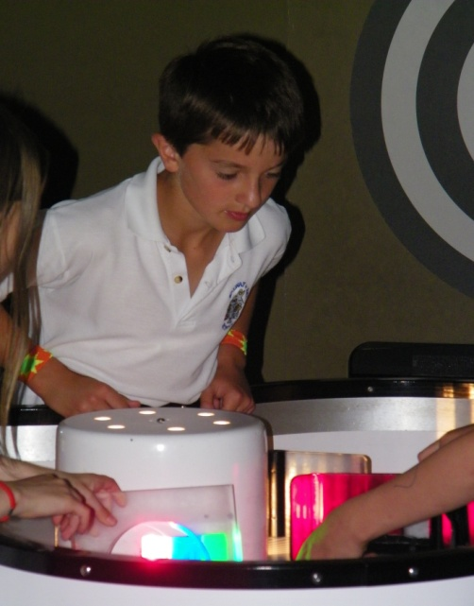
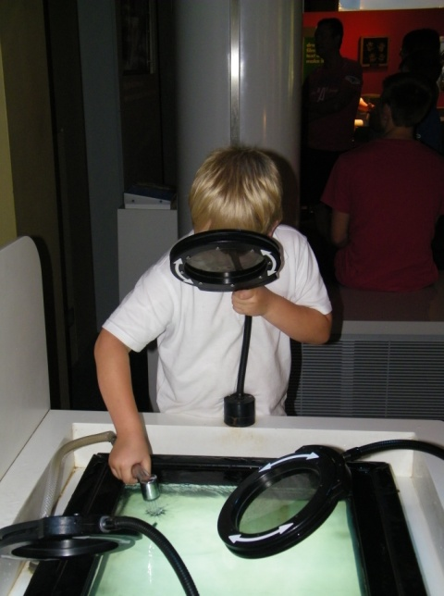

SCIENCE
The aim of science education in the school is to encourage the children’s natural curiosity through experimentation, observation and investigation to make sense of the world around them. Teachers endeavour to make it fun and interactive including a mix of practical activities and investigations and recording of results, which enable children to gain first-hand knowledge and experience.

In their early years the children will encounter key ideas and concepts in simple form and then will continue to build on these to develop a higher level of understanding.

Science in the school is taught through ‘units of work’ and follows a two-year rolling programme and as in all areas follows the National Curriculum Guidelines.

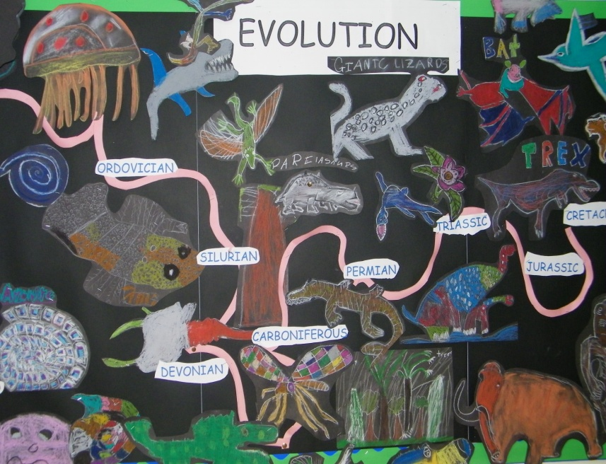
Examples of topics:

Geography, History and Science
Reception, Years 1 and 2: Houses and homes, Penguins, Explorers, Toys, WW2, Everyday materials, Plants, Animals, Seasonal changes, Living things and their habitats, Weather, Local geography, Seaside, Food, Kampong Ayer, Charles in prison, Greatest history maker, Sappho.

Years 3 and 4: Ancient Britons, Bronze Age, Iron Age, Jungles, Mega cities, Local geography, Romans, Sustainability, Anglo Saxons, Earthquakes, Vikings, Magic kingdom.
Years 5 and 6: Fair trade, Mayans, Climate change, British Empire, National Parks, Local history, Rivers, Trojan horse, Chinese mystery, Volcanoes, Mountains, Battle of Britain.

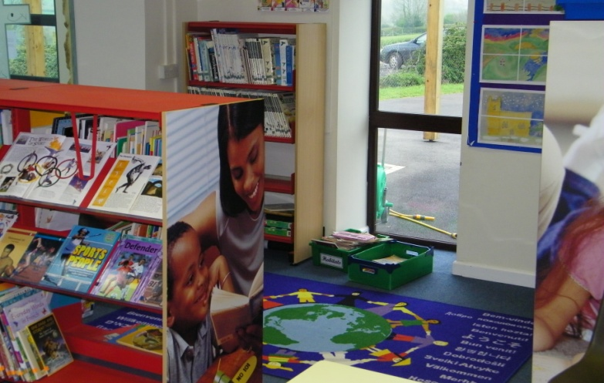

Examples of I.C.T. areas of work
Reception, Years 1 and 2: Create and debug simple programs, plan a route on ‘Beebot’,create, store
and retrieve digital content, keep personal information safe. concerns.
Years 3 and 4: Design programs that accomplish specific goals, Debug programs, Use logical reasoning
to detect and correct errors in programs, select appropriate software, select, use and combine
internet services, analyse, evaluate, collect and present data, know how to get support with internet/online and recognise acceptable/unacceptable behaviour when using technologies.
Years 5 and 6: Solve problems by decomposing them into smaller parts , use logical reasoning to explain
how some simple algorithms work, appreciate how search results are ranked, multi-media presentations,
understand computer networks, select, use and combine software on a range of digital devices, be
discerning in evaluating digital content.

Examples of Design & Technology areas of work
Reception, Years 1 and 2: Puppets, Make a 3D picture, Moving vehicles, Food design, Construction kits
Years 3 and 4: Food, Packaging, 3D model making (linked to History, Geography and Science topics)
Years 5 and 6: Design, Make and Evaluate Products, (Linked with Geography/History/Food Tech. /Science topics), Appropriate use of Tools and Materials
P.E. & Games
Physical Education is a real strength at Salway Ash.
The school has very successful school teams which compete against other primary and middle
schools. There are many opportunities for pupils to enter area and district sporting competitions, for example in cross
country running, swimming, gymnastics, tennis and golf.
In the early years, lessons are designed to improve hand and eye skills through a variety of activities such as group games, individual exercises and using and exploring apparatus.
As children reach Key Stage 2, they are introduced to games which require specific skills in particular football, netball, cricket, tag rugby, uni-hoc and short tennis.
All children attend school swimming lessons held at Bridport Leisure Centre. Children and teachers are transported by bus and lessons are run by trained instructors. Voluntary contributions are requested to cover transport and tuition costs.
In 2013, 2014, 2015, 2016 and 2017 the school has been awarded the GOLD School Games Kitemark for PE and Sport. In 2018 , 2019 and 2020 we received the top Platinum Award, one of only a very few in Dorset.
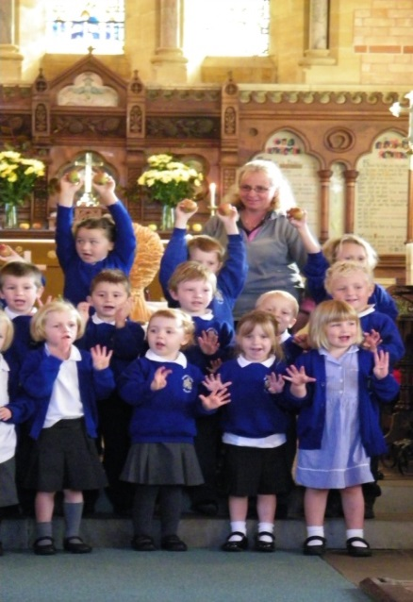
Religious Education and Collective Worship
As a Church of England Voluntary Aided (VA) School we maintain strong links with the Church. We carry a strong Christian ethos, building upon children’s fundamental unity, sensitivity to difference and the faiths of others. Our Christian values of Love, Hope, Peace, Endurance, Forgiveness, Humility, Compassion and Justice create an ethos within the school where all children are valued equally, we work together as a team and all seek to achieve their potential. Our values and vision statement are explored in the context of biblical stories so we can root our values in biblical precedents.
As part of our tradition we invite you to join us to celebrate traditional festivals in our village Church. Every day we hold an assembly (collective worship) and often welcome outside speakers. Friday Celebration assemblies are held to recognise children's achievements and parents are welcome to attend. Children love to demonstrate what they have been learning and grow increasingly confident with doing this. Each week certificates are awarded for particular accomplishments. Amongst these are ‘British Values’. RE lessons are designed to provoke thought and enquiry in a religious context and to inform the children about Christianity, along with other important World faiths. We hope to broaden children’s horizons and through understanding, lay the groundwork for a more tolerant and informed society. Parents are entitled, on application to the headteacher, to withdraw their children from collective worship. In such an event your child will not be made to feel isolated or ‘different’.

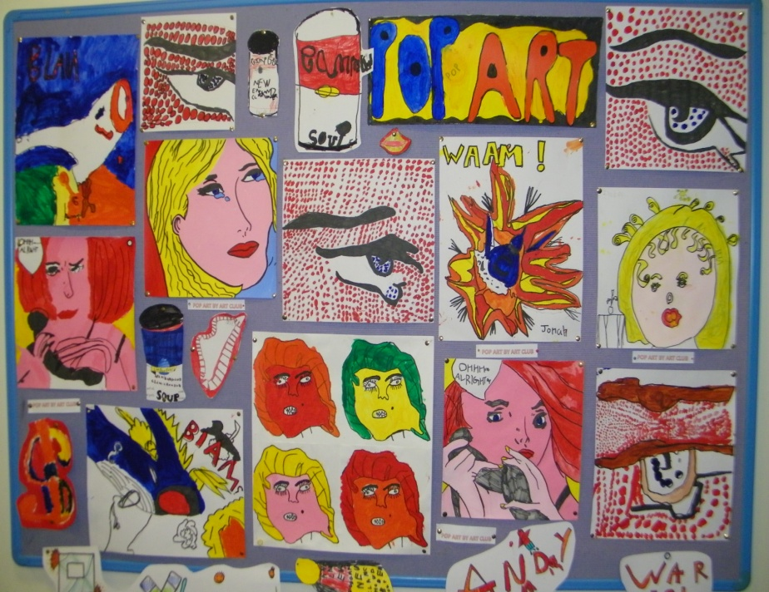
Art
All children possess a creative instinct. Throughout the course of their education at this school children will be encouraged to undertake Art and Craft projects which encourage independence of thought and action and involves them in exercising choice and making decisions.

Children are directed towards observing, recording and expressing the natural and manufactured world through a variety of media to develop practical skills.

We enable our children to become visually literate, to understand and use art as a form of visual and tactile communication and to give them opportunities to enjoy and express themselves.

They are also given the opportunity to discover the work of famous artists past and present.
We encourage involvement with local artists and liaison with other schools.

Music
There is a strong tradition of music at Salway Ash School which we aim to maintain and develop.
Throughout the school every child is given an opportunity to express themselves through music.
Children experience performing, composing, listening and appraising music.

Singing plays a prominent part in school and it is wonderful to hear the children singing in assemblies, performances and concerts.
We find it very rewarding that many children have the confidence to sing or play solo in these events.

Through being actively involved in music-making, children learn about the main elements of music, about music of different styles and from a range of times and places.

All pupils in year 4 are loaned an instrument for 10 weeks and given free tuition during school time in order to have a taster in playing an instrument. There is then the opportunity to carry on with lessons if so desired.
A team of visiting instrumental teachers offer tuition in woodwind, piano, drums, brass and strings. A charge is made for this tuition and information can be obtained from the school office.

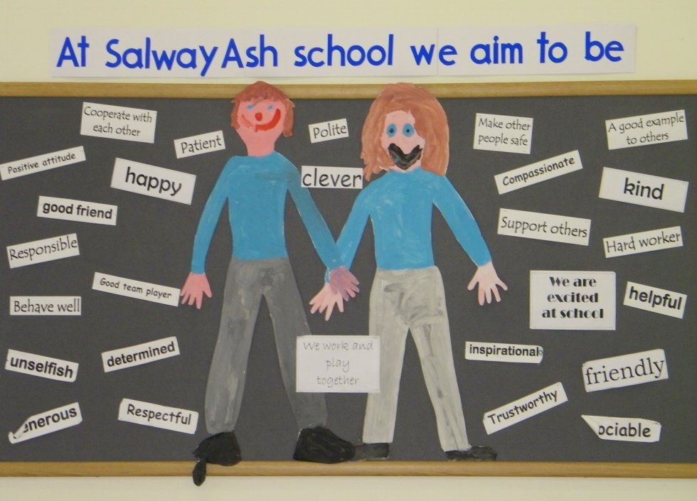
Sex Education and Personal Relationships
At Salway Ash pupils develop an awareness of self and sensitivity to others and acquire the confidence to make and hold moral judgements.

Personal and social relationships and health education are integral parts of day to day teaching. Children are encouraged in habits of self-discipline and acceptable behaviour within a family oriented and Christian framework.

Efforts are made to encourage straightforward discussion in order to develop constructive attitudes in these areas.
In Years 5 and 6 child development and puberty are discussed to prepare children to cope with the physical and emotional challenges of growing up and to give them an understanding of human reproduction. Through this programme children will explore how to make and maintain relationships with their families and peers, to learn respect for themselves and for others.
Parents have the right, on application to the headteacher, to withdraw their children from all or part of the sex education programme (but not from teaching of biological aspects of human growth and reproduction, which are required under the national curriculum for science).

HOMEWORK
The class teacher will set homework relating to a curriculum area or topic currently being studied within the class. In the first years, this is likely to be reading and letter recognition tasks. Later it may consist of an art and design task, reading, research, writing, spellings or a mathematics related task.
We hope that you will take an interest in the homework set and encourage your child to talk about the work they do in school. We always appreciate parental involvement in children’s learning. Online programmes such as Sumdog and Accelerated Reader are often used to facilitate homework tasks.
PARTNERSHIP WITH PARENTS
It is very important to keep parents informed as much as possible on aspects of learning taking place in school. During past years we have run parent information sessions on teaching reading, phonics, writing, mathematics, internet safety and the School Development Plan. These have been well attended and feedback indicates that parents have found them very informative and useful. Detailed information across all school areas is documented on the school website.
SCHOOL LIBRARY
The school has a library situated in a quiet and comfortable area. It is stocked with a wide range of high quality fiction and non-fiction books. A large selection of these books are also part of our Accelerated Reader scheme. This means they are clearly labelled in order to help our pupils to select suitable reading material for their age and reading ability. Children are encouraged to use the library as often as they wish and to join in with poetry and story reading clubs.
STAFF
Teaching staff
Headteacher: Mr L Overment Designated Safeguarding Lead, Co-ordinator for Collective Worship, English, Assessment, Health & Safety.

Early Years Foundation Stage (EYFS)
Miss J Emmett Co-ordinator – Early Years & RE.

KS1:
Mrs H Thomson Co-ordinator – PE, History & Geography
Mrs T Murray Co-ordinator - PSHE, Art, Design and Technology

KS2:
Mrs K French Co-ordinator – Science, Computing
Mrs E Smith SENCO, Deputy Designated Safeguarding Lead , Co-ordinator - Mathematics, Music

Cover Supervisors and Teaching Assistants:
Mrs H Aburrow
Mrs M Riani
Mrs D Phillips
Mrs R Mackay
Miss L.M House
Mrs M Harrison (1:1)

ICT Technician
Mr. D. Harris

Administrative staff
Mrs L Stanton Finance Officer
Mrs J Huxter Administrator
Playground & lunchtime supervisors
Mrs D Roberts, Mrs S Huxter, Mrs G England
THE GOVERNING BODY
School Governors are in place to act as a 'critical friend' to the school. The governors at Salway Ash are very committed and take great pride in their role.
Communication between governors and parents is valued and there is always an item on each meeting's agenda for items parents wish to raise.
Please contact the Clerk to Governors or a parent governor.

Category of Governor Number Name of Governor
Foundation Governor 7 Mr D Stanton Chair

Mr M Best
Mrs. E Brown
Mrs. V. Holland
Mr. R Pepper vice chair
Ex-Officio Rev'd J Neary

Dorset LEA Governor 1

Parent Governors 2 Miss H Skelton Parent
Mrs C Murless Parent Joint vice chair

Staff Governor 1 Mrs H Aburrow

Headteacher 1 Mr L Overment

The chair of the governing body is Mr D Stanton.
Correspondence should be addressed to Salway Ash CE VA Primary School, Salway Ash Bridport Dorset DT6 5JE.
Clerk to Governors: governors@salwayash.dorset.sch.uk

The Headteacher is the designated person for any issues relating to child protection.
Our first priority is your child’s welfare and we will usually discuss any concerns we might have about your child with you.
There may be occasions, however, when we have to provide information to or consult other agencies such as Children’s Social Care before contacting you.
Our responsibility to do so is outlined in the Sept. 2021 document ‘Keeping Children Safe in Education’ If you want to know more about these procedures, please speak to the Headteacher.
ORGANISATION OF CLASSES
With an age range of seven years (4-11 years) the children are taught in four classes.

Reception/Yr.1 4-5 and 5-6 years Miss Emmett
Years 1/2 5-6 and 6-7 years Mrs H Thomson/Mrs T Murray
Years 3/4 7-8 and 8-9 years Mrs K French
Years 5/6 9-10 and 10-11 years Mrs E Smith

At the end of year 6, children transfer to secondary school. For our pyramid this is Beaminster Comprehensive School. However, parents can choose alternative
secondary school provision if they wish.

TIMES OF SCHOOL SESSIONS

Registration is taken at 8.55am. Classes finish at the following times:
Reception, Year 1 and Year 2: 3.15pm
Year 3, Year 4, Year 5 and Year 6: 3.30pm

Children will not be allowed to leave the premises at any time during sessions unless a parent gives written or verbal permission.

WEST DORSET COLLABORATION AND BEAMINSTER PYRAMID PARTNERSHIPS
Our school regularly joins with neighbouring schools within these partnerships and enjoys engaging in many activities with them. This includes professional development for staff, music and sporting events, as well as academic days on particular themes or curriculum subjects.

Partnership members are: Beaminster School Symondsbury CE VA Primary Powerstock CE VA Primary
Salway Ash CE VA Primary Parrett & Axe CE VA Primary Thorner’s CE VA Primary
Broadwindsor CE VC Primary Stickland’s CE VA Primary Charmouth Primary
Greenford CE VC Primary Beaminster St. Mary’s Academy
Computing At School
We have an ICT suite which has greatly increased the ICT provision for the pupils. Laptops and computers are installed in each classroom. There are also 32 ipads for the children to use. In the year 5 and 6 class each child has their own laptop which remains with them until they leave the school.
We provide opportunities for all of our pupils to become computer literate and to use all available resources with confidence and understanding. The children are also encouraged to make contributions to the school website so that parents can share in the successes of our school.

Our hardware and software are updated at regular intervals and we are helped in this by the generosity of the P.T.A.
These combined resources provide an excellent bank of hardware for the children to work on. The computers in the suite are also available for parents to use, for example, in order to fill in applications for school placements, ordering school meals or adult learning courses etc.
Every class has an interactive whiteboard.

Located in the main corridor is a wide screen TV which keeps parents updated on past and future events coming up in school.

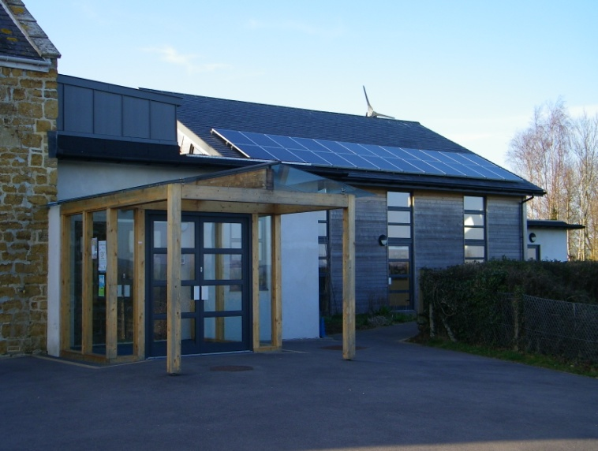
PUPILS WITH DISABILITIES AND PUPILS WITH SPECIAL EDUCATIONAL NEEDS
The school is committed to equal opportunities for all pupils and enabling those with physical disabilities access to the everyday activities in the school. The school is on a single floor for the pupils enabling access for pupils with a physical disability. Where there are particular needs, physical adaptations will be made to the school environment, as and when they arise.

Mrs Smith is our special educational needs co-ordinator and our five teaching assistants and specialist
SEN teacher support pupils in our four class bases.
The school has developed a comprehensive policy for special educational needs and our policies and procedures are subject to regular evaluation and audit. Parents are involved throughout and can see the policy at the school on request or via the website. Our SEN policy includes the current guidelines for identifying, assessing and providing for pupils with special educational needs. Information
about our ‘Local Offer’ is on Dorset’s Family Information Directory.
The school liaises with various support services through the Dorset Educational partnership, for example the Educational Psychology service. Information regarding Dorset's funding and provision arrangements for children with special educational needs is available at www.dorsetcc.gov.uk/educ/sen.

PARENT APPOINTMENTS and REPORTING PROGRESS
We hope parents will feel comfortable to contact teachers and/or the Headteacher at any time, if concerned about their child’s progress.
Parents’ appointments are held in the autumn and spring terms to enable parents to discuss their child’s progress and future targets with the class teacher. In the summer term there is an open afternoon for parents to look at work and discuss progress.
This does not mean that teachers are available only at formal appointment times.

At the end of the school year each child receives a written report which highlights their progress over the year.
When a pupil finishes year 1 they receive a report on the phonics screening assessment. At the end of year 4 a report on the times tables test.
At the end of year 2 and year 6 national comparisons are given to parents by the Department for Education in order to gauge their child’s and the school’s performance.

COMPLAINTS
The school will endeavour to satisfy any concerns or enquiries as soon as they are raised.
If a parent is not satisfied with the response that they have received, they may lodge a formal complaint.
The procedure will depend on the nature of the complaint and the headteacher will give advice about this on request.
A copy of the School Policy for Complaints Procedures is available on request from the school office and available on the school website.

BULLYING POLICY
In our school instances of bullying are rare.
Bullying in any form, whether verbal, physical, psychological or by using technology will not be tolerated and in cases where we know it to be happening, swift action will be taken. If as a parent you come to know of such matters or if your child appears to be unhappy about attending school, please let us know.
Bullying can only be tackled if someone else knows about it. All children are encouraged to tell us if they feel threatened or uncomfortable in any way. The headteacher will always be available to discuss such matters with parents should the need arise.
If further information is required please ask for a copy of the school’s anti-bullying policy

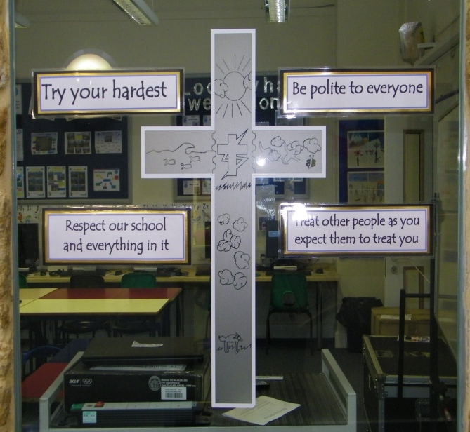
SCHOOL RULES
The school aims to keep rules to a minimum. The school council decides on the 'Golden Rules'
This year these are:
Respect our school and everything in it.
Try your Hardest.
Be Polite to everyone.
Treat other people as you expect them to treat you.

Our guidelines for acceptable behaviour are that children show respect, courtesy and kindness to all people at all times.
All children are required to behave in a sensible manner showing courtesy to everyone. No form of bullying will be tolerated and the school insists on the need for children to respect all property at all times.

This means that children are expected to:

1) respect everyone’s right to feel safe in and around the school environment,
2) make it as easy as possible for everyone to learn and for the teachers to teach,
3) have respect for other people’s property,
4) show respect to all staff carrying out their requests without argument,
5) be considerate and caring toward others.

Parents are asked not to allow their children to wear jewellery or to bring large amounts of money to school. Wristwatches may be worn at the owner’s risk.
Incidences of poor behaviour are very rare in this school. If sanctions are necessary, children may miss a playtime, or several playtimes — and parents would be informed.

SCHOOL UNIFORM
Boys - Grey trousers or shorts, white shirt, blue sweatshirt with school logo, grey socks
Black shoes — sensible shoes that provide good support (no trainers)
Girls- Grey skirt or pinafore dress, black/grey trousers, white polo-shirt, blue sweatshirt/cardigan with school logo, grey/white socks
Summer uniform - royal blue gingham (checked) dress (any style)
Black shoes — sensible shoes that provide good support (i.e. no wedge heels/jellies or trainers)

PE Kit - All children- Gym shoes (non-black soles), navy blue or black shorts, and pale blue T-shirts with school logo (in a named bag).
The football team will also need football boots and football socks.
Swimming — girls need a one-piece swimming costume.
Please note - All items of clothing should be clearly marked. Tracksuits are advised for winter outdoor sports.
NB - Those eligible for Pupil Premium are entitled to a clothing grant equivalent to 2 sweatshirts, a P.E T-shirt and a book bag every year.

SCHOOL MEALS We have ‘Healthy School’ status and therefore encourage healthy eating.
We are very fortunate to be supplied with hot school meals by Local Food Links in Bridport.
They are delivered hot and served straight away with no reheating needed. The meals are sourced locally whenever possible and are of high nutritional value. All children in KS1 and Reception receive a free hot meal every day with a choice from three available meals (vegetarian option available) .Parents of children in KS2 can order on-line from a four weeks menu, at a cost of £2.30 per meal.

Pupils can mix and match hot meals with packed lunches as suits. Packed lunches should be brought into school in a plastic container/lunchbox.
During the colder winter months the children may bring hot drinks in an unbreakable vacuum flask.
We prefer that no canned drinks, sweets, nuts or chocolate are brought into school.

Free school meals are available to the children of parents receiving certain benefits eg: Job Seekers allowance. Information can be obtained from the school. These children receive Pupil Premium Funding and there is more information about the benefits of this funding for the children on our school website.

Fruit is provided for reception and key stage 1 pupils as a mid-morning snack. There is also fruit for key stage 2 pupils for a nominal charge.

Children are encouraged to drink water during the day from their water bottles.
TRANSPORT
The school buses serve the children from Melplash, Netherbury and Salway Ash.
No transport however is provided for children living outside the catchment area.
The basis for deciding a child’s entitlement to free transport is the distance from the child’s home to the school and varies with the child’s age.
In Dorset the qualifying distances from school for free transport are as follows:
Children aged 5-8 years 2 miles
Children aged 9 -16 years 3 miles
Children are not escorted on these journeys, it is their responsibility to behave sensibly and safely, and we ask parents to support and reinforce this.

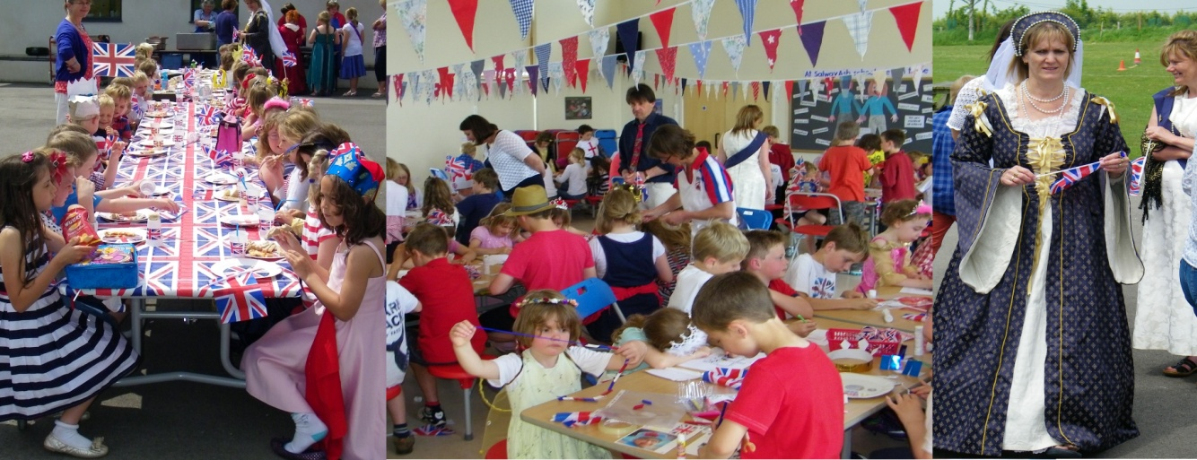
OPTIONAL EXTRAS
There are a variety of extra curricular activities available
to children during their time at Salway Ash School.
We hope that at least one of these will appeal to each
child. The clubs vary according to times of the year,
staff availability and skills. They often include; running, gym, art, band, choir, gardening, football and dance.
Information via email, text and newsletters is sent out regularly regarding these.

VOLUNTARY CONTRIBUTIONS

Voluntary contributions may be requested in the following circumstances:

1. For board and lodging when children are taking part in residential visits. The school can advise about
exemptions for families in the receipt of certain benefits.
2. Contributions towards the cost of materials/ingredients needed for an item that parents wish their
child to take home and keep.
3. Trips arranged by the school. (Travel costs, board and lodging, materials, entrance fees to museums, etc.)
Participation in such activities is on the basis of parental choice.
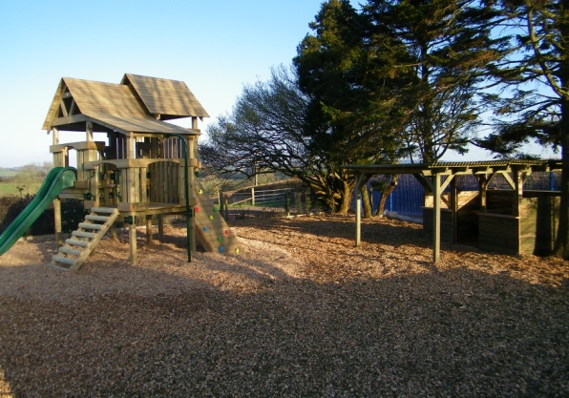
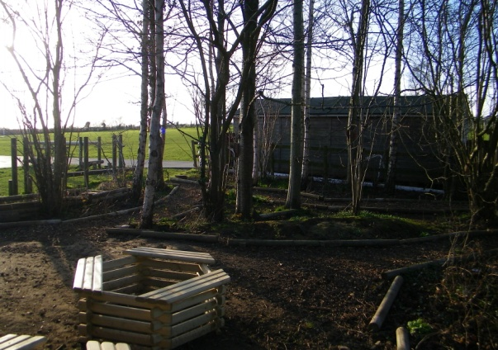
PARENT TEACHER ASSOCIATION (PTA)
Staff can always think of equipment they would like, but are restricted by the school budget. The PTA raises additional funds to enhance the children’s education.

All parents are automatically members of the PTA and meetings are open to all members. Events can only take place with the support of parents. The PTA hope that the parents of every child at the school will get involved with fund-raising events and offer support and ideas at PTA meetings.

The school very much values the PTA.
Please see the school website for further information.
Our outdoor play equipment (July 2017) and Conservation area were PTA projects.

HEALTH
The school nurse comes to school to complete various statutory NHS tests. These include height and weight screenings and hearing tests. Parents are always informed in order to give their consent..
Medicines should only be brought to the school if prescribed by a Doctor with a letter stating that the medicine is necessary. Such medicines should be clearly labelled with the child’s name, stating the dose and time of administration.
Children are not allowed to keep medications (except inhalers) in their own possession. If your child has to take a prescribed drug during school time parents should discuss the matter with the class teacher and/or headteacher and an ‘Administration of Medicine/Treatment’ consent form must be completed.

From time to time any school experiences an outbreak of head lice. We like to be very matter of fact about this and we do not regard it as anything unusual. In the event of your child catching head lice, and in the case of it being identified at school, you will be informed. Your vigilance will help to confine any outbreak.

We try to ensure that the children are supervised at all times but unfortunately accidents do happen. All injuries are recorded and dealt with appropriately. We have six trained first aiders. Unless the injury is very minor, you will be informed (and always where there has been injury to the head).
For this reason, it is important that we have a contact telephone number for reaching parents and that these are kept up to date.
Please make sure you inform us if you change your mobile phone number as we have a parent information service using this number.

NATIONAL CURRICLUM ASSESSMENT AT KEY STAGES 1 AND 2

Testing is a statutory requirement that helps the school to assess the progress each child is making.
Results from the tests will form part of your child’s record of attainment.

Each year all pupils who have reached the end of Key Stage 1 (Year 2) are teacher assessed in Mathematics, Science Reading and writing.
SATs tests for Year 6 are administered during a prescribed week in May.
Parents are requested to ensure that their children attend school during the week when the children are being tested. Dates of the tests will be sent out in newsletters during the year and parents may obtain this information directly from the school office.

We also test children in Years 3, 4 and 5 during May but this is not a statutory requirement.

At the end of year 1 the children are screened for their phonics knowledge. Below is a table to show 2021 percentage pass rate for the school compared to provisional national figures. In 2021 there were 16 Year 1 Pupils.

DUE TO COVID-19 LOCKDOWN NO PHONICS TEST WAS TAKEN IN 2020

 | Passed (%) | Did not pass (%) | Absent | Test not taken (%)
National
Salway Ash

Key Stage One Results

Below is the table of attainment following teacher assessment in 2021. In that year the number of eligible 7 year old pupils in the final year of Key Stage 1 was 16. No pupils were disapplied. The table shows the percentage of pupils reaching the expected standard and above and ‘Greater Depth Standard’ (GDS). For comparison the national results for 2019 are provided.

DUE TO COVID-19 THERE WAS NO END OF KEY STAGE 1 ASSESSMENT IN 2020 OR 2021

 | Salway Ash School |  | National Results
 | Expected Standard and above | Greater Depth Standard (GDS) | Expected Standard and above | Greater Depth Standard (GDS)
 | % | % | % | %
Reading
Writing
Mathematics

Key stage Two Results

In 2021 the number of eligible 11-year-old pupils in the final year of Key Stage 2 was 21. The table below shows the percentage of year 6 pupils achieving the expected standard `and a ‘Greater Depth’ standard compared to provisional national end of Key Stage 2 figures. Please note writing and science are teacher assessed as there are no national statutory tests for these areas.

DUE TO COVID-19 THERE WAS NO END OF KEY STAGE 2 ASSESSMENT IN 2020 OR 2021

 | Expected Standard and above | Greater Depth Standard (GDS) | Average Scale  Score per  pupil
School English grammar, punctuation, and spelling
National English grammar, punctuation, and spelling
School reading
National reading
School mathematics
National mathematics
School writing (Teacher assessment)
National writing (Teacher assessment)
School science
National science
School Reading, Writing and Maths combined
National Reading, Writing and Maths combined
ABSENCE DATA

 | 2020/2021  DUE TO COVID-19 THERE IS NO ABSENCE DATA | 2019/2020  DUE TO COVID-19 THERE IS NO ABSENCE DATA | 2018/19
Total number of children on roll. | 117 | 117 | 116
Percentage of half days missed through absence that was:
Authorised: |  |  | 2.6%
Unauthorised: |  |  | 0.5%
EXCLUSIONS
No child has ever been excluded from the school.
This is an enviable record and one that staff and governors very much expect to retain.
COMMUNICATIONS WITH THE SCHOOL
As the School serves a scattered catchment area, newsletters are sent out, which inform parents of events that take place at the school.
Parents sometimes have problems or queries concerning their children and if these can be dealt with on the telephone the most convenient times to speak to teaching staff are 8.30am and 3.30pm.
The office also has an answer phone, which we hope you will use if necessary. Tel 01308 488302.
You may also contact the school by e-mail at office@salwayash.dorset.sch.uk.
Newsletters are also sent out via email.
Short messages and reminders are also sent to parents via text messaging. ‘ESchools’ is our school learning platform where you will find parent information and homework set for your child.’Tapestry’ is our online platform for Reception pupils. Families can keep up to date on the developmental progress of their child and also send in to the class teacher any achievements completed at home.
The most convenient time to see the headteacher personally is before or after school, but please do not feel that you are restricted to that time.
The headteacher will always try to make time to see you.
You may also wish to visit our website which has a great deal of information for you about the school and your child’s learning. This can be found at www.salwayashschool.org

Admissions Policy 2022-23
Salway Ash Primary School
- Introduction

- The governing body of Salway Ash school is the admission authority and responsible for the admission arrangements of the School. School governors have agreed that Dorset County Council will carry out the following procedures on the schools behalf. This document sets out the admission arrangements of the School for the academic year 2022/2023.

- The published admission number (PAN) for entry into the School is 15.The School will admit up to the PAN in the normal year of entry which is the Reception year. Where there are more applications for admission than places available at the School, then places will be offered in accordance with the oversubscription criteria at section 3 of this policy.

- Infant Class Size Regulations apply to the normal year of entry (and Year 1 and Year 2). These regulations require classes to be no bigger than 30 children although the PAN may be much lower than 30.

- Where a child has an education, health and care plan (EHCP) which names the School, then that child will be admitted to the School and the number of available places in the PAN will reduce correspondingly. Admission of children with an EHCP is dealt with by the home Local Authority (LA) Dorset County Council.

- When applying to start school in Reception in September 2022 you must apply to Dorset County Council. All applications for first admission must be received by the LA by the closing date of 15 January 2022. The LA will make a single offer of a place on 16 April 2022 (or next working day).

- Religious Character of the School

- The School is designated with a religious character. The School’s religious authority is the Diocese of Salisbury. The School must have regard to its religious authority when setting the terms of its admission arrangements.

- Recognising its historic foundation, the School will preserve and develop its religious character in accordance with the principles of the Church of England and in partnership with the churches at parish and diocesan level. The School aims to support children and their families by providing an education of the highest quality within the context of Christian belief and practice. It encourages an understanding of the meaning and significance of faith and promotes Christian values through the experience it offers to all its pupils.

- Oversubscription Criteria
Where the School is oversubscribed (there are more applicants than places available) places will be allocated in accordance with the following criteria and in the following order. Please read the explanatory notes for further guidance.
- Looked After Children or Previously Looked After Children – A child who is in the care of an LA, or was in the care of an LA but immediately after being looked after became subject to an adoption, child arrangement, or special guardianship order.

- Vulnerable Children
A child is eligible in this category where the child has an identified social or medical need.

- Children living in the Catchment Area with a sibling at the School
A child living inside the Catchment Area is eligible for this category where they have a sibling attending the School on the date of application and the sibling will still be attending the School at the time of admission.

- Children living in the Catchment Area

- Children living outside the Catchment Area with a sibling at the School
A child living outside the Catchment Area is eligible for this category where they have a sibling attending the School on the date of application and the sibling will still be attending the School at the time of admission.

- All other children
Tie Breaker

If there are not enough places to satisfy all the applications under any one criterion, priority will be given to those living nearest the School. The School will adopt the measurement system of Dorset County Council Local Authority to determine the distance from the School to the Home address. Where two or more applicants live an equal distance from the School and it is not possible to differentiate between them, priority will be determined by random allocation through the drawing of lots supervised by someone independent of the School.

Oversubscription Criteria : Explanatory Notes
Catchment Area means the geographical area from which children will be afforded priority for admission to the School. A map indicating the Catchment Area which includes the Ecclesiastical Parish is available to view on the School website. A hard copy is available at the School office.
Vulnerable Children
- Medical need means where written evidence has been provided from a senior clinical medical officer or the child’s general practitioner / specialist showing that the child’s condition would make it detrimental to the child’s health not to admit him/her to the School. This may include written evidence where the parent has a medical need and/or disability which would make it detrimental for the child to attend a different school; this may be supported by evidence of the child as a young carer. Evidence to be relied upon must be submitted with the Supplemental Information Form and sent to the School on or before 15th January 2022.

- Social Need means where the child is of confirmed refugee status. Written evidence of this from Dorset County Council must be submitted with the Supplemental Information Form and sent to the School on or before 15th January 2022.
Sibling means brother or sister, half brother or sister, adopted brother or sister, step brother or sister, foster brother or sister, or the child of the parent/carer’s partner where the child for whom admission is sought is living in the same family unit as that sibling and at the same address.
Home address means the place where the child resides for the majority of the school week (Sunday to Thursday) with the person/s who legally has care of the child (child care arrangements are excluded). The Local Authority may require documentary evidence of house ownership or tenancy together with evidence of the child’s residency at the property.

- Supplementary Information Form (SIF)
- Where seeking priority under the vulnerable children criterion (3b) parents must fully complete the relevant part of the SIF and provide the required supporting evidence. Where relying on the vulnerable children criterion (3b) you must supply evidence to support the application.

- The SIF must be returned to the local authority admissions department or school office on or before 15th January 2022. The SIF is available on the School website or a paper copy may be requested from the School office.

- Appeals
- Where an application is unsuccessful the parents/carers have the statutory right to bring an appeal against that decision to an independent appeal panel. Details of how to appeal will be included in the letter advising that the application has been unsuccessful.

- The admission appeal timetable is published on the School’s website by 28th February each year.

- Important Information
- Waiting Lists
If the School is oversubscribed for September 2022 entry a waiting list will be maintained the entire academic year. The position of the child on the waiting list will correspond with the oversubscription criteria; it will not be based on length of time on the waiting list. The right of appeal at Section 5 remains. You may request your child’s name be removed from the waiting list at any time. If a place is offered but refused then the child’s name will be removed from the waiting list.

- Summer Born children
Summer born children (which refers to children born from 1 April to 31 August) are not required to start school until a full year after the point at which they could first have been admitted – the point at which other children in their age range are beginning year 1. Should the parent wish their child to be admitted to reception, rather than year 1, they may request that the child is admitted out of their normal age group. Please note the following:

- You must make an application for admission to the School for September 2022 entry but make it clear on the application form that you wish your child to enter the reception class in September 2023.

- Discussions with the School are strongly recommended prior to making a decision to decline entry for an entire year and to be admitted to reception in September 2023. Any decision will be on the basis of the circumstances of each case and in the best interests of the child concerned.

- If the request is agreed the September 2022 application may be withdrawn before a place is offered but a fresh application will need to be made for September 2023 entry which will be processed as a fresh application along with all other applications and in accordance with the School’s admission arrangements. PLEASE NOTE that it is possible even if the request is agreed that the child may not be admitted in September 2023 as there is no guarantee of a school place.

- If the request is refused the parent must decide whether to accept the offer of a place for the normal age group, or to refuse it and make an in year application for admission to year one for the September following the child’s fifth birthday.

- Deferred entry and part time attendance below statutory school age
A child may start at the School in the academic year in which he/she reaches the age of 5. Where the child has not yet reached statutory school age (5 years old), the child is entitled to a full time place and parents may choose for their child to attend full time. Alternatively parents may choose for their child to attend part time until their child attains compulsory school age. If parents do not consider their child is ready to start school then they may defer entry altogether to later in the school year but not beyond the point at which the child reaches compulsory school age or not beyond the beginning of the final term in the school year (whichever is the sooner).

- Admission of children outside their normal age group
Parents may seek a place for their child outside their normal age group, for example if the child is gifted and talented or has experienced problems such as ill health.

Such requests should be discussed with the Headteacher as early as possible in the admissions round associated with that child’s date of birth. This will allow the School sufficient time to make a decision regarding the request before the closing date for applications and national offer day. Decisions to admit a pupil outside their normal age group will be based on the circumstances of each case and based on what is in the best interests of the child concerned. We may request supporting professional evidence to assist in the decision-making. There is no legal requirement for this medical or educational evidence to be secured from an appropriate professional. However, failure to provide this may impede our ability to make an informed decision.

- Multiple Birth Applications
Where there are multiple birth applications the PAN will, provided it is practicable, be exceeded or increased at the point of allocation in order to ensure that multiple birth siblings can be allocated places at the School.

- Withdrawal of an Offer
The local authority may withdraw an offer where it has been offered in error, has been made on the basis of a fraudulent or intentionally misleading application, or a parent has not responded to an offer of a place within a reasonable period of time.

- In Year Admissions
- Applications for in year admission may be submitted at any time during the school year. A link to the Dorset County Council application form is on the school website or a paper copy may be requested from the School office.

- Where the School has no spaces available, because the admission of another child would prejudice the efficient education of others at the School or would prejudice the efficient use of resources, or would breach Infant Class Size Regulations, the application will be refused and a right of appeal, as set out in Section 5, will arise.

- The oversubscription criteria at section 3 will be only used where the School is considering more than one in year application at the same time and there are not enough spaces to accept all applicants.

- Further Information
- Important information published by the LA applies to some aspects of school admissions. If you are considering applying for a place at the School you are advised to refer to Dorset County Council’s website.

- If you have any questions in relation to these admission arrangements please contact the School office on 01308 488302 or office@salwayash.dorset.sch.uk.

- The School will handle all personal data in accordance with the requirements of the Data Protection Act 2018.

Home School Agreement - SALWAY ASH CE.VA.PRIMARY SCHOOL -Together we will succeed!
SCHOOL RESPONSIBILITIES
• To ensure that children receive an excellent education.
• To ensure that the school provides a safe, secure and sound learning environment.
• To provide a caring Christian ethos.
• To listen to both parents’ and children's concerns and be responsive to those concerns.
• To encourage children to do their best.
• To inform parents of their children’s progress, school activities and developments.
• To encourage a high standard of discipline. Signature (Headteacher)………………………..

PARENTS RESPONSIBILITIES
• To ensure that the children arrive on time, ready to learn and are collected promptly at the end of the day.
• To encourage children with their homework and help whenever possible.
• To send children to school in an appropriate uniform.
• To ensure that children return school property.
• To liaise with teachers regarding any of their child’s concerns. To encourage full time attendance and avoid holidays during term time.
• To encourage children with their school work.
• To attend open evenings and other meetings to discuss progress and to support events run by both the school and the P.T.A.
• To reinforce the school’s responsibilities and encourage a high standard of discipline.
• To refrain from using mobile telephones in school apart from specified events.
Signature (Parent/Guardian) ………………….
CHILDREN’S RESPONSIBILITIES
• To do my best at school.
• To take care of all school property.
• To be helpful, kind and respectful to all children and staff.
• To do my homework on time.
• To keep the school free from litter.
• To behave sensibly on the school bus. Signature (Child)………………………….......

Please note. This is a voluntary agreement and you are under no legal obligation to sign.
However it would be helpful to all involved in school life if you do. Thank you in anticipation.

Operation Encompass

The school has taken up the opportunity to take part in a project that will run jointly between schools and Dorset Police.

Operation Encompass is the notification to schools when a child or young person has experienced any domestic abuse, this information will be shared with the schools.

Operation Encompass will ensure that senior safeguarding members of the school staff, Designated Safeguarding Lead and Deputy Designated Safeguarding Lead, known as Key Adults, are trained to allow them to receive information from the police and to use the information that has been shared, in confidence, while ensuring that the school is able to make provision for possible difficulties experienced by children, or their families, who have been involved in a domestic abuse incident.

We are keen to offer the best support possible to all our pupils and we believe this will be extremely beneficial for all those involved.

TERM DATES FOR THE ACADEMIC YEAR 2022/23

Autumn term starts | Thursday 1 September 2022
Autumn half term | Monday 24 October 2022 to  Friday 28 October 2022
Autumn term ends | Friday 16 December 2022
Christmas holiday | Monday 19 December 2022 to  Monday 2 January 2023

Spring term dates 2022 to 2023
Event | Date
Spring term starts | Tuesday 3 January 2023
Spring half term | Monday 13 February 2023 to  Friday 17 February 2023
Spring term ends | Friday 31 March 2023
Easter holiday | Monday 3 April 2023 to  Friday 14 April 2023

Summer term dates 2022 to 2023
Event | Date
Summer term starts | Monday 17 April 2023
Summer half term | Monday 29 May 2023 to  Friday 2 June 2023
Summer term ends | Friday 21 July 2023
Summer holiday | Monday 24 July 2023 to  Thursday 31 August 2023

The Dorset Family Information Service

The Family Information Service providing information to parents, carers and professionals on:-
• Registered before / after school clubs and childminders
• Registered childcare for under 5’s
• Activities for 0-19 year olds
• Parent and toddler groups / activities for pre-school age children
• Information on help with costs of childcare
• Play parks / skate parks
• Local and national support groups

Contact Details
• Tel: 01305 221066 Helpline open 8am – 7pm, Monday to Friday

• Email: familyinfo@dorsetcc.gov.uk

• Website: www.dorsetforyou.com/fis
Then

