07 February 2017

Dear Parents and Carers,

Over the last year or so, we have seen quite a change in the make-up of our Governing Body, so I would like to bring you up to date with developments. Our new recruits are:

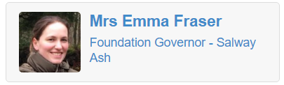

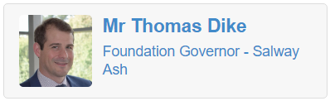

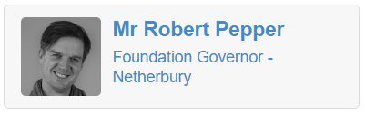

Our new governors bring an excellent set of professional skills to the team along with an enthusiasm to support the school to the best of their ability. We have a strong and capable Governing Body that the school should be proud of and I would like to thank all the governors for the time and effort that they give to the school.

Our West Dorset Schools Collaboration continues to develop and has produced its first newsletter which you will see overleaf. To remind you, the collaboration includes:

- Salway Ash Primary
- Sticklands Primary (Evershot)
- Greenford Primary (Maiden Newton)
- Parrett and Axe Primary (Mosterton)
- Broadwindsor Primary
- Thorner’s Primary (Litton Cheney)
- Powerstock Primary
- Symondsbury Primary
- Beaminster School

With kind regards,
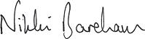

Nikki Bareham
Chair of Governors
governors@salwayash.dorset.sch.uk

