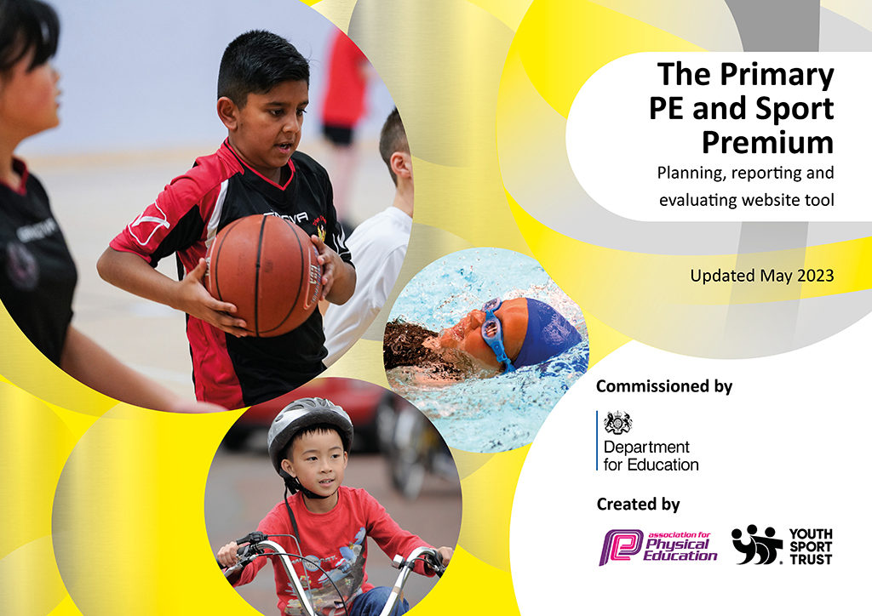
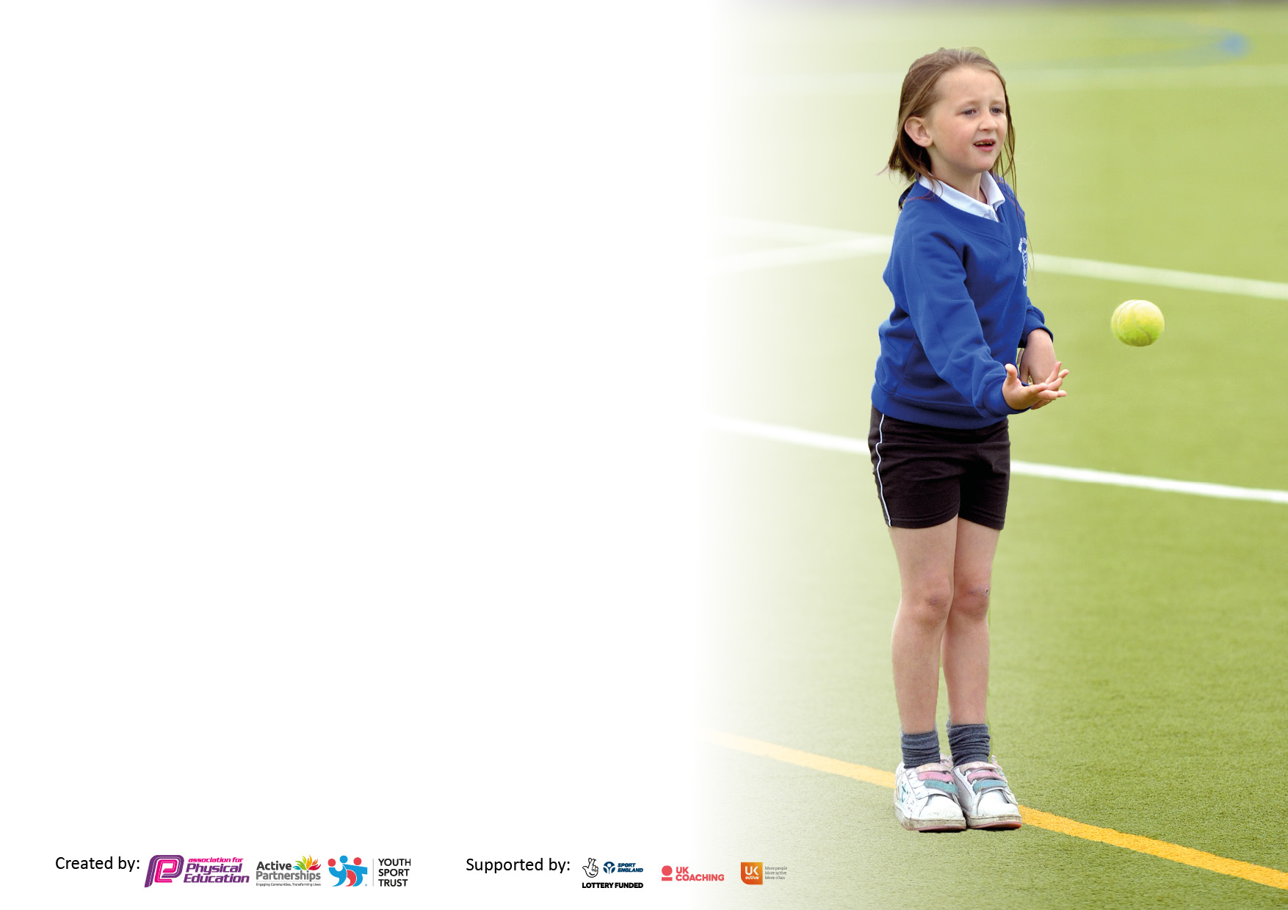

It is important that your grant is used effectively and based on school need. The Education Inspection Framework makes clear there will be a focus on ‘whether leaders and those responsible for governors all understand their respective roles and perform these in a way that enhances the effectiveness of the school’.

Under the Quality of Education Ofsted inspectors consider:
Intent - Curriculum design, coverage and appropriateness
Implementation - Curriculum delivery, Teaching (pedagogy) and Assessment
Impact - Attainment and progress

To assist schools with common transferable language this template has been developed to utilise the same three headings which should make your plans easily transferable between working documents.

Schools must use the funding to make additional and sustainable improvements to the quality of Physical Education, School Sport and Physical Activity (PESSPA) they offer. This means that you should use the Primary PE and sport premium to:

- Develop or add to the PESSPA activities that your school already offer
- Build capacity and capability within the school to ensure that improvements made now will benefit pupils joining the school in future years
- The Primary PE and sport premium should not be used to fund capital spend projects; the school’s budget should fund these.

Pleasevisitgov.ukfortherevisedDfEguidanceincludingthe5keyindicatorsacrosswhichschoolsshoulddemonstrate animprovement.Thisdocumentwillhelpyoutoreviewyourprovisionandtoreportyourspend.DfEencouragesschools to use this template as an effective way of meeting the reporting requirements of the Primary PE and Sport Premium.

We recommend you start by reflecting on the impact of current provision and reviewing the previous spend.

Schools are required to publish details of how they spend this funding, including any under-spend from 2021/2022, as well as on the impact it has on pupils’ PE and sport participation and attainment. All funding must be spent by 31st July 2023.

We recommend regularly updating the table and publishing it on your website throughout the year. This evidences your ongoing self-evaluation of how you are using the funding to secure maximum, sustainable impact. Final copy must be posted on your website by the end of the academic year and no later than the 31st July 2023. To see an example of how to complete the table please click HERE.

Details with regard to funding
Please complete the table below.

Total amount carried over from 2020/21 | £7784.90
Total amount allocated for 2021/22 | £24774.90
How much (if any) do you intend to carry over from this total fund into 2022/23? | ********
Total amount allocated for 2022/23 | £16978.00
Total amount of funding for 2022/23. To be spent and reported on by 31st July 2023. | £16978.00
Swimming Data
Please report on your Swimming Data below.

Meeting national curriculum requirements for swimming and water safety.
N.B. Complete this section to your best ability. For example you might have practised safe self-rescue techniques on dry land which you can then transfer to the pool when school swimming restarts.
Due to exceptional circumstances priority should be given to ensuring that pupils can perform safe self rescue even if they do not fully meet the first two requirements of the NC programme of study
What percentage of your current Year 6 cohort swim competently, confidently and proficiently over a distance of at least 25 metres?  N.B. Even though your pupils may swim in another year please report on their attainment on leaving primary school at the end of the summer term 2022. Please see note above | 100%
What percentage of your current Year 6 cohort use a range of strokes effectively [for example, front crawl, backstroke and breaststroke]? Please see note above | 100%
What percentage of your current Year 6 cohort perform safe self-rescue in different water-based situations? | 100%
Schools can choose to use the Primary PE and sport premium to provide additional provision for swimming but this must be for activity over and above the national curriculum requirements. Have you used it in this way? | Yes

Action Plan and Budget Tracking - Capture your intended annual spend against the 5 key indicators. Clarify the success criteria and evidence of impact that you intend to measure to evaluate for pupils today and for the future.
Academic Year: 2022/23 | Total fund allocated: | Date Updated: July 2023
Key indicator 1: The engagement of all pupils in regular physical activity – Chief Medical Officers guidelines recommend that primary school pupils undertake at least 30 minutes of physical activity a day in school
Intent | Implementation |  | Impact
Your school focus should be clear what you want the pupils to know and be able to do and about what they need to learn and to consolidate through practice: | Make sure your actions to achieve are linked to your intentions: | Funding allocated: | Evidence of impact: what do pupils now know and what can they now do? What has changed? | Sustainability and suggested next steps:
- Educate children in the value and benefits of a healthy active lifestyle.  - Ensure our high-quality PE and school sport offer develops competent and confident movers with the aim of inspiring lifelong participation in physical activity.  - Use active lessons to increase physical activity levels and learning.  - Raise awareness of the best places to take part in sport and physical activity outside of school.  - Provide opportunities for daily physical activity and increase pupils’ activity levels throughout the day.  - Ensure each year group have PE timetabled on their timetable at least once a week and 2 hours a week where possible. | - Through PE lessons and sport, ensure our children understand the role of movement in the development of their own physical literacy, fitness and wellbeing.  - In the summer term, have a whole school daily dance at the start of the day.  - Develop physical activity during playtimes with the introduction of new play equipment – including an assault course style of activities.  - Timetable PE on each year groups timetable. Create a PE overview for the year for each year group.  - Subject leader release time for monitoring activities to ensure successful implementation. | £645.00 | - Positive attitudes to health and well-being  - Pupil concentration, commitment, self-esteem and behaviour enhanced  - Pupils’ activity at lunch and break increased with the use of play equipment and climbing frames  - Children taking part in daily additional activities active play across the school, this includes parents in the playground.  - children across the school are more active on a daily basis and enjoy being active using the climbing frames and assault course at playtimes or through use of the play equipment in the huff and puff box.  - Through pupil voice children have requested more equipment at breaktimes – they say that the same people use it and there is not enough for everyone to have a chance to play. They have suggested a rota. | - Monitor physical activity levels to ensure ALL classes meet the government guidelines of at least 30 minutes a day for each child in school time.  - Continue to give the children opportunities to experience new sports and work with clubs such as the rugby & cricket club  - training children in playground games. Peer mediators to incorporate physical activity  - All children have access to 2 hours of taught PE every week  - All children have access to Forest School sessions which increase physical activity.  - New equipment to be purchased for playtime – particularly balls that do not bounce to reduce the times that balls are kicked into the road.  - Investigate new play equipment for EYFS.  - Investigate Skipping workshops for schools.

Key indicator 2: The profile of PESSPA being raised across the school as a tool for whole-school improvement
Intent | Implementation |  | Impact
Your school focus should be clear what you want the pupils to know and be able to do and about what they need to learn and to  consolidate through practice: | Make sure your actions to achieve are linked to your intentions: | Funding allocated: | Evidence of impact: what do pupils now know and what can they now do? What has changed? | Sustainability and suggested next steps:
- That children feel that sport is valued in the school, both activities they have done in school and out of school.  - To learn about the importance of SEMH which is supported through Physical Activity.  Encourage active play times and lunch times | Children are encouraged to bring in certificates that they have been given. They are celebrated in weekly Celebration Assembly.  When children participate in sporting events with other schools’ certificates and awards shall be handed out in the celebration assembly.  Involve Bronze Ambassadors in selecting PE and Sports equipment for children to use at break and lunch. | £1205  Additional printing costs for certificates | Children regularly bring in certificates to be awarded in assembly. The certificates include; swimming, gymnastics, trampolining, football, hockey, running  Pupil voice and ECL visit notes highlight positive play times and high levels of activity. | Continue to value children’s achievements in celebration assembly.  Create a school sports board to promote sports and physical activity – pictures of children with awards  Develop an understanding of adults and pupils in links between SEMH and PA to support more positive physical activity.  Improve opportunities for pupils in school to take part in outdoor learning.

Key indicator 3: Increased confidence, knowledge and skills of all staff in teaching PE and sport
Intent | Implementation |  | Impact
Your school focus should be clear | Make sure your actions to | Funding | Evidence of impact: what do | Sustainability and suggested
what you want the pupils to know | achieve are linked to your | allocated: | pupils now know and what | next steps:
and be able to do and about | intentions: |  | can they now do? What has
what they need to learn and to |  |  | changed?:
consolidate through practice:
For staff to build a bank of skills and activities to use in PE lessons.  Staff Audit of skills and confidence in teaching PE.  Audit of equipment which is available for staff to use for lessons  For staff to build confidence in teaching swimming and water safety in PE lessons | Weekly CPD opportunities for support staff from observing a Sports coach for ideas of games and skills that can be taught.  Carry out skills and confidence audits with staff.  Audit equipment. Store equipment in boxes/bags that are clearly labelled for easy access to specific sports.  Provision of swimming lessons at Bridport leisure centre, including transportation and cost of qualified swimming teachers delivering sessions. | £1000  £4734.99 | Staff provide termly feedback on something that they have learnt from the observations.  Staff discussion about skills and confidence. Identified strengths and areas for development. Through staff discussion areas of PE where they feel least confident are swimming and gymnastics.  Equipment audited and sorted into sports. Equipment has been stored so that there is easy access to equipment in sports boxes.  100% pupils leave KS2 meeting swimming requirements of the national curriculum. | Continue to use a sports coach to gain ideas for games and skills that can be taught. All staff to provide feedback once a half term on something that they have learnt.  Staff support and new staff coming into the school will need further support in PE. Planning, assessment and CPD tool to be sought.  Timetable termly PE CPD sessions  Expand the curriculum offer to include new sports taught to children.  Engage with local charities and workshops to improve pupil’s knowledge of staying safe at the beach and cold water shock.

Key indicator 4: Broader experience of a range of sports and activities offered to all pupils |  |  |  | Percentage of total allocation:
Intent | Implementation |  | Impact
Your school focus should be clear  what you want the pupils to know  and be able to do and about  what they need to learn and to  consolidate through practice: | Make sure your actions to  achieve are linked to your  intentions: | Funding  allocated: | Evidence of impact: what do  pupils now know and what  can they now do? What has  changed?: | Sustainability and suggested  next steps:
For children across key stage 2 school to have experience of a range of sporting activities to introduce them to new activities that they can have a go at.  Introduce Stormbreak mental health and wellbeing activities in KS2, starting in Y3/4. | Working with the WDSC children to have access to sporting events  Working with staff to learn new sporting activity skills through use of new PE equipment in sporting packs – Sailing, Paddleboarding & Windsurfing.  Mental health is at the core of each and every stormbreak delivered, however the idea is also to get the children moving as we know how much movement supports our mental wellbeing. Activities include:  Run Moves  Creative Moves  Free Moves  Mindful Moves  Nature’s Moves | £502.17 | Through pupil’s voice, the majority of children say that they like PE and Physical Activity. They enjoy the lessons and the range of sports that are available.  UKS2 have experiences of sailing, paddleboarding and windsurfing.  Pupil voice reflects positive impact of Stormbreak session on pupil wellbeing. | Develop/investigate further opportunities for children to experience sports both in lessons and as extra curricula sports or competitions or sporting days  Develop Physical Activity opportunities through playtimes, after-school clubs, team competitions  Develop basic skills in sports. From observations children lack the fundamental skills for participation in sports – for example, skipping skill.  Expand EYFS outdoor area to offer wider range of activities to pupils.  Embed Stormbreak activities across the school from Reception to Y6.  Develop Forest School area on school grounds.

Key indicator 5: Increased participation in competitive sport
Intent | Implementation |  | Impact
Your school focus should be clear  what you want the pupils to know  and be able to do and about  what they need to learn and to  consolidate through practice: | Make sure your actions to  achieve are linked to your  intentions: | Funding  allocated: | Evidence of impact: what do  pupils now know and what  can they now do? What has  changed?: | Sustainability and suggested  next steps:
After COVID has halted inter-school sports competitions children will have the opportunity to engage in sporting activities. | Working with the WDSC schools to ensure full participation in Beaminster area events. | £1341.05 | Where possible, children have had access to as many sporting opportunities as we can attend. This has included; Tag Rugby, Cross Country, Dance, Football, Handball, Hockey, Multi-skills, Quadkids, Cricket  Children have enjoyed attending these sporting events and participating against other schools.  Participation of key groups of pupils, including disadvantaged and those with SEND is monitored to ensure representation and opportunities for all. | Develop/investigate further opportunities for children to experience sports both in lessons and as extra curricula sports or competitions.  Plan out next years activities – attend September SSPC meeting to identify a timetable. Look at staffing/adult support for attending activities  Invest in new team strips to allow the children to show pride in being part of the team. All kit is old, worn, too small for the children to wear.

Signed off by
Head Teacher: | L Overment
Date: | 20.7.23
Subject Leader: | L Overment
Date: | 20.7.23
Governor: | D Stanton
Date: | 20.7.23

