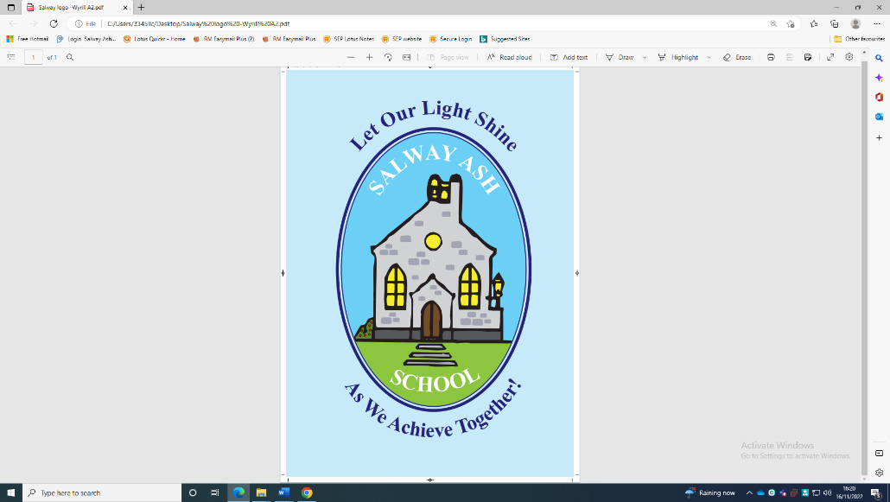

Equality information
Salway Ash CE VA Primary School

Approved by: | FGB | Date: February 2025
Last reviewed on: | February 2025
Next review due by: | February 2026

Part 1: Information about the pupil population
Number of pupils on roll at the school: 110

Information on pupils by protected characteristics

The Equality Act protects people from discrimination on the basis of ‘protected characteristics’. Every person has several of the protected characteristics, so the Act protects everyone against unfair treatment.

In order to ensure that all pupils are protected from discrimination, the school collects information on some protected characteristics of their pupils these include:

Disability
Ethnicity and Race
Gender
Religion and Belief

Sensitive information on some pupils with protected characteristics

It is not appropriate for us to collect information from pupils in relation to some protected characteristics, gender identity and sexual orientation.

However, as a school, we are aware that there may be a number of equality issues for gay, lesbian and bisexual pupils, as well as those who are undergoing or who have undergone a reassignment of their gender.

Maternity and pregnancy is also a protected characteristic.

Information on other groups of pupils

Ofsted inspections of schools will look at how schools help "all pupils to make progress, including those whose needs, dispositions, aptitudes or circumstances require additional support".

In addition to pupils with protected characteristics, we gather further information on the following groups of pupils:

Pupils on free school meals
Pupils with Special Educational Needs (SEN) Pupils with English as an additional language
Pupils with a Traveller heritage
Pupils from low income households
Young carers
Looked after children
Other vulnerable groups

Part 2: How we have due regard for equality
The information provided here aims to show that we give careful consideration to equality issues in everything that we do in the school.

Disability, Ethnicity and Race, Gender, Religion and Belief
Summary information and data (including gaps in attainment, inequalities of outcome and relations between different groups of pupils).

We have analysed statutory assesment data regarding Salway Ash CE VA Primary School:
End KS2 Teacher Assessment Results (Yr6) , Gender: 8 boys and 9 girls.
59% of pupils achieved EXS in Reading, 65% achieved EXS and writing, 65% achieved EXS in Maths, 65% achieved EXS in SPAG and 47% achieved EXS combined.
Pupil Premium Pupils:
There were 3 disadvantaged pupils in this cohort. One achieved EXS in writing, one achieved EXS in math. Two of the three were on the SEND register.
Ethnic Groups:
There were no pupils from different ethnic groups in this cohort.
End of KS1(Yr2)
Gender: 9 boys and 7 girls.
63% achieved EXS in reading, 50% achieved EXS in writing, 75% achieved ARE in maths and 50% achieved ARE combined.
Pupil Premium:
There was 1 disadvantaged pupils in this cohort. They achieved the expected standard in Maths.
Special Educational Needs:
5 pupils were on the SEND register, including 2 children with an EHCP.

We are committed to working for the equality of all our staff, children and parents. To meet our duties under the Equality Act 2010 we have due regard to the need to:

Eliminate unlawful discrimination by:

- The Ofsted parent survey in September 2023 was overwhelmingly positive about the school:
- 100% said their children were happy at school
- 97% said their children felt safe
- 94% said they felt school made sure pupils behaved well
- 91% said school had high expectations of their child

- Following an on-line parent survey in July 2023 key strengths included 92% saying school supports their child’s wider personal development & 100% agreed with the statement that “My child has SEND and the school gives me the support they need to succeed.
- Comments on how to improve playtimes mainly evolved around having more equipment available to play with.

Advance equality of opportunity by:

- We use the information we collate through our tracking system to identify underachieving groups or individuals and plan targeted interventions
- We strive to ensure participation of all parents and pupils in school development through parents meetings, the PTA, our “Great Works”, parent talks and workshops and our Pupil Voice sessions.
- Reading books and library books reflect equality issues and the wider society that we live in.

Foster good relations and community cohesion by:

- We constantly strive to ensure that equality and diversity are embedded in the curriculum and we often focus on these key areas in assemblies.
- We actively participate in national events like Anti Bullying Week and Safer Internet Day. Parents often comment on the usefulness of receiving regular E-safety information which is circulated to all families and taught to the children.
- We regularly contribute to the following charities; Red Nose Day, MacMillan Cancer, Children In Need and Surfers Against Sewage.
- During 2015/2016 we gained Green Flag status due to our Eco Schools work.

What has been the impact of our activities? What do we plan to do next?

- Ofsted September 2023 – “During breaktimes, ‘Bronze Ambassadors’ organise games that encourage pupils of all ages to play together. Pupils respond to each other with kindness and respect.”
- Ofsted September 2023 – “Positive relationships between staff and pupils help pupils to become independent, resilient learners, willing to ‘have a go’… They are
well prepared for the next stage of their education.”
- Ofsted September 2023 – Pupils learn to be active citizens in their school community.
- Ofsted September 2023 – “The school has high expectations for the academic and personal development of all pupils. The school meets the needs of individual pupils right from the start. Staff get to know the interests and needs of children before they start school. Appropriate adaptations are then made to ensure that disadvantaged pupils and pupils with special educational needs and/or disabilities (SEND) learn the same curriculum as their peers.”
- Ofsted September 2023 – “The school has high aspirations for pupils’ behaviour. This is evident in pupils’ exemplary conduct and attitudes to learning. There is a calm and orderly environment in the school. The school ensures that pupils who need additional support to recognise and manage their feelings receive the right help. Pupils are equipped with the tools and confidence to manage their own behaviour and to secure friendships.”

Part 3: Consultation and engagement

We aim to engage and consult with pupils, staff, parents and carers and the local community so we can improve our information, learn about the impact of our policies, develop our equality objectives and improve what we do.

Our main activities for consulting and engaging are:

• | Questionnaire to parents
• | Questionnaires to pupils
• | Staff meetings
• | Governors meetings
• | Parental consultations
• | Pupil Voice
• | Engage wider community through Governor links
• | Equality parent questionnaire
• | A named governor responsible
• | Governors included pupil voice as part of monitoring visits
• | School Council

Part 4: Record of how we have considered equality issues when making decisions

The Equality Act 2010 requires us to show due regard to equality issues when we make significant decisions or changes in our policies. This means we need to consider what the impact of those decisions or policies will be on pupils and staff with protected characteristics before a decision is made or a policy is finalised.

Date | Policy or decision | Equality issues we considered | Action taken or changes made
September 2023 | Strategy meeting. To monitor gender  suitability in all curriculum, extracurricular clubs and activities provision and premises | With 60 girls and 51 boys in school as a whole it is important to analyse if content in provision is equally suitable and attractive to the school.  Language used non gender specific. | Sports premium money used to increase range of activities available which appeal to girls and boys e.g. comic club, football, netball, dodgeball. The use of a range of teaching styles and topic choices to suit both gender. Plans for toilets to be adapted to non-gender specific.

Part 5: Our equality objectives

The Equality Act 2010 requires us to publish specific and measurable equality objectives. Our equality objectives are based on our analysis of data and other evidence. Our equality objectives focus on those areas where we have agreed to take action to improve equality and tackle disadvantages.
We will regularly review the progress we are making to meet our equality objectives.

Equality objective 1:
Monitor and analyse pupil achievement by race, gender and disability and act on any trends or patterns in the data that require additional support for pupils.
Progress we are making on this objective:
Regular pupil progress meetings allow us to focus on individuals and groups to identify any gaps or additional support that may be needed through interventions supported by the SENDCO.

Equality objective 2:
Ensure that the curriculum promotes role models and heroes that young people positively identify with, which reflects the school’s diversity in terms of race, gender and disability. Also so that it prepares pupils for life in modern Britain as part of a more multicultural and diverse society than they may currently grow up in.
Progress we are making on this objective:
Staff plan a rich and varied curriculum that celebrates difference and promotes a range of role models and heroes. Teachers regularly review their class curriculum and subject curriculum to ensure there is breath taught across each cohort.
We believe that publishing our equality information will make us transparent about the progress we are making on equality, and more accountable to parents and the local community.

For more information please contact: Leif Overment, Headteacher
Tel: 01308 488302 Email: office@salwayash.dorset.sch.uk

Member of governing body with responsibility for equality issues: Phil Smith

Information on pupils by protected characteristics
Ofsted inspections of schools will look at how schools help "all pupils to make progress, including those whose needs, dispositions, aptitudes or circumstances require additional support."

In addition to pupils with protected characteristics, we wish to provide further information on the following groups of pupils:

Ethnicity and race Pupils aged 5 years and over at 31.08.23 Autumn 2024 Census
Asian or Asian British |  | Boys | Girls | Total |  |  |  | Boys | Girls | Total
Bangladeshi heritage |  | 0 | 0 | 0 |  | Mixed
Indian heritage |  | 0 | 0 | 0 |  | Other mixed heritage |  | 0 | 0 | 0
Other Asian heritage |  | 0 | 0 | 0 |  | White and Asian |  | 0 | 0 | 0
Pakistani heritage |  | 0 | 0 | 0 |  | White and Black African |  | 0 | 0 | 0
Black or Black British |  |  |  |  |  | White and Black Caribbean |  | 0 | 0 | 0
Black African heritage |  | 0 | 0 | 0 |  | Any Other  Ethnic Group
Caribbean heritage |  | 0 | 0 | 0 |  | White
Other heritage |  | 0 | 0 | 0 |  | British heritage |  | 53 | 54 | 107
Chinese |  | 0 | 0 | 0 |  | Irish heritage |  | 0 | 0 | 0
 |  |  |  |  |  | Traveller of Irish heritage |  | 0 | 0 | 0
 |  |  |  |  |  | Gypsy / Romany |  | 0 | 0 | 0
 |  |  |  |  |  | Any Other White background |  | 0 | 3 | 3
Information withheld
 | Pupil Special Educational Needs (SEN) Provision Spring Census
 |  |  |  |  | Number of pupils |  | Percentage (%) of school population
 | No Special Education Need |  |  |  | 88 |  | 80 %
 | Special Needs Register |  |  |  | 23 |  | 21%
 | Education and Health Care Plan |  |  |  | 7 |  | 6%

Pupils from low income households
 | Boys | Girls | Total | Percentage of school population
Number of pupils currently eligible for free school meals | 5 | 6 | 11 | 10%

Looked after children
2

Young carers
0

Other vulnerable groups
N/A

Religion and Belief
Buddhist | 0 | Sikh | 0
Christian | 40 | No religion | 34
Hindu | 0 | Other religion | 0
Jewish | 0 | Unknown | 36
Muslim | 0
Pupil with English as an additional language (EAL)

Boys

Girls

Total

Percentage of
school
population

Number of pupils who speak
Engli
sh as an additional
language

0

20

20

2%

Number of pupils who are at an
early stage of English language
acquisition

0

0

0

0

Gender

Male

(48
%)

Female

(52
%)

