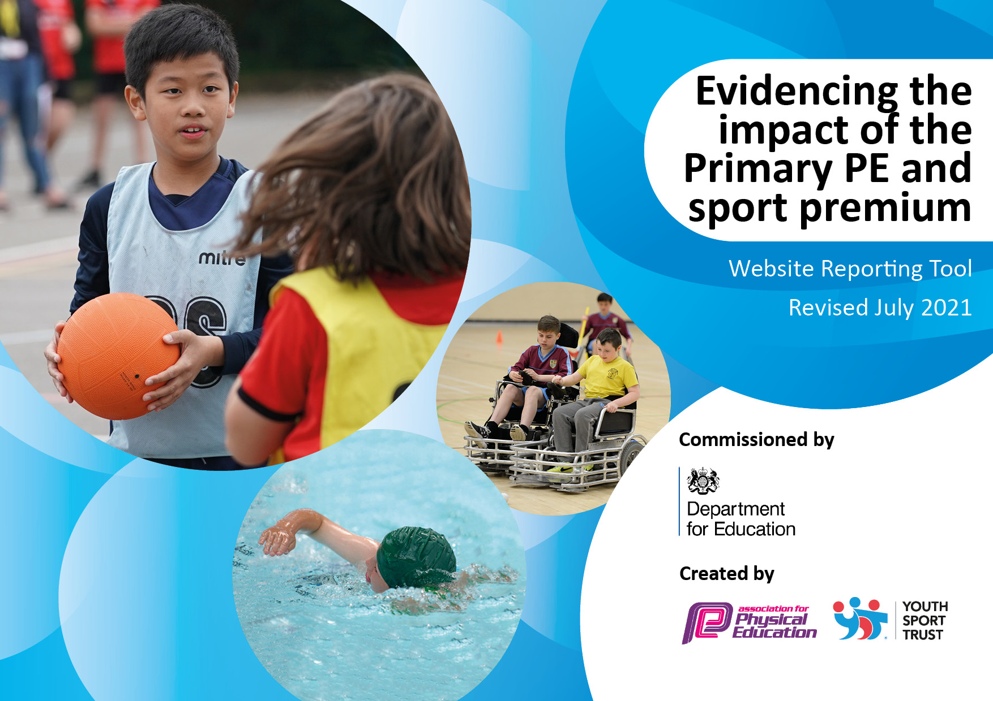
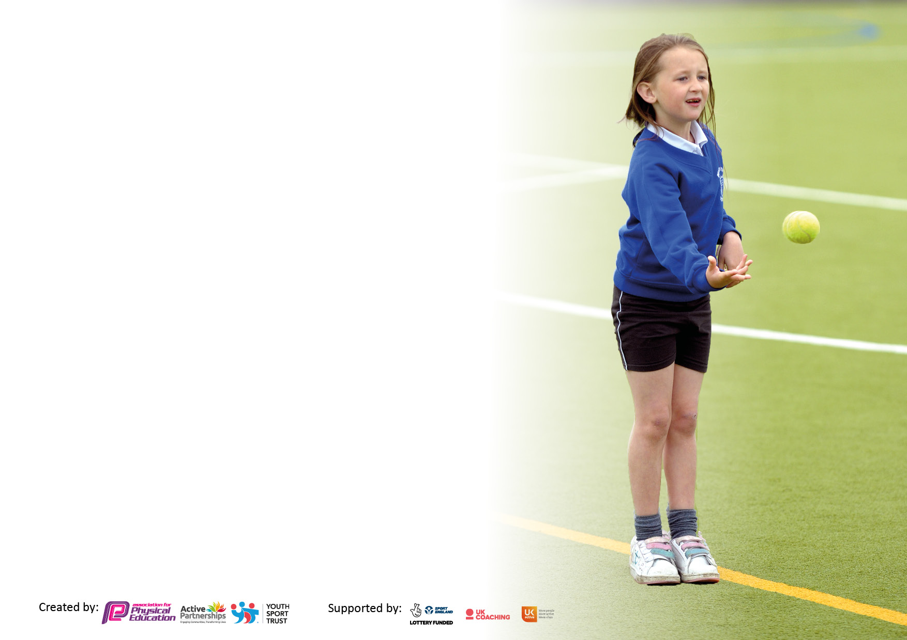

It is important that your grant is used effectively and based on school need. The Education Inspection Framework makes clear there will be a focus on ‘whether leaders and those responsible for governors all understand their respective roles and perform these in a way that enhances the effectiveness of the school’.

Under the Quality of Education Ofsted inspectors consider:
Intent - Curriculum design, coverage and appropriateness
Implementation - Curriculum delivery, Teaching (pedagogy) and Assessment
Impact - Attainment and progress

To assist schools with common transferable language this template has been developed to utilise the same three headings which should make your plans easily transferable between working documents.

Schools must use the funding to make additional and sustainable improvements to the quality of Physical Education, School Sport and Physical Activity (PESSPA) they offer. This means that you should use the Primary PE and sport premium to:

- Develop or add to the PESSPA activities that your school already offer
- Build capacity and capability within the school to ensure that improvements made now will benefit pupils joining the school in future years
- The Primary PE and sport premium should not be used to fund capital spend projects; the school’s budget should fund these.

Pleasevisitgov.ukfortherevisedDfEguidanceincludingthe5keyindicatorsacrosswhichschoolsshoulddemonstrate animprovement.Thisdocumentwillhelpyoutoreviewyourprovisionandtoreportyourspend.DfEencouragesschools to use this template as an effective way of meeting the reporting requirements of the Primary PE and sport premium.

We recommend you start by reflecting on the impact of current provision and reviewing the previous spend.

Schools are required to publish details of how they spend this funding, including any under-spend from 2019/2020, as well as on the impact it has on pupils’ PE and sport participation and attainment. All funding must be spent by 31st July 2022.

We recommend regularly updating the table and publishing it on your website throughout the year. This evidences your ongoing self-evaluation of how you are using the funding to secure maximum, sustainable impact. Final copy must be posted on your website by the end of the academic year and no later than the 31st July 2021. To see an example of how to complete the table please click HERE.
Created by: Supported by:

Details with regard to funding
Please complete the table below.

Total amount carried over from 2019/20 | £4550.48
Total amount allocated for 2020/21 | £16986.00
How much (if any) do you intend to carry over from this total fund into 2021/22? | £7784.90
Total amount allocated for 2021/22 | £16990.00
Total amount of funding for 2021/22. To be spent and reported on by 31st July 2022. | £24774.90
Swimming Data
Please report on your Swimming Data below.

Meeting national curriculum requirements for swimming and water safety.  N.B. Complete this section to your best ability. For example you might have practised safe self-rescue techniques on dry land which you can then transfer to the pool when school swimming restarts.  Due to exceptional circumstances priority should be given to ensuring that pupils can perform safe self rescue even if they do not fully meet the first two requirements of the NC programme of study | Pupils take part in 10 swimming sessions each year which cover water safety.
What percentage of your current Year 6 cohort swim competently, confidently and proficiently over a distance of at least 25 metres?  N.B. Even though your pupils may swim in another year please report on their attainment on leaving primary school at the end of the summer term 2021.  Please see note above | 100%
What percentage of your current Year 6 cohort use a range of strokes effectively [for example, front crawl, backstroke and breaststroke]?  Please see note above | 100%
What percentage of your current Year 6 cohort perform safe self-rescue in different water-based situations? | 100%
Schools can choose to use the Primary PE and sport premium to provide additional provision for swimming but this must be for activity over and above the national curriculum requirements. Have you used it in this way? | Yes

Action Plan and Budget Tracking
Capture your intended annual spend against the 5 key indicators. Clarify the success criteria and evidence of impact that you intend to measure to evaluate for pupils today and for the future.

Academic Year: 2021/22 | Total fund allocated: £ |  |  | Date Updated:
Key indicator 1: The engagement of all pupils in regular physical activity – Chief Medical Officers guidelines recommend that primary school pupils undertake at least 30 minutes of physical activity a day in school |  |  |  |  |  |  | Percentage of total allocation:
 |  |  |  |  |  |  | 9%
Intent | Implementation |  |  |  |  | Impact
Your school focus should be clear what you want the pupils to know and be able to do and about  what they need to learn and to  consolidate through practice: | Make sure your actions to achieve are linked to your intentions: |  |  | Funding allocated: |  | Evidence of impact: what do pupils now know and what can they now do? What has changed?: | Sustainability and suggested next steps:
Improving some of our sports equipment enabling more children to participate in a variety of sports and clubs. | Purchase of x12 Mitre Impel Footballs Size 4 |  |  | £83.88 |  | Better quality balls to use when playing football.  Increased numbers attending weekly after school football club + feedback from pupils | Provide more after school football clubs to encourage pupils to participate in physical activities.
Promoting fitness and leadership skills to some of our less confident children. | Purchase of sports equipment for teaching PE (football goals, Chinese skipping ropes and sports day rewards) |  |  | £619.02 |  | Greater enjoyment during PE lessons and higher levels of engagement at break times and lunch times. | Bronze Sports Ambassadors trained to engage pupils in more activities during break/lunch times.
Improving our links with external community sports providers. | Footie 4 Dorset – Football coaching for KS2 during PPA |  |  | £1482 |  | Self-confidence and pride is boosted through learning a new skill. Also, an increase in numbers participating in after school football club. | Continue to use Footie 4 Dorset to provide PPA cover and after school clubs in football and dodgeball throughout the year.
Key indicator 2: The profile of PESSPA being raised across the school as a tool for whole school improvement |  |  |  |  |  |  | Percentage of total allocation:
 |  |  |  |  |  |  | 9%
Intent | Implementation |  |  |  |  | Impact
Your school focus should be clear what you want the pupils to know and be able to do and about  what they need to learn and to  consolidate through practice: | Make sure your actions to achieve are linked to your intentions: |  |  | Funding allocated: |  | Evidence of impact: what do pupils now know and what can they now do? What has changed?: | Sustainability and suggested next steps:
Encouraging safety in water. | Cost of swimming lessons and transport for all classes (Spring & Summer terms |  |  | £2075.66 |  | All pupils take part in 10 swimming lessons a year and most are able to swim 25m unaided by the end of Year 6. | To continue to provide swimming lessons for all pupils.
Maintenance of PE/play equipment. | Annual service and visual inspection of PE equipment |  |  | £61.10 |  | No accidents/injuries during use of PE equipment. | To maintain play/PE equipment annual servicing.
Key indicator 3: Increased confidence, knowledge and skills of all staff in teaching PE and sport |  |  |  |  |  |  |  | Percentage of total allocation:
 |  |  |  |  |  |  |  | 6%
Intent |  | Implementation |  |  | Impact
Your school focus should be clear |  | Make sure your actions to | Funding |  | Evidence of impact: what do |  |  | Sustainability and suggested
what you want the pupils to know |  | achieve are linked to your | allocated: |  | pupils now know and what |  |  | next steps:
and be able to do and about |  | intentions: |  |  | can they now do? What has
what they need to learn and to |  |  |  |  | changed?:
consolidate through practice:
Providing training for staff in a range of sports. |  | Purchase of 3 year Primary PE package with Get Set 4 Education | £825.00 |  | Clear progress for pupils in each unit of work. Pupil voice highlights evidence of enjoyment of PE and developing confidence, knowledge and skills |  |  | Lesson observation and drop in visits to assess fidelity to scheme of work.
Hiring specialist teachers to work alongside our teachers in PE lessons. |  | Staff watch specialist teacher and gain new ideas. | £750 |  | Each year group has had a block of sessions with a Performing Arts teacher, they learned and helped create a dance/piece of drama. |  |  | Staff to continue to develop pupils’ confidence through active literacy.
Key indicator 4: Broader experience of a range of sports and activities offered to all pupils |  |  |  |  |  |  |  | Percentage of total allocation:
 |  |  |  |  |  |  |  | 7%
Intent |  | Implementation |  |  | Impact
Your school focus should be clear |  | Make sure your actions to | Funding |  | Evidence of impact: what do |  |  | Sustainability and suggested
what you want the pupils to know |  | achieve are linked to your | allocated: |  | pupils now know and what |  |  | next steps:
and be able to do and about |  | intentions: |  |  | can they now do? What has
what they need to learn and to |  |  |  |  | changed?:
consolidate through practice:
Providing the opportunity for children to take part in cricket lessons. |  | Cricket coaching for Years 3, 4, 5 and 6 during the Summer term. | £432 |  | Cricket knowledge for staff and teaching tips for pupils. Greater engagement and gaining of skills along with increased fitness. Pupil participation in cricket tournament. |  |  | To continue to provide cricket coaching during the Summer term and to participate in the annual primary school cricket tournament.
Provide the opportunity for pupils to take part in outdoor and adventurous sports. |  | Paddleboarding/windsurfing for all KS2 children. | £874.17 |  | Self-confidence and pride is boosted through learning a new skill. Positive feedback from pupils after the trips. |  |  | To continue to provide this opportunity to all KS2 children in the future.
Enabling children to take part in the Sail for a Fiver experience at the National Sailing Academy in Portland. |  | Transport for Year 5/6 children to get to Portland to take part in the Sail for a Fiver initiative. | £420 |  | Learning new skills out of comfort zone for many. Feedback showed increased confidence for many in water based activities. |  |  | To continue to provide this opportunity to Year 5/6 children in the future.
Key indicator 5: Increased participation in competitive sport |  |  |  |  |  |  |  | Percentage of total allocation:
 |  |  |  |  |  |  |  | 1%
Intent |  | Implementation |  |  | Impact
Your school focus should be clear |  | Make sure your actions to | Funding |  | Evidence of impact: what do |  |  | Sustainability and suggested
what you want the pupils to know |  | achieve are linked to your | allocated: |  | pupils now know and what |  |  | next steps:
and be able to do and about |  | intentions: |  |  | can they now do? What has
what they need to learn and to |  |  |  |  | changed?:
consolidate through practice:
Providing the opportunity for children to participate in a wide range of sports and physical activities with a broader network of peers from the West Dorset area. |  | Contribution towards the cost of medals and ribbons for the West Dorset Schools Cross Country individual races at Beaminster School and Colfox School | £22.17 |  | Self-confidence and pride is boosted. High levels of enjoyment and engagement in sport. |  |  | To continue to provide the opportunity for pupils to take part in West Dorset Cross Country events.
Providing the opportunity for children to participate in a wide range of sports and physical activities with a broader network of peers from the West Dorset area. |  | Contribution towards the cost of x15 size 1 handballs and carrier for the West Dorset Schools Sports Association | £13.21 |  | Participation in the Handball competition. High levels of enjoyment and engagement in sport. |  |  | To continue to provide the opportunity for pupils to take part in West Dorset sport competitions.
Providing the opportunity for children to participate in a wide range of sports and physical activities with a broader network of peers from the West Dorset area. |  | Contribution towards the cost of trophies for the West Dorset Schools Quicksticks competition | £10.82 |  | Self-confidence and pride is boosted. High levels of enjoyment and engagement in sport. |  |  | To continue to provide the opportunity for pupils to take part in West Dorset sport competitions.
Providing the opportunity for children to participate in a wide range of sports and physical activities with a broader network of peers from the West Dorset area. |  | Transport to the Year 1&2 Multiskills festival | £225 |  | Participating in team sports. High levels of enjoyment and engagement in different sports. |  |  | To continue to provide the opportunity for pupils to take part in West Dorset sport events.

Signed off by
Head Teacher: | Leif Overment
Date: | 22.7.22
Subject Leader: | Hannah Thomson
Date: | 22.7.22
Governor: | Rob Pepper
Date: | 22.7.22

