Salway Ash CE VA Primary School

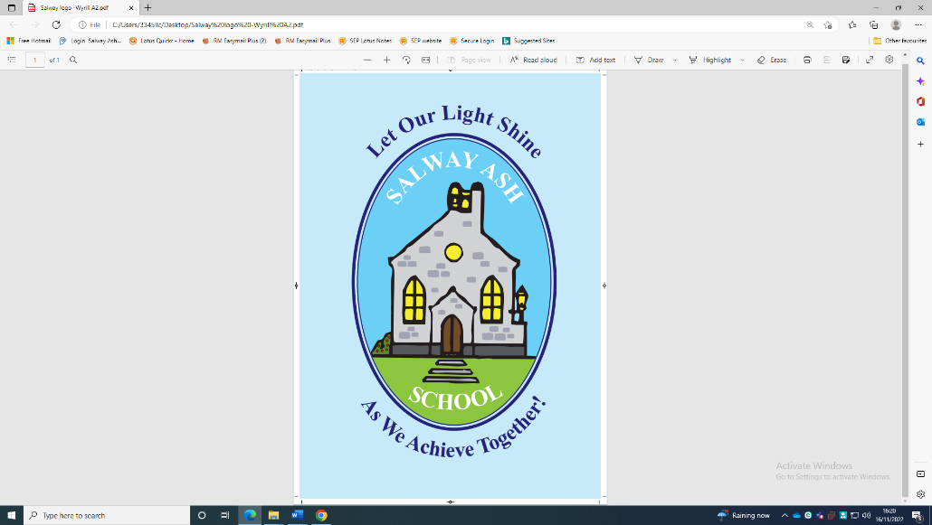

Religious Education policy
Approved by: | Governing Body | Date: February 2023
Last reviewed on: | February 2023
Next review due by: | February 2026

Model Policy for Religious Education (RE) in Salway Ash CE VA Primary School.
POLICY GUIDANCE in line with the latest Statement for Entitlement guidance (2019) and the SIAMS Evaluation Schedule (2018). This is an example policy document and is offered as guidance only, so please implement within the context of your academy/school’s vision and the style/expectations of policy documentation. Please also amend the policy to ensure that it reflects the locally agreed syllabus and practice that happens within your school.
In our school our Christian vision shapes all we do.

Our aim at Salway Ash School is to:

- provide a safe and supportive environment where children, staff, parents, governors all work in partnership with the local community to attain high standards, achieving academic, creative, spiritual, social and emotional fulfilment.
- develop pupils who are kind and considerate towards one another and want to make a positive contribution to the world around them
- provide a secure, caring Christian ethos that enables us to grow together, learn together and inspire each other.

Rationale
‘Religious education in a Church school should enable every child to flourish and to live life in all its fullness. (John 10:10). It will help educate for dignity and respect encouraging all to live life well together.’
Such an approach is offered through a commitment to generous hospitality, being true to
our underpinning faith, but with a deep respect for the integrity of other religious traditions (and worldviews) and for the religious freedom of each person.
RE Statement of Entitlement from the Church of England Education Office Feb 2019

Pupils and their families can expect a high-quality religious education (RE) curriculum that is rich and varied, enabling learners to acquire a thorough knowledge and understanding of a range of faiths and worldviews. RE has a very high profile within the curriculum and makes a significant contribution to preparing pupils for life in modern Britain.

Christianity is taught as a living and diverse faith, focused on the teachings of Jesus and the Church, alongside a range of religions and worldviews. We encourage pupils to learn from different religions, beliefs, values and traditions while creating a safe space for them to explore their own beliefs and questions of meaning.

We aim for pupils to be inspired by the subject and that through their learning in RE they will develop a wide range of skills such as enquiry, analysis, interpretation, evaluation and reflection, to deepen their understanding of the impact of religion on the world.

Legal Requirements
As a Voluntary Aided School, our governing body determines our RE curriculum, which is in accordance with the school’s trust deed and has been discussed with The Diocese of Salisbury Board of Education. The school teaches religious education according to the Dorset agreed syllabus.

Section 48 of the 2005 Education Act requires the inspection of religious education in schools which have a religious character. This is the Statutory Inspection of Anglican and Methodist Schools (SIAMS)

Aims of RE - Curriculum Intent
As stated in the Church of England Statement of Entitlement for Religious Education, our school aims for all pupils:
- Through exploration of core beliefs and using an approach that critically engages with biblical text, to enable pupils to know about and understand Christianity as a diverse, global and living faith that influences the lives of people worldwide and as the religion that has most shaped British culture and heritage.
- To enable pupils to know about and understand different major world religions and world views, their impact on society, culture and the wider world, and to appreciate the diversity, continuity and change within those religions and worldviews
- To engage with challenging questions of meaning and purpose raised by human existence and experience.
- To contribute to the development of pupils’ own spiritual/philosophical convictions, exploring and enriching their own beliefs, ways of living, thinking and values.

Curriculum balance
Reflecting the school’s trust deed parents and pupils are entitled to expect that in Church schools Christianity should be the majority religion studied in each year group and should be at least 50% of curriculum time. Sufficient dedicated curriculum time, meeting explicitly RE objectives, however organised, should be committed to the delivery of RE. This should aim to be close to 10% but must be no less than 5% in key stages 1-2.

Schools must take note that the RE entitlement is totally separate from requirements for collective worship. Collective worship must not be considered curriculum time for RE or the teaching of RE.

Curriculum Implementation
RE lessons provide a safe space for pupils to explore their own religious, spiritual and/or philosophical ways of seeing, living and thinking, believing and belonging. Lessons provide opportunities to engage in meaningful and informed dialogue with those of all faiths and worldviews. Learning activities provide fully for the needs of all pupils, so that they develop a wide range of skills including enquiry, analysis, interpretation, evaluation and reflection.

Teaching in RE aims to challenge stereotypes, misinformation and misconceptions about race, gender and religion. Lessons seek to present religions and world views in all their richness and diversity in terms of beliefs, traditions, customs and lifestyle in a sensitive and accurate way in order to encourage a positive attitude towards diversity. All questions, views, and opinions are treated with sensitivity and respect.

Teachers establish clear links between elements of religious belief and practice and aspects of the children’s own lives. Teaching enables pupils to gain something of personal value from their study of religious belief and practice, for example, the way that they might apply insights gained from religious stories to their own lives.

- Religious education is usually taught in a ‘whole class’ setting but with flexibility to allow for discussion, questioning and reflection in small groups and individually
- Visits to local churches and places of worship and visitors to school are encouraged
- A variety of teaching approaches including teacher presentations, role play, drama art and story-telling as well as quizzes, questions and answer sessions, discussions and debates are employed in order that RE learning is active and enjoyable as well as rigorous and challenging.
- Pupils experience opportunities to learn and express themselves through an enquiry-based style of learning by:
- Posing and discussing ‘big’ and challenging questions
- Reading and critically analysing texts.
- Interpreting information from different sources.
- Seeking information for themselves in libraries and on computers.
- Listening to and discussing with the teacher and other pupils.
- Engaging in pair and group work.
- Exploring a range of media such as artefacts, pictures, photographs, music and drama.
- Experiencing visits and visitors.
- Taking part in outdoor learning.
- Taking time for reflection.

This means that the RE curriculum:
- is intrinsic to the outworking of our distinctive Christian vision in enabling all pupils to flourish. In addition, it contributes to British values and to pupils’ spiritual, moral, social and cultural development.
- is delivered in an objective, critical and pluralistic manner to engage and challenge all pupils through an exploration of core concepts and questions. Lessons provide meaningful and informed dialogue with a range of religions and worldviews.
- reflects a good balance between the disciplines of theology, philosophy and human science, to enable pupils to develop their religious literacy
- enables pupils to acquire a rich, deep knowledge and understanding of Christian belief and practice, including the ways in which it is unique and diverse, whilst engaging with biblical texts and theological ideas.
- provides opportunities for pupils to understand the role of foundational texts, beliefs, rituals, and practices and how they help to form identity in a range of religions and worldviews.
- supports the development of other curriculum areas and other general educational abilities such as literacy, empathy and the ability to express thoughts, feelings and personal beliefs.
- encompasses the full range of abilities to ensure that all flourish academically, using a wide range of teaching and learning strategies which consider the task, outcome, resource, support and pupil grouping as appropriate to pupils’ needs
- offers tasks that are age appropriate, challenging and sufficiently demanding to stimulate and engage all pupils, whilst extending the most able and providing support for those who need it.
- ensures that all pupils’ contributions are valued in RE as they draw on their own experiences and beliefs

Cross-curricular links - RE supports the development of general educational abilities such as literacy, empathy and the ability to express thoughts, feelings and personal beliefs. RE also makes a major contribution to pupils’ Spiritual, Moral, Social and Cultural (SMSC) development. It addresses issues which arise in a range of subjects, such as English, art, drama and history, geography, computing, music as well as personal, social and emotional education and citizenship (PSHE&C).
Further details about our RE curriculum can be found on our website.

Managing the right to withdraw
Parents have a right by law to withdraw their children from the Religious Education curriculum and our school will comply with any such request. However, in view of the Christian ethos and distinctive Christian character of our school, we would hope that all children admitted will participate fully in RE, and ask that anyone wishing to withdraw their child arranges to discuss this with the headteacher and to take up the opportunity to discuss the contents of the RE curriculum in school before making this decision.

Resources
Religious education is funded to enable a range of resources on different religions to be purchased, such as books for teachers, pupils and the library; posters, CDs, DVDs and artefacts. The school makes use of guidance material produced by the Diocese of Salisbury. Funding will also allow, where possible, visits to different places of worship and provide INSET for staff. All resources will be listed, stored, be easily accessible and kept in good condition. Resource banks will be available for both staff and pupils on all major religions and worldviews as appropriate.

Health and Safety
Health and safety issues may arise in religious education for example, when pupils:
- Handle artefacts.
- Consume food.
- Visit places of worship.

Teachers will conform to guidelines in the school’s health and safety policy in these circumstances.

Assessment and reporting
Assessment in religious education will:
- Be directly related to the expectations of the Dorset Locally Agreed Syllabus
- Be carried out through suitable opportunities identified in resources used in teaching, such as Understanding Christianity.
- Seek to identify pupils’ development in the different areas of learning in the subject and not only in the acquisition of factual knowledge.
- Recognise the range of skills and attitudes which the subject seeks to develop.
- Employ well defined criteria for marking and assessment which identify progress and achievement as well as effort, following the school’s marking policy.
- Include pupil self-assessment.
- Enable effective tracking of pupil progress to identify areas for development in pupil’s knowledge and understanding, as well as whole school areas for development.
- Enable effective reporting to parents.

The Impact of RE - Assessment, Recording, Reporting
Pupils are assessed regularly throughout the teaching of each RE unit through effective questioning and discussion. When outcomes are not recorded by being written down, pupils’ understanding can be captured in a variety of different ways from floor books, verbal responses, video recordings to drama. At the end of each unit, class record sheets are used for teachers to summatively assess pupil’s progress and attainment. These are monitored by the subject leader.

Monitoring and Evaluation
In our school, subject link governors have responsibility for monitoring the effectiveness of RE and how the RE in the school reflects our Christian vision. Key questions include:
- How well does RE help pupils to know about and understand Christianity as a living world faith through the exploration of core theological concepts using an approach that critically engages with text? And how well does RE help pupils consider the impact and connection that Christianity has on Britain’s cultural heritage and the lives of people worldwide?
- How well does RE enable all pupils to develop knowledge and understanding of major world religions and worldviews and their impact on society and culture?
- How well does RE give pupils a safe space to critically reflect on their own religious, spiritual and/or philosophical convictions?

The headteacher has overall responsibility for monitoring and evaluation of the curriculum. The RE subject leader will assist the headteacher and governors by:
  - monitoring long term and medium-term plans to ensure that all pupils receive their legal entitlement to religious education and that RE provision reflects the Church of England Statement of Entitlement.
  - monitoring RE through work scrutiny and observation of teaching, carrying out pupil conferencing/pupil voice sessions; reviewing the learning environment/lesson visits.

The subject leader will also:
- Produce and regularly review this subject policy to ensure that it remains up to date.
- Be responsible for drawing up an action plan for religious education. Generally, this will be an annual plan and should be informed by this policy.
- Keep a file/photographic record of examples of pupils’ work to demonstrate continuity and progression.
- Ensure all teachers know what should be taught in religious education, what resources are available, and what standards of attainment are expected at the end of each Key Stage.
- Monitor and review the implementation of policy and units of work.
- Monitor the quality and effectiveness of teaching and learning in RE and pupils’ progress and standards.
- Ensure there are rigorous assessment systems in place to enable teachers and pupils to gauge progress and attainment in RE.
- Monitor, analyse and question RE assessments carried out by staff so that assessment informs future teaching.
- Liaise with the HT and Governors to feedback on the monitoring and impact of RE across the school.
- Keep up to date with information, initiatives and developments in religious education and disseminate this as appropriate.
- Support colleagues by sharing new ideas and pedagogy, to help develop their subject confidence and expertise through CPD opportunities and support sessions.
- Seek opportunities to share effective practice locally and regionally and engage in professional development for themselves and other staff members.
- Oversee the RE budget and monitor RE resources to ensure they are kept and stored respectfully and replaced where necessary.
- Ensure there is a school protocol, that covers safeguarding procedures and a suitability process, for when visitors are invited into RE lessons.
- Liaise with the school’s Diocesan adviser and/or the Diocesan adviser with responsibility for Religious Education

Section 48 of the 2005 Education Act requires the inspection of religious education in schools which have a religious character. The term religious education (RE) is therefore used throughout this document as it is connected to the Section 48 SIAMS inspection and therefore until the law changes schools should continue to use the term.
The term worldviews is used throughout this policy/in our school to refer to a person’s way of understanding, experiencing and responding to the world. It can be described as a philosophy of life or an approach to life. It could refer to an ‘institutional’ worldview to describe organised worldviews including religions as well as Humanism, Secularism and Atheism or a ‘personal’ worldview for an individual’s way of understanding and living in the world which may be drawn from one or many institutionalised worldviews. Based on Commission on Religious Education, Religion and worldviews: The way forward A national plan for RE (Religious Education Council for England and Wales 2018) p4.
Church of England – Religious Education in Church Schools – A Statement of Entitlement – February 2019
Religious Literacy: Helping children and young people hold balanced and well-informed conversations about religion and belief. (Church of England - Key Principles of a balanced curriculum in RE. 2018.)
Religious Education must be provided for all registered pupils in full time education except those withdrawn at their parents’ request (or their own request if aged 18 or over). (DfE Circular 1 / 94, paragraphs 44 & 49, and Non-Statutory Guidance 2010 page 28) The law relating to Religious Education for pupils who are not yet in key stage 1 is different from that relating to subjects of the National Curriculum. As Religious Education must be taught to ‘all registered pupils at the school’, it includes pupils in reception classes, but not those in nursery classes or play groups.

