**Skill 1E**

**Grammar**

We are getting better at:

New National Curriculum Objectives:

* Writing can usually be read without mediation

*Uses phonics appropriately

*Uses correct letter formation

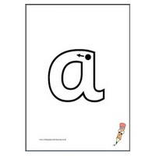Examples:

[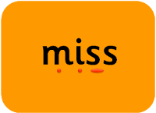](http://www.primaryteachingtools.co.uk/inc/sdetail/letters-and-sounds-phase-2---blending-for-reading/162/319)