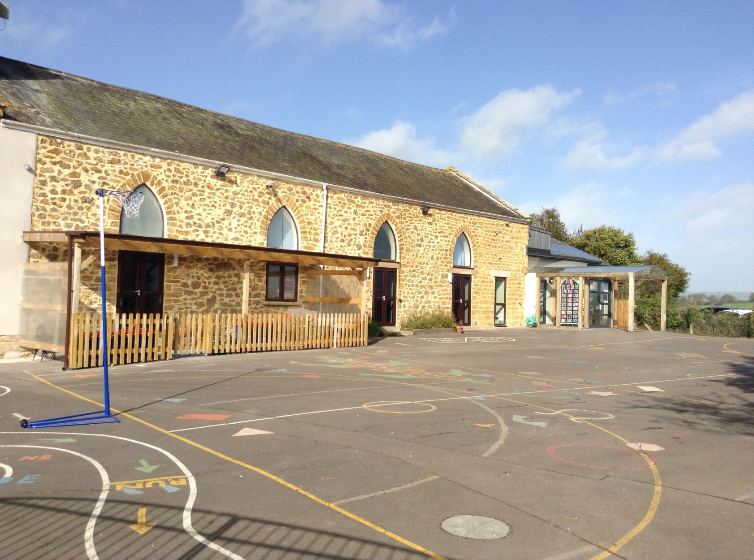

Salway Ash CE VA Primary School
School Development Plan 2022-2023
Let our light shine as we achieve together

The School Development Plan has been designed to support the school’s curriculum intention that all pupils at the school become:
- Successful learners, who enjoy learning, make progress and achieve.
- Confident individuals who are able to live safe, healthy and fulfilling lives.
- Responsible citizens who make a positive contribution to society.
School Development Plan Priorities 2022-2023

Target 1 | To embed effective subject leadership across the school
Target 2 | To improve pupil outcomes in phonics & early reading
Target 3 | To improve attainment in writing by embedding teaching English through literature
Target 4 | Pupil mental health & wellbeing
Target 5 | The Salway Ash Artist

Salway Ash CE VA Primary School
School Development Plan 2022-2023
Key Issue 1
To embed effective subject leadership across the school

Rationale: Following staff turnover, the school must ensure the provision of a broad and balanced curriculum

Success criteria:
- A clear and consistent approach to subject leadership will be evident throughout the school.
- Staff will understand what is expected of them as subject leaders and will be able to articulate the impact of their actions.
- All groups of pupils, especially pupil premium, SEND and more able children, will make good progress across the curriculum.

Actions | Key  Personnel | Monitoring  (including named governor) | Timescale | Resources | Outcomes
 |  |  |  |  | Autumn  2022 |  | Spring  2023 |  | Summer  2023
Staff to have clear understanding of expectations of subject leaders under the new inspection framework | LO  All staff | LO & subject link governors | Autumn term 1 | WDSC INSET | Subject leaders create action plans.  Effective induction of new staff | Mid-year review of progress |  | Present impact of curriculum leadership during PM meeting
Subject leaders own curriculum plans which cover the key concepts, knowledge and skills you need to cover in each subject. | All staff | LO & subject link governors | Autumn term 1 | Release time | Shared on website & in staff meeting | Mid-year review of progress |  | Present impact of curriculum leadership during PM meeting
Subject audits to ensure all subject adequately resourced | All staff | LO | Ongoing | Subject leader time to discuss with HT | Subject leaders to audit curriculum areas. | Gaps in resourcing identified. Resources ordered. |  | Resources monitored by subject leaders at end of the year ahead of 2023/24
Subject leaders to be able to demonstrate impact on planning and outcomes across the school | All staff | LO  Governor subject link | Ongoing | Subject leader release time | Subject leaders released to support planning and resourcing across the school to share expertise.
Subject leader share expertise on how to engage and support SEN, PP and more able pupils | All staff | LO | Ongoing | Subject leader release time | Pupil voice survey of key groups |  |  | Pupil voice survey of key groups
Improved CPD and subject knowledge through external collaborations | All staff | Governors | Ongoing | CPD courses as available.  Subject association subscriptions &  WDSC meetings | Where possible/available, staff to participate in external, subject specific collaborations to improve subject knowledge and impact on pupil outcomes.  Staff kept up to date with developments in their subjects and share in staff meetings.
Governor monitoring & challenge record and comments:

Salway Ash CE VA Primary School
School Development Plan 2022-2023
Key Issue 2
To improve pupil outcomes in phonics & early reading
Rationale: The school is implementing a new systematic synthetic phonics scheme this year to ensure consistency of teaching and learning to improve pupils’ attainment. Research shows that reading for pleasure has a significant positive impact on a child’s academic attainment and personal development and is a key factor in the SSP scheme.
Success Criteria
- A clear and consistent approach to teaching phonics across EYFS, KS1 and KS2 interventions
- Staff receive training on delivering phonics teaching in validated SSP scheme
- All groups of children will make good progress through accelerated reading
- Children are enthused, engaged and challenged in their reading
- Website gives clear information about school’s approach to teaching phonics
- Parents understand how to support children with reading

Actions | Key  Personnel | Monitoring | Timescale | Resources | Outcomes
 |  |  |  |  | Autumn  2022 | Spring  2023 | Summer  2023
Staff training of Little Wandle tutorials completed  Staff use “How to” videos before teaching | All staff | HT to review training “heat map” to identify areas for support | September  Ongoing | Little Wandle website access | All staff to access training videos and complete  Staff to know how to access training videos. | HT to monitor staff effectiveness and fidelity to SSP scheme and teaching style
Weekly meeting with EYFS & KS1 team to review phonics progress | All staff teaching phonics | Weekly coaching session and peer observations  Emerging strengths and areas for development identified and shared by all staff.  Staff to feel they are heard and support but in place by subject leader and Head Teacher where necessary | Ongoing | Staff to use singing assembly time | Ongoing weekly record of meeting and peer observation
Accurate assessment of pupils’ progress ensures grouping is appropriate | HT, SL, VDLH | Ongoing | Groups updated every 6 weeks | Teacher, subject leader and TA release time | Staff to know where to access assessment documents and how to use them effectively.  Staff to be given time to complete assessment.  Results from assessments show good progress of all groups of pupils. Additional support and intervention used where necessary.
All pupils have reading books which match their phonics level | HT, SL, VDLH | HT, LO & link governor | Ongoing | Early reading books linked to group stage | Half-termly check for reading levels  All children to read 3 times a week with staff who are trained. Regular discussions with class teacher and reading leader to help support staff to know groups are accurate.
Daily catch up provided for pupils who aren’t secure with the sound taught  Record kept of pupils requiring this to identify those needing further support | HT, SL, VDLH | HT, LO & link governor | Ongoing | TA release time | Pupil progress monitored and further support implemented if required | Pupil progress monitored and further support implemented if required | Pupil progress monitored and further support implemented if required
Rapid catch up programme used to support pupils who are further behind | TM | HT | 3 weekly review | Specific rapid catch up training and resources on Little Wandle website | Targeted pupils make accelerated progress | Targeted pupils make accelerated progress | Targeted pupils make accelerated progress
Improve parental engagement and support with teaching early reading | HT | Parents’ evening | September | Information prominent on school website | Parents have clear understanding on school’s approach to teaching phonics and how to support at home. | Parents’ evening used as an opportunity to support parents with reading to and with children | Phonics screening information evening for Y1 parents to explain how phonics check will work.
Monitoring of Y2 & Y3 pupils who didn’t pass phonics screening | HT, VDLH, LC, LO | HT & LO | Half-termly | Historic phonics screening check materials | Pupils receive regular phonics teaching and intervention to enable them to have secure grasp of phonic code. Assessment used to identify when they have achieved this.
Increase book stock for classrooms and library | LO, HT, DP | LO | Autumn term | New books to be purchased | Gaps in AR identified and new books purchased | Book corners in classrooms developed | Pupils have wide range of different types of text
Love of reading promoted through different events | All staff | HT, LO & link governor | Ongoing |  | Summary of events to take place throughout the year:  Books @ bedtime, author visit, mystery readers, community links
Work with Cornerstones English Hub to support implementation of new phonics scheme and RfP | LO,  All staff | HT, LO & link governor | Ongoing | Online webinar training | Specialist support given to reading leader to monitor the implementation and impact of new phonics scheme.  Support from English hub in developing RfP pedagogy and culture in the school
Governor monitoring & challenge record and comments:

Salway Ash CE VA Primary School
School Development Plan 2022-2023
Key Issue 3
To improve attainment in writing by embedding teaching English through literature
Rationale: Teaching English through literature was introduced last academic year and saw an uplift in pupil attainment across the school. With the changes in staffing, the successes achieved must be embedded
Success Criteria
- Clear overview of curriculum coverage followed by staff ensures appropriate curriculum coverage
- Pupils in each year group study a wide range of high quality texts
- Progress of all groups of pupils monitored closely with targeted intervention used to support if required

Actions | Key Personnel | Monitoring | Timescale | Resources | Outcomes
 |  |  |  |  | Autumn | Spring | Summer
Use SLN to provide targeted CPD to support staff’s subject knowledge | LO | LO & link governor | Ongoing | SLN membership | Evidence of impact CPD shown in PM meetings & wider staff feedback | Evidence of impact CPD shown in PM meetings & wider staff feedback | Evidence of impact CPD shown in PM meetings & wider staff feedback
Consistent approach to teaching spelling in KS2 | All staff | LO & link governor | September | Westover Green resources | Pupils’ attainment in spelling will improve as shown in standardised scores in NFER tests
Handwriting scheme and policy introduced | All staff | LO & link governor | September | Letter Join subscription | Clear progress seen in children’s work at each assessment point.
Create long term curriculum map | LO | LO & link governor | Autumn | Literacy Tree  Subject leadership time | Curriculum follows two-year rolling cycle to ensure sufficient coverage of writing genres
Progression of skills for each genre of writing shared with staff ensures | LO | LO & link governor | Autumn | SLN membership | Curriculum follows two-year rolling cycle to ensure sufficient coverage of writing genres
Use of specialist teaching strategies to support pupils with additional needs i.e. dyslexia | All staff | LO, ES | Ongoing | Dorset Council Specialist teachers  Staff meeting time | Staff given training from specialist teacher | SENCO and subject lead monitoring to see strategies used in classrooms
Moderate writing assessment judgements across the school & within WDSC | All staff | LO | End of each term | Staff meeting time | Secure assessment judgements made at each assessment point. | Secure assessment judgements made at each assessment point. | Secure assessment judgements made at each assessment point.
Seek out curriculum enrichment opportunities | All staff | LO | Ongoing | Bank of Dreams & Nightmares | Impact of pupil workshops evident through pupil voice and outcomes | Impact of pupil workshops evident through pupil voice and outcomes | Impact of pupil workshops evident through pupil voice and outcomes
Governor monitoring & challenge record and comments:

Salway Ash CE VA Primary School
School Development Plan 2022-2023
Key Issue 4
To assess, support and improve the Mental Health and Wellbeing of staff and pupils
Rationale: Staff observed a growing number of pupils needing support for their mental health and wellbeing during 2021/22.
Success criteria:
- All staff are knowledgeable about children’s views and what they feel they are struggling with
- Targeted individual support is given to pupils in need
- Curriculum provision supports areas of greatest concern for pupils across the school
- Assessment of pupil needs is updated throughout the school year and provision and support altered accordingly
Actions | Key Personnel | Monitoring | Timescale | Resources | Outcomes
 |  |  |  |  | Autumn | Spring |  | Summer
Targeted groups of pupils to receive ELSA support | HA, MF | LO  ES | Ongoing | ELSA training sessions & supervision through Dorset Nexus | Pupils identified and sessions begin. Reviewed at regular intervals. | Sessions continue and regularly reviewed. |  | Sessions continue and regularly reviewed.
‘Worry Box’ in each class for pupils to express their thoughts, followed through with PSHE curriculum or individual support as most appropriate | All staff | LO, MF, HA | Autumn Term | Worry Boxes | Worry Box used by pupils and concerns addressed | Worry Box used by pupils and concerns addressed |  | Worry Box used by pupils and concerns addressed
Provide additional training to staff i.e. Five to Thrive | All Staff | Governors | Ongoing | Dorset Nexus training | Identify training opportunities | Monitor participation
Clear impact of collective worship on pupils’ personal and spiritual development | All staff | LO  Governors | Ongoing | Class worship books  Collective worship planning | Record of pupils’ reflections on themes discussed in collective worship and class assemblies.
Use Forest Schools sessions to support mental health and wellbeing | JH | LO  Governors | Robins – Autumn 1 & 2  Bumblebees – Spring  Badgers – Summer 1  Dragonfly – Summer 2 | Forest school sessions with JH | 6 week plan for Forest school sessions to mirror harmony principle in each year group | Pupil voice highlighting the impact on forest school sessions
To build opportunities for pupil voice across the curriculum | All staff | LO  Governors | Ongoing | Subject leadership time | Subject leaders to conduct pupil voice interviews with groups of pupils to gain feedback on learning.
Support parents in work with children to address their emotional needs | All staff | Governors | Ongoing | External support through NHS/Dorset Nexus | Parent workshops run with support from external providers
Survey staff to identify areas of strength and where support is needed | All staff | LO  Governors | Ongoing | GVO  NHS  The Key | Staff surveys complete |  | Action plan delivered |  | Review with follow up survey & support
Governor monitoring & challenge record and comments:

Salway Ash CE VA Primary School
School Development Plan 2022-20223 Key Issue 5
The Salway Ash Artist
Rationale: To address an identified need to improve staff subject knowledge in Art, along with pupils’ lack of confidence in the subject identified last academic year, we will enhance our art curriculum to ensure that we are able to provide an excellent art curriculum.
Success criteria:
- Subject leader ensures curriculum plans are followed to ensure the breadth of skills are taught over the two-year rolling cycle
- Targeted CPD provided to ensure all teaching is of a good standard
- Pupils progress in art is accurately assessed
Actions | Key Personnel | Monitoring | Timescale | Resources | Outcomes
 |  |  |  |  | Autumn | Spring | Summer
Curriculum map updated to match art topics and skills with class topics | SL | SL & link governor | Autumn 1 | Subject leader time | Curriculum map created | Monitoring of pupil outcomes | Review of curriculum strengths & weaknesses ahead of next academic year
High quality staff training and CPD provided to develop teacher’s subject knowledge | SL | SL & link governor | Half termly | Staff meeting time | Autumn 1 meeting provides staff with teaching strategies and skills to use in Autumn 2 | Further training needs identified and planned for in future sessions | Further training needs identified and planned for in future sessions
Pupils explore additional opportunities to practice art skills through the principle of geometry | All staff | SL & link governor | Ongoing | Planning time | Pupils’ sketchbooks will show evidence of a range of skills | Pupils’ sketchbooks will show evidence of a range of skills | Pupils’ sketchbooks will show evidence of a range of skills
Assessment of pupils’ work highlights clear progression of knowledge and skills | SL | SL & link governor | Termly | Recording device  Sketch books | Pupil voice | Great works used to enable pupils to showcase artwork | Great works used to enable pupils to showcase artwork
Governor monitoring & challenge record and comments:

