Memorandum of Understanding
Partnership agreement between Salwayash
Primary and Dorset Police
Version: 1.4
Date: Dec 2020

Working in partnership to help keep children and young people safe

Introduction:
The role of the Dorset Police is to provide a visible, accessible and familiar presence to young people; in order to promote positive engagement, reduce victimisation of young people and reduce offending by young people.

As part of our ‘policing in schools’ approach, every school in Dorset will have a named police contact, based on our Policing in Schools ‘Needs’ model, this will either be a Safer Schools & Communities Team (SSCT) officer, or a Neighbourhood Police Team (NPT) officer dependent on level of need (see appendix A).
Your school meets the threshold for a named NPT officer and this Memorandum of Understanding (MoU) is the written agreement between you and the NPT.

Working in partnership, we can identify those young people at greatest risk of becoming involved in anti-social behaviour, crime and wrongdoing and we can work collaboratively to put in place preventative / diversion opportunities. We can also identify our most vulnerable young people and provide ‘wrap around’ support to them and their families.

Policing in Schools partnership agreement:

This Memorandum of Understanding (MoU) is a formal agreement between your school and Dorset Police that outlines how we will work together to keep young people safe, reduce anti-social behaviour, crime and wrongdoing, and help reduce the fear of crime in schools and the wider community.

We will offer you a dedicated NPT officer to act as the link between your school and Dorset Police. Having a visible officer linked to the school has many benefits for the school community and a partnership approach should be encouraged at all levels with clear channels of communication between the Police and a nominated Senior member of school staff.

This MoU is a live document, to be reviewed regularly or at least every 12 months, in order that it remains current and effective

Reassurance & responsiveness | - A visible and approachable police presence to provide advice on issues around crime, safety and the law.  - Early identification of risk and vulnerability within the school community.  - The school community feels safer.
Relationships | - Young people can meet with an officer in a neutral environment to positively influence relationships and behaviour inside and outside of school.  - Allow the sharing of innovative and successful new approaches to safeguarding and crime prevention.  - Improved links to other services
Risk | - Improved information sharing and reaction to safeguarding concerns.

Roles and responsibilities:

Dorset Police via the NPT will:
- Provide a named officer to be a visible and familiar contact with your school (mutually agreed time/date)
- Offer an officer as a point of contact between school and their local neighbourhood policing team
- Update Head Teacher and their staff on local policing issues.
- Provide regular updates to school staff on local policing issues.
- Provide school information on what should be reported to Police in line with the ‘When to report to police’ guidance (link) and Dorset Police ‘schools incident’ policy (link)
- Work in partnership with your school to ensure a correct balance between engagement and enforcement, supporting a restorative approach where appropriate.
- Participate, as appropriate, in multi-agency case conferences within and outside the school environment for students coming to notice.
- Gather and disseminate intelligence in relation to pupil behaviour linked or potentially linked to crime or ASB.
- Share information/intelligence with wider police colleagues which impacts on their assigned school(s).
- Perform regular uniform patrols in the vicinity of the school to address truancy, ASB and crime.
- Support restorative practices to support pupils in understanding the consequences of their behaviour and impact on others.
- Be available for 1:1 and small group discussions with students on the periphery of crime and anti-social behaviour including those who are vulnerable to being exploited (SSCT can be used if deemed necessary).

The school will:

- Agree and sign this MoU and the information sharing agreement
- Identify a Link member of the Senior Leadership Team to liaise with the named NPT officer
- Ensure all school staff are aware of the MoU
- Ensure that all parents are aware of this partnership and understand that the Police may engage with their child. School behaviour policies to reflect this partnership.
- Share with the Police signs of concern/vulnerability to support an early intervention model (please follow your usual safeguarding referral mechanism)
- Utilise the expertise of the named officer to problem solve specific crime and anti-social behaviour related issues inside and outside of the school
- Ensure a partnership approach to provide the best outcomes for young people involved in crime and antisocial behaviour
- Provide a clear behaviour recording process; schools related misbehaviour to be recorded on school systems.
For info the Police will use police systems to record ‘crime related’ information and their involvement (if any)
- Provide appropriate ‘work’ space for the Police when they are on-site and/or when they are engaging with pupils.
- Termly engagement with NPT management team to facilitate on-going appraisal of the MoU.

.

This MoU should be applied in conjunction with:
Behaviour and discipline in schools (guidance for head teachers and staff): https://www.gov.uk/government/publications/behaviour-and-discipline-in-schools
Behaviour and discipline in schools (guidance for governing bodies): https://www.gov.uk/government/publications/behaviour-and-discipline-in-schools-guidance-for-governing-bodies
Searching, screening and confiscation (Advice for head teachers, school staff and governing bodies): https://www.gov.uk/government/publications/searching-screening-and-confiscation
Use of reasonable force in schools: https://www.gov.uk/government/publications/use-of-reasonable-force-in-schools
Home Office Counting Rules for recorded crime in schools: https://assets.publishing.service.gov.uk/government/uploads/system/uploads/attachment_data/file/877783/count-general-apr-2020.pdf
Education Bill Part 2 (Discipline): http://www.legislation.gov.uk/ukpga/2011/21/contents/enacted/data.htm
Advice on school security: Access to, and barring of individuals from school premises (For local authorities, school leaders and school staff): https://www.gov.uk/government/publications/school-security
Working together to Safeguard children: https://www.gov.uk/government/publications/working-together-to-safeguard-children--2
Data Sharing Agreement (DISC): https://www.dorsetcouncil.gov.uk/care-and-support-for-adults/dorset-information-sharing-charter-disc/about-the-dorset-information-sharing-charter-disc.aspx
When to report to Police: (https://www.npcc.police.uk/documents/Children%20and%20Young%20people/When%20to%20call%20the%20police%20guidance%20for%20schools%20and%20colleges.pdf)
Policing in Schools toolkit (PSHE): https://www.pshe-association.org.uk/policing
Body Worn Video - https://www.dorset.police.uk/news-information/body-worn-video/

This agreement will be subject to an annual review and may be terminated at any time by either party.

Signatures Name / Title Date

…………………………. ……………. PCSO 5404 Alex Bishop 02/02/21
Dorset Police

Lisa L Crew Lisa Crew
Headteacher Salway Ash Primary School 05/02.2021
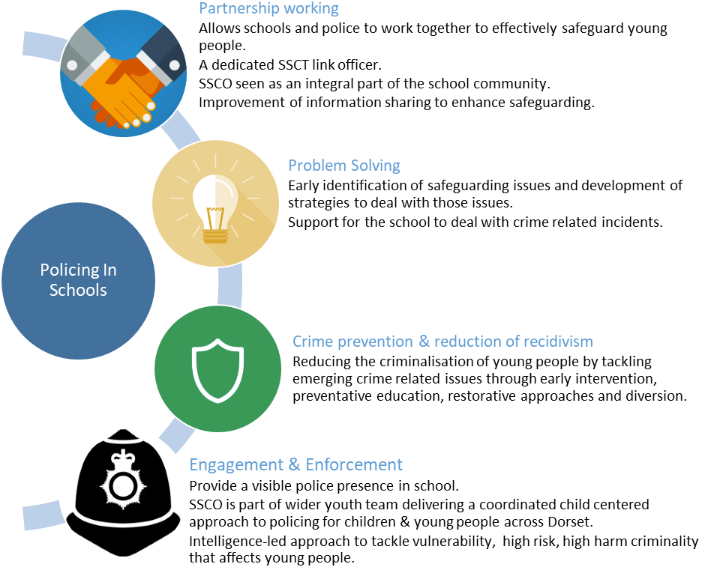
Credit – MPS Safer Schools Partnership

Appendix A
Safer Schools & Communities Team Operating Model
September 2020

- Introduction
1.1 This paper sets out the redesign of the Dorset Safe Schools & Communities Team (SSCT) as part of the force’s Prevention Department restructure and disaggregation from the Alliance in this area of business.

1.2 As of April 1st 2020, the SSCT will adopt the name ‘Safer Schools and Communities Team’ to align with the ‘Safer Dorset’ branding.

1.3 The SSCT will sit within the Dorset Prevention Department as part of Territorial policing and will take a targeted, intelligence led approach to tackle and prevent youth crime and wrongdoing as opposed to the current ‘Traded Services Model’.

1.4 This paper proposes both a new operating model for the SSCT as well as a wider ‘Policing in Schools’ model that looks to develop our Neighbourhood Policing Team (NPT) approach to working with schools. It also outlines an education/training delivery plan aligned with the model, giving access to education/advice/support and intervention to schools and young people on a scaled approach.

- Background
2.1 Dorset Police in partnership with the Dorset Youth Offending Team (YOT) were successful in securing funding via the Dorset Children’s Fund to set up a ‘Safer Schools Partnership’ (SSP) in 2003.
2.2 The SSP consisted of a seconded Police Constable (PC), a Youth Justice Project Worker and Admin support and was based in Ferndown Middle school.
2.3 In 2005 the SSP changed its operating model, to focus on all schools in the then Eastern BCU as well as broadening its focus from schools to include communities, as such it took on the title ‘Safe Schools and Communities Team’ (SSCT). Three additional officer posts were added (2 PCs and a Police Community Support Officer) as well as a co-ordinator.
2.4 In readiness for the move from a four BCU model to a two, which would merge the Eastern and Western Basic Command Unit into a Dorset BCU, the SSCT was expanded to cover Weymouth, Portland and Dorchester and the team was increased by a further two school officer posts
2.5 The SSCT were involved in supporting schools and colleges in the areas of anti-bullying, internet safety, reducing anti-social behaviour, alcohol and drug misuse, diversity, weapons as well as working with small groups of young people or on a 1:1 basis.
2.6 In 2009, the SSCT expanded into Bournemouth and Poole (as was), with an offer of a year’s ‘free’ service with a view to ‘trading’ from 2010
2.7 Traded service began in 2010, initially the SSCT were commissioned via the ‘schools designated fund’ (top slice), following government changes to this funding formula the local authority set up a ‘consortium; for schools to group together and ‘buy in’ SSCT.
2.8 Dorset YOT, which later became the Dorset Combined YOS continued to fund the SSCT as did the OPCC

- SSCT Model 2020 – ‘Needs’ based model
3.1 The Prevention Department restructure created 9 Safer Schools & Communities Officers (SSCOs) posts to cover the force-wide area.
3.2 The focus of the SSCOs will be to provide a visible, accessible and familiar presence to young people in order to promote positive engagement, reduce victimisation of young people and prevent & reduce offending by and between young people.
3.3 Working in partnership, we will use a series of indicators and data sets to assist us in identifying children, schools and communities that require the support of the SSCT the most and we will prioritise our engagement to most effectively meet this need (see figures 1 and 2).
3.4 As part of our ‘policing in schools’ approach, every school in Dorset will have a named police contact, based on our ‘Needs’ model this will either be a SSCT officer or a NPT officer.
3.5 For those schools (all types) who are within the ‘complex’ category, we propose to offer a dedicated SSCO to work as part of the school ‘family’, operating from within the school (times to be jointly agreed, but at least weekly).
3.6 All Amber (non-complex) secondary and middle schools (over year 7) to have a named NPT Single Point of Contact (SPOC) with the expectation that they will have regular engagement with their school, (times/dates to be jointly agreed).
3.7 All Green ‘non-complex’ Secondary/Primary & First schools will have an NPT SPOC with expectation of a minimum of termly engagement.
3.8 For those secondary/middle schools in the ‘Enhanced’ category, the expectation is that the NPT and SSCO will work closely with the school to identify issues and work together to put in place effective practices to mitigate them (1:1 work, small groups or classroom inputs).
3.9 Primary and First schools within the ‘enhanced’ category will be offered targeted advice and support from the SSCT, who will, where possible, work in partnership to develop diversionary activities.
3.10 All schools within the ‘universal’ category will be offered ‘targeted’ educational inputs via the SSCT such as ‘weapons’, ‘child exploitation’ and ‘sexting’ in line with force and local priorities and as deemed appropriate.

‘Policing in Schools’ Model
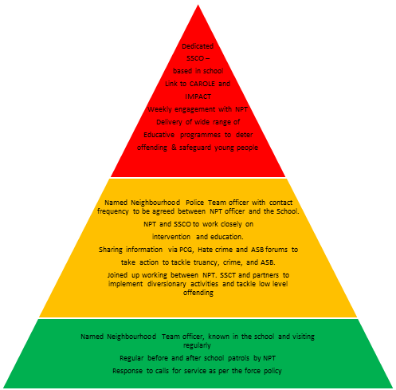
Tier 3: Complex
Schools with identified risks around knife crime, county lines, child exploitation or violent extremism.

Tier 2: Enhanced
Schools vulnerable as a result of increased incidence of crime and/or ASB
Tier 1: Universal
Universal Services to all schools.

Fig 1 – Secondary & Middle school proposed response

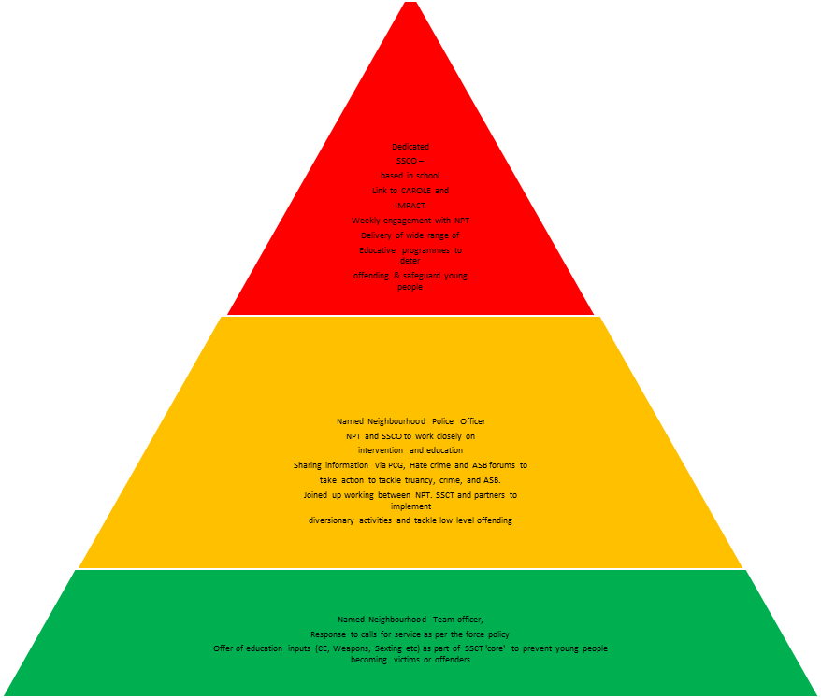
Tier 3: Complex
Schools with identified risks around knife crime, county lines, child exploitation or violent extremism.

Tier 2: Enhanced
Schools vulnerable as a result of increased incidence of crime and/or ASB
Tier 1: Universal
Universal Services to all schools.

‘Policing in Schools’ Model
Fig 2 – Primary and First School response
Table 1 – assessment of need matrix

SCHOOL ASSESSMENT OF NEED
Tier 1 | Tier 2 | Tier 3
Universal Service | Enhanced Service | Complex Service
Emerging Risk Factors Evidenced Risk Factors
 | INCREASING RISK
Geographic location of school (deprivation, crime, ASB)  Area is rated as low | Area is ranked moderate and/or the types of offending are serious in the area | high cohort of youth offenders as pupils  weapons incidents/ offences on school premises  county lines / drugs involvement by pupils
unauthorised attendance / exclusion rates are low | levels of permanent exclusions above national avg or local target | specialist teaching environments for excluded children
high risk issues such as  Child exploitation, county lines, radicalisation, weapons are low | individuals known to be involved and/or at risk of becoming involved in these issues | Vulnerable groups  high cohort of youth offenders related to these incidents.  multiple students linked to these issues
Demographics (low levels of free school meals, SATs and GCSE in line with national average | increased levels of free school meals, SATSs and GCSE outcomes, high SEND | Significant numbers of pupils with free school meals, SEND and not achieving SATs & GCSE outcomes.

