Salway Ash CE VA Primary

Inclusion Policy
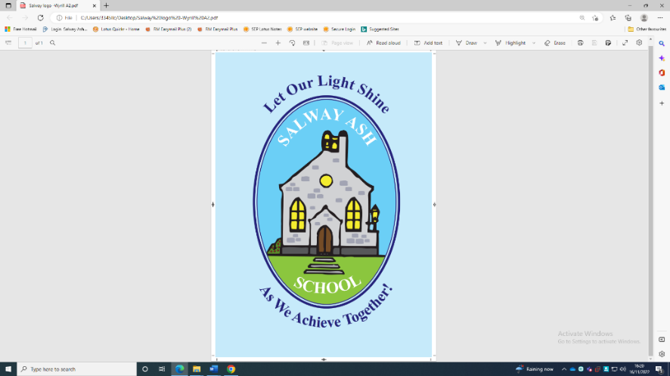

Approved by: | Leif Overment - Headteacher | Date: March 2025
Last reviewed on: | March 2025
Next review due by: | March 2027

School Vision Statement
Our aim at Salway Ash School is to:
- provide a safe and supportive environment where children, staff, parents, governors all work in partnership with the local community to attain high standards, achieving academic, creative, spiritual, social and emotional fulfilment.
- develop pupils who are kind and considerate towards one another and want to make a positive contribution to the world around them
- provide a secure, caring Christian ethos that enables us to grow together, learn together and inspire each other.
School Values
Compassion
We show compassion in the way we act with our friendships and people in our community.
Perseverance
We are determined and resilient in the face of challenges.
Hope
We share high expectations and aspirations for everyone in our school and seek to make a positive difference to the world.
Respect
We are respectful in the way we interact with each other and the world around us.
Joy
We celebrate the joy of each other’s achievements and bring joy to the world.

1 Introduction
1.1 We are committed to giving all of our children every opportunity to achieve the highest of standards. We do this by taking account of pupils' varied life experiences and needs. We offer a broad and balanced curriculum and have high expectations for all children. The achievements, attitudes and well-being of all our children matter. This policy helps to ensure that this school promotes the individuality of all our children, irrespective of race, religion, ethnicity, attainment, age, disability, gender or background.

2 Aims and objectives
2.1 Salway Ash CE VA Primary school is an inclusive school. We actively seek to remove the barriers to learning and participation that can hinder or exclude individual pupils, or groups of pupils. This means that equality of opportunity must be a reality for our children. We make this a reality through the attention that we pay to the different groups of children who may be within our school community and how this is presented:
- Girls and boys
- Children with special educational needs
- Children with medical needs
- Children who are neurodiverse
- Children with physical disabilities
- High potential learners
- Children for whom English is an additional language (EAL)
- Minority ethnic and faith groups
- Pupil Premium children, including disadvantaged (Free School Meals & Ever 6)
- Children from mobile or displaced backgrounds
- Children ‘looked after’ by the local authority (fostered or in care)
- Children whose families are being monitored and supported by the Social Services
- Other children, such as sick children, young carers and those from families under stress
- Children who are at risk of disaffection or exclusion
- Children who have moved house/school frequently

2.2 The National Curriculum is our starting point for planning a curriculum that meets the specific needs of individuals and groups of children. We meet these needs through:
- quality first teaching including differentiation, within the classroom or other whole class learning environment
- providing suitable learning targets and challenges to promote progress
- responding to children's diverse learning needs
- using a range of teaching techniques to accommodate different learning styles/needs
- overcoming potential barriers to learning for all pupils
- ensuring specialist advice is sought to meet the needs of individuals or groups of children, such as speech and language therapy

2.3 We achieve educational inclusion by continually reviewing what we do, through asking ourselves these key questions:
- Are all our children achieving their best?
- What differences are evident in the achievement of various groups of children?
- Have we provided effective interventions for those children who may be underperforming?
- Are our actions effective?
- Are we successful in promoting racial harmony and the integration of minority groups, thereby preparing pupils to live in a diverse society?

The data we gather annually, using the school’s system of progress trackers, help us to review our children’s progress against these criteria and where needed the school will intervene through additional support. We also monitor children’s access to extra-curricular activities through the use of extensive provision and class inclusion maps. For example those who struggle to complete homework at home are identified for homework club.

3 Teaching and learning
3.1 We aim to give all our children the opportunity to succeed and reach the highest level of personal achievement. Through summative assessment coupled with teacher assessment. we analyse the attainment of different groups of pupils to ensure that all children are reaching their potential. We also make ongoing assessments of each child's progress. This enables teachers to plan from where the children are in their learning, taking into account the abilities of all children and scaffolding work accordingly. A child’s particular learning style may also be taken into account, sometimes using advice from support services.
3.2 When the attainment of a child falls significantly below or above the expected standard for their year group, teachers help the child to succeed by planning work that is in line with that child's individual needs, and providing appropriate support. Where the attainment of a child significantly exceeds the expected level of attainment, teachers use materials that extend the depth of understanding within the area for which the child shows particular aptitude.
3.3 Teachers are familiar with the equal opportunities legislation covering race, ethnicity, gender and disability.
    - Teachers support all children to:
- feel secure and know that their contributions are valued
- appreciate and value the differences they see in others
- take responsibility for their own actions
- are taught in ways that allow them all to experience success
- use materials that reflect a range of social and cultural backgrounds, without stereotyping
- have a common curriculum experience that allows for a range of different learning styles
- have challenging targets that enable them to succeed
- participate fully, regardless of disabilities or medical needs

4 Children with disabilities
4.1 Some children in our school may have disabilities or medical needs. We are committed to meeting the needs of these children, as we are to meeting the needs of all groups of children within our school. The school fully meets the requirements of the amended Disability Discrimination Act that came into effect in September 2010. All reasonable steps are taken to ensure that these children are not placed at a disadvantage compared with non-disabled children.
4.2 The school is committed to providing an environment that allows disabled children full access to all areas of learning. All our classroom entrances are wide enough for wheelchair access, and the designated points of entry for our school also allow wheelchair access. Our Accessibility Plan identifies how disabled pupils can take advantage of all that our school has to offer.
4.3 Teachers modify teaching and learning expectations as appropriate for children with disabilities. For example, they may give additional time to complete certain activities, or they may modify teaching materials. In their planning, teachers ensure that they give children with disabilities the opportunity to develop skills in practical aspects of the curriculum.
4.4 Teachers ensure that the work undertaken by children with a disability:
- takes account of their pace of learning and the equipment they use
- takes account of the effort and concentration needed in written/oral work, or when using specialist equipment e.g. vision aids
- is adapted or offers alternative activities in those subjects in which children are unable to manipulate tools or equipment, or use certain types of materials
- allows opportunities for them to take part in educational visits and other activities linked to their studies
- implement assessment techniques that suit individual needs and abilities

5 Disapplication and modification
5.1 The school can, where necessary, modify the National Curriculum and its assessment arrangements. Our school policy is to do this only in exceptional circumstances. The school makes every effort to meet the learning needs of all its children, without recourse to disapplication or modification. We achieve this through greater differentiation of the child's work, or through the provision of additional learning resources. When necessary, we also support learning through appropriate external specialists. In such cases, teachers work closely with these specialists to support the child.
5.2 In exceptional circumstances, we may decide that modification, disapplication or rarely ‘back-yearing’ is the correct procedure to follow. We would only do this after detailed consultation with parents and the LA. The school's governor with responsibility for special educational needs would also be involved in this process. We would ensure that every effort had been made to provide the necessary support from within the school's resources before considering such action.
5.3 Should we need to go ahead with modification or disapplication, we would do so through:
- Section 364 of the Education Act 1996. This allows modification or disapplication of the National Curriculum, or elements of it, through an EHCP.
- Section 365 of the Education Act 1996. This allows the temporary modification or disapplication of the National Curriculum, or elements of it
- use of the NAA guidelines, updated annually.

6 Inclusion and racism
6.1 The school is aware of the recommendations of The Stephen Lawrence Inquiry; Macpherson Report (1999). The diversity of our society is addressed through our schemes of work, which reflect the programmes of study in the National Curriculum. Teachers are flexible in their planning and offer appropriate challenges to all pupils, regardless of ethnic or social background. We ensure that our curriculum reflects diverse cultures, histories, and perspectives, promoting an inclusive worldview among our pupils.
All racist incidents are now recorded and reported to the governing body by the headteacher. The school contacts parents or carers of those pupils involved in racist incidents.
Our definition of racism: “A racist incident is any incident which is perceived to be racist by the victim or any other person”
Further details are to be found in the school's Anti-Racism Policy.

7 Summary
7.1 In our school, we value each child as a unique individual with equal rights. We will strive to meet the needs of all our children, ensure their rights are met, and seek to ensure that we meet all statutory requirements related to matters of inclusion.

8 Monitoring and review
8.1 This policy is monitored by the governing body, and will be reviewed every two years, or earlier if necessary.

7. Reinforce Anti-Racism Measures
- The anti-racism section (6.1) could benefit from a clearer commitment to embedding diverse perspectives in the curriculum rather than just responding to incidents. Example addition:
  - “We ensure that our curriculum reflects diverse cultures, histories, and perspectives, promoting an inclusive worldview among our pupils.”

