Dear Parents and Carers,
I am very pleased to be able to share with you the content of two letters recently received in school from Dorset County Council and Rt. Hon Nick Gibb M.P.
These letters are congratulating Salway Ash on our continued delivery of a high standard of education for all pupils and our exceptionally high standards achieved in pupil’s reading progress and attainment.
It is a pleasure to share these letters with you and to have the opportunity to celebrate our school and the hard working staff and pupils.
As always, thank you for your continuing support with all we are striving to achieve.
Yours Sincerely

Lisa.L Crew

DORSET COUNTY COUNCIL:
Dorset Education Advisory Service West Court
County Hall Dorchester DT1 1XJ Date:7th February 2017

Dear Lisa Crew,
Subject: School Improvement 2016-17
Following a recent review of schools undertaken by the Dorset Advisory Service, it was agreed that Salway Ash CE VA Primary School continues to perform consistently well and that you deliver a high standard of education to your pupils.
………………………………….
…………………………………
Should you wish to discuss this further, please do not hesitate to contact me.
Yours sincerely
Sheila O’Donnell
Senior Advisor
Dorset Education Advisory Service P.T.O
Education Services

Rt Hon Nick Gibb MP
Minister of State for School Standards

Sanctuary Buildings, 20 Great Smith Street, Westminster , London, SW1P 3BT tel: 0370 000 2288 www.educat ion.gov.uk/help/contactus

Mrs Lisa Crew Headteacher
Salway Ash Church of England Voluntary Aided Primary School Salwayash
Bridport DT6 SJE
7 February 2017

Dear Mrs Crew,

I would like to congratulate you, your staff and your pupils for the very high standard that pupils in your school have achieved in reading in the 2016 key stage 2 assessments.

Your school's results, as published on 15 December, show that 100 per cent of your pupils reached or exceeded the expected standard in reading at the end of key stage 2. This means that your school is in the top 1% of primary schools in England for achievement in reading.

We want to ensure that every child has the necessary fluency in reading to prepare them for a successful secondary education and beyond, and your school has provided this to all your pupils.

Thank you for your hard work and professionalism in producing such high standards and congratulations again to you and your staff for all you have achieved.

With best wishes. Yours sincerely,
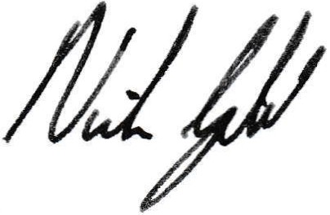

Nick Gibb MP

