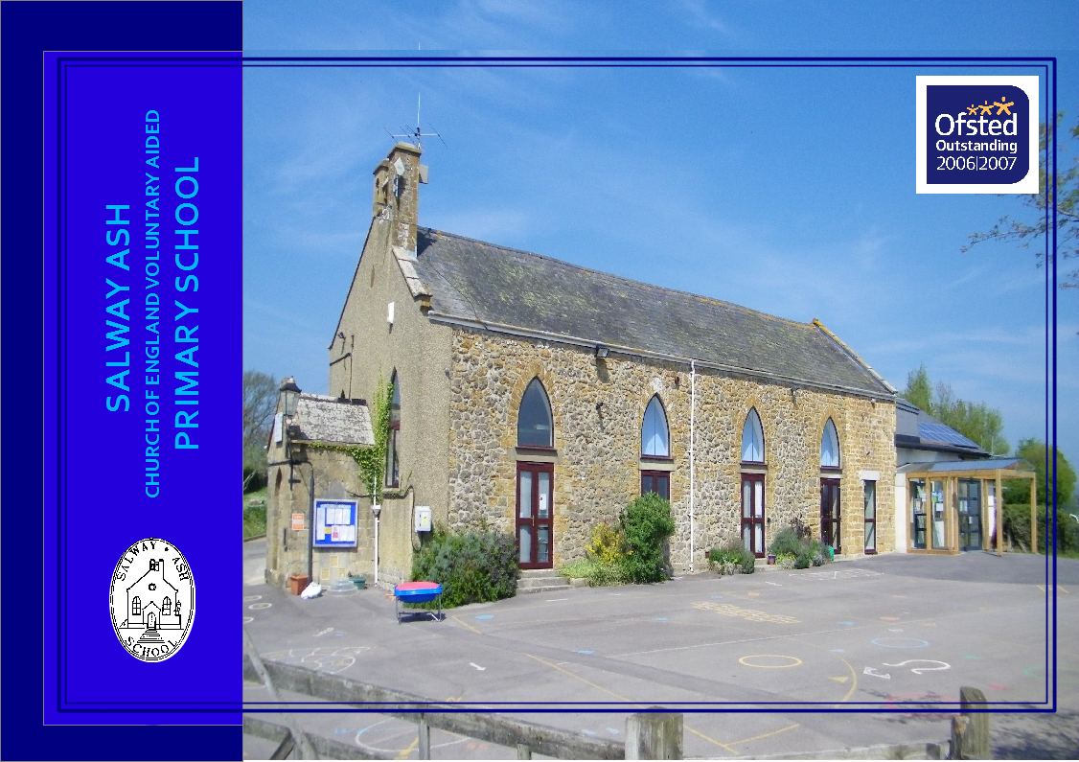

Salway Ash School, Salway Ash, Bridport, Dorset DT65JE 01308488302
www.salwayashschool.org office@salwayash.dorset.sch.uk

PROSPECTUS 2016/17

Introduction .......................................................... 3 | School uniform ..................................................... 15
The Governor’s mission statement ……………... 3 | School meals ......................................................... 16
The school curriculum .......................................... 4-9 | Transport ............................................................... 16
Homework ............................................................ 9 | Optional extras ...................................................... 17
School library ....................................................... 9 | Voluntary contributions ........................................ 17
Staff ……………………………………….......... 10 | Parents and Teacher Association ........................... 18
The Governing body .............................................. 11 | Health ................................................................... 18
Organisation of classes ......................................... 12 | Assessments and Results....................................... 19
Beaminster pyramid ............................................. 12 | Absence data .......................................................... 22
Times of school sessions ...................................... 12 | Exclusion data ........................................................ 22
Information and communications technology ...... 13 | Communications with the school ………………... 22
Pupils with disabilities and special needs …............ 13 | Admissions policy .................................................. 23
Parents’ appointments and reporting progress...... 14 | Home School Agreement ………………………… 33
Complaints Policy............................................................14 | School diary ............................................................ 34
Bullying policy ..................................................... 14 | Dorset Family Information Service................................ 35
School rules .......................................................... 15

INTRODUCTION

Lisa Crew, Headteacher

Selecting a school that will provide the best education for your child is one of the most important decisions that we as parents have to make for our children.
This brochure is to provide you with information that will help you to make that choice.
You are also welcome to visit the school and see the children at work. I will be happy to answer any questions that you may have.

At Salway Ash we continually strive for outstanding results but will always place equal emphasis on helping to create happy, confident children. We have high expectations of our children and enjoy watching them live up to those expectations.

We look forward to welcoming you and giving you the opportunity to discover
why we are so proud of our school and all that it offers you and your child.

Let our Light Shine, As we achieve together!

Our aim at Salway Ash School is to:-
provide a supportive environment where children, staff, parents, governors and the local community all work together to attain high standards,
achieving academic, creative, spiritual, social and emotional fulfilment.
provide a secure, caring Christian ethos that enables us to grow together, learn together and inspire each other.

THE SCHOOL CURRICULUM
The Department for Education set out a new framework for the National Curriculum at Key Stages 1 and 2 from September 2014.
Teachers carefully plan work to cover all curriculum subjects in order to give as broad a base as possible. Throughout the year interesting and exciting work is produced by the children through following the National Curriculum and completing termly topics.

The core subjects of numeracy and literacy are taught on a daily basis throughout the school year and through other subjects.
Science is also a core subject and is taught weekly. Foundation subjects are: Art and Design, Computing, Design and Technology,
Geography, History, Music, and Physical Education. A Foreign Language, in our school this is French, is also compulsory at
Key Stage 2. In addition, we are required to teach Religious Education to both Key Stages and Early Years Foundation Stage.
According to statutory requirements, children are formally tested (SATs) towards the end of Year 6 in English and Mathematics, and teacher assessed for Science.
They are also teacher assessed towards the end of Year 2 for English, Mathematics and Science.
Children are given a statutory Phonics screening test at the end of year 1.
Although it is not a legal requirement, we are assessing all of our pupils throughout the year, in order to ensure excellent progress across all areas of the curriculum.

ENGLISH
Literacy is taught daily in each class often connected to a class topic. Our aim is to develop an understanding of the spoken and written word enabling children to express feeling and meaning clearly.

READING:
We recognise that some children will begin school having already acquired many reading skills. This will be valued and recorded by the teacher and will be built upon.
The main Reading Scheme throughout the school is ‘Oxford Reading Tree’. This is supplemented by other reading material at the appropriate level.
By the time the children have reached Years 3, 4, 5, and 6 they are well into the routine of selecting books and recording what they have read. They will then move on to 'free readers' when a good standard of fluency and comprehension has been reached. The school uses a software system called ‘Accelerated Reader’. This allows teachers and parents to keep track of pupil’s progress in reading comprehension, whilst also ensuring they regularly read books which are appropriate to their ability and age.
YOU HAVE AN IMPORTANT PART TO PLAY!
Set aside a time during the evening when you are able to devote your attention to helping your child to read.
Share the enjoyment of the story and boost your child’s confidence with constant praise for even the smallest achievement.

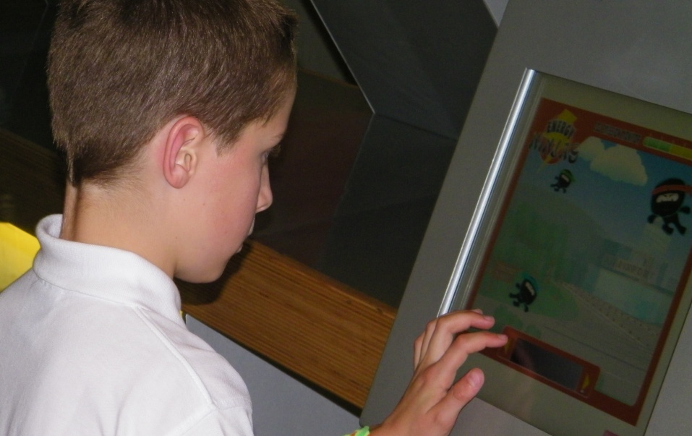
MATHEMATICS

Mathematics is taught on a daily basis. Each class has a clear programme of work,
which they follow according to the child’s level of ability.
We know that basic numeracy skills are the foundation for success at a later stage of development.
-as such, a good mix of basic routine work and investigational skills are included in our lessons.

You can help us to help your child become competent with numeracy.
Help them enjoy using numbers in everyday life by familiarity with telling the time,
understanding money, number puzzles and games.

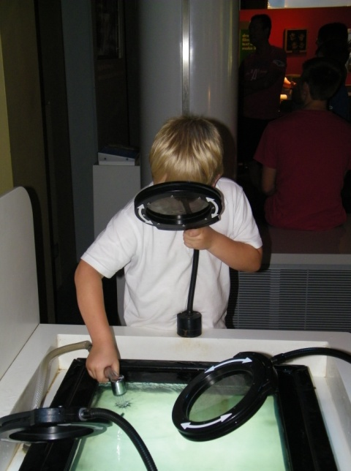
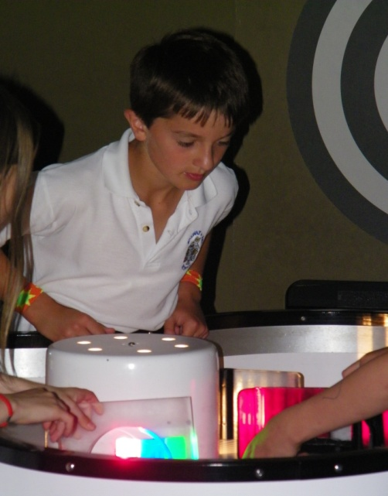

SCIENCE
The aim of science education in the school is to encourage the children’s natural curiosity through experimentation, observation and investigation to make sense of the world around them. Teachers endeavour to make it fun and interactive including a mix of practical activities and investigations and recording of results, which enable children to gain first-hand knowledge and experience.

In their early years the children will encounter key ideas and concepts in simple form and then will continue to build on these to develop a higher level of understanding.

Science in the school is taught through ‘units of work’ and follows a two-year rolling programme and as in all areas follows the National Curriculum Guidelines.

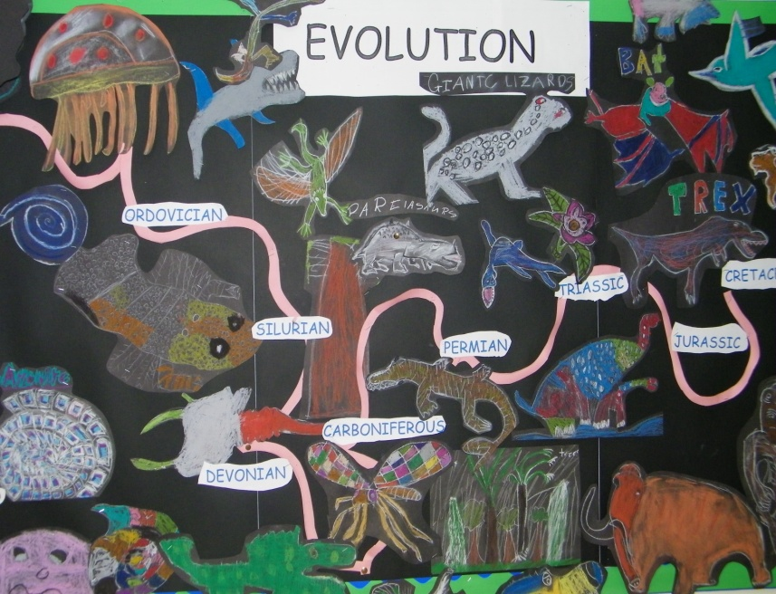
Examples of topics:

Geography, History and Science
Reception, Years 1 and 2: Weather, Homes, Transport, Knights and Castles, Water, In The Woods, Our Food, Pre-historic Life, Vikings, Mini beasts, Rivers, Birds, Two Islands, Our Town, Superheroes, This is me and my world, Under the sea.

Years 3 and 4: The Romans, Light and Electricity, Animals and plants, Friction, The Anglo-Saxons, Greece and Ancient Greece
Years 5 and 6: The World, Mountains, Volcanoes and Earthquakes, Vikings, Mayan Civilisation,

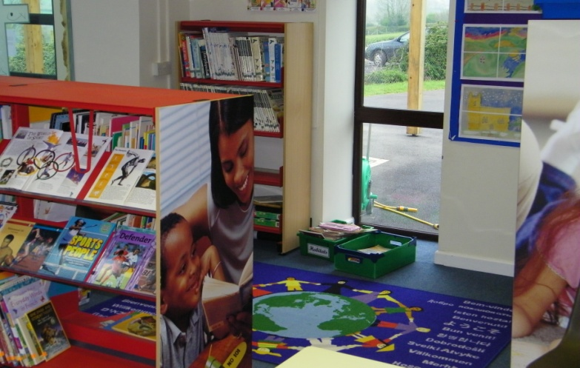

Examples of I.C.T. areas of work
Reception, Years 1 and 2: Create and debug simple programs, plan a route on ‘Beebot’,create, store
and retrieve digital content, keep personal information safe. concerns.
Years 3 and 4: Design programs that accomplish specific goals, Debug programs, Use logical reasoning
to detect and correct errors in programs, select appropriate software, select, use and combine
internet services, analyse, evaluate, collect and present data, know how to get support with internet/online and recognise acceptable/unacceptable behaviour when using technologies.
Years 5 and 6: Solve problems by decomposing them into smaller parts , use logical reasoning to explain
how some simple algorithms work, appreciate how search results are ranked, multi-media presentations,
understand computer networks, select, use and combine software on a range of digital devices, be
discerning in evaluating digital content.
Examples of Design & Technology areas of work
Reception, Years 1 and 2: Puppets, Make a 3D picture, Moving vehicles, Food design, Construction kits
Years 3 and 4: Food, Packaging, 3D model making (linked to History, Geography and Science topics)
Years 5 and 6: Design, Make and Evaluate Products, (Linked with Geography/History/Food Tech. topics), Appropriate use of Tools and Materials

P.E. & Games
Physical Education is a real strength at Salway Ash.
The school has very successful school teams which compete against other primary and middle
schools. There are many opportunities for pupils to enter area and district sporting competitions, for example in cross
country running, swimming, gymnastics, tennis and golf.
In the early years, lessons are designed to improve hand and eye skills through a variety of activities such as group games, individual exercises and using and exploring apparatus.
As children reach Key Stage 2, they are introduced to games which require specific skills in particular football, netball, cricket, tag rugby, uni-hoc and short tennis.
All children attend school swimming lessons held at Bridport Leisure Centre. Children and teachers are transported by bus and lessons are run by trained instructors. Voluntary contributions are requested to cover transport and tuition costs.

In 2013, 2014, 2015 and 2016 the school has been awarded the GOLD School Games Kitemark for PE and Sport (The highest level).

Religious Education and Collective Worship

As a Church of England Voluntary Aided (VA) School we maintain strong links with the Church. We carry a strong Christian ethos, building upon children’s fundamental unity, sensitivity to difference and the faiths of others.
As part of our tradition we invite you to join us to celebrate traditional festivals in our village Church.
Every day we hold an assembly (collective worship) and often welcome outside speakers. Friday Celebration assemblies are held to recognise children's achievements and parents are welcome to attend. Children love to demonstrate what they have been learning and grow increasingly confident with doing this. Each week certificates are awarded for particular accomplishments. Amongst these are ‘British Values’ with one chosen each week as a focus.
RE lessons are designed to provoke thought and enquiry in a religious context and to inform the children about Christianity, along with other important World faiths. We hope to broaden children’s horizons and through understanding, lay the groundwork for a more tolerant and informed society.
Parents are entitled, on application to the headteacher, to withdraw their children from collective worship. In such an event your child will not be made to feel isolated or ‘different’.

Art
All children possess a creative instinct. Throughout the course of their education at this school children will be encouraged to undertake Art and Craft projects which encourage independence of thought and action and involves them in exercising choice and making decisions.

Children are directed towards observing, recording and expressing the natural and manufactured world through a variety of media to develop practical skills.

We enable our children to become visually literate, to understand and use art as a form of visual and tactile communication and to give them opportunities to enjoy and express themselves.

They are also given the opportunity to discover the work of famous artists past and present.
We encourage involvement with local artists and liaison with other schools.

Music
There is a strong tradition of music at Salway Ash School which we aim to maintain and develop.
Throughout the school every child is given an opportunity to express themselves through music.
Children experience performing, composing, listening and appraising music.

Singing plays a prominent part in school and it is wonderful to hear the children singing in assemblies, performances and concerts.
We find it very rewarding that many children have the confidence to sing or play solo in these events.

Through being actively involved in music-making, children learn about the main elements of music, about music of different styles and from a range of times and places.
All children are taught to play the recorder in years 3 and 4 and have many opportunities to sing.

All pupils in year 4 are loaned an instrument for 10 weeks and given free tuition during school time in order to have a taster in playing an instrument. There is then the opportunity to carry on with lessons if so desired.
A team of visiting instrumental teachers offer tuition in woodwind, piano, drums and strings. A charge is made for this tuition and information can be obtained from the school office.

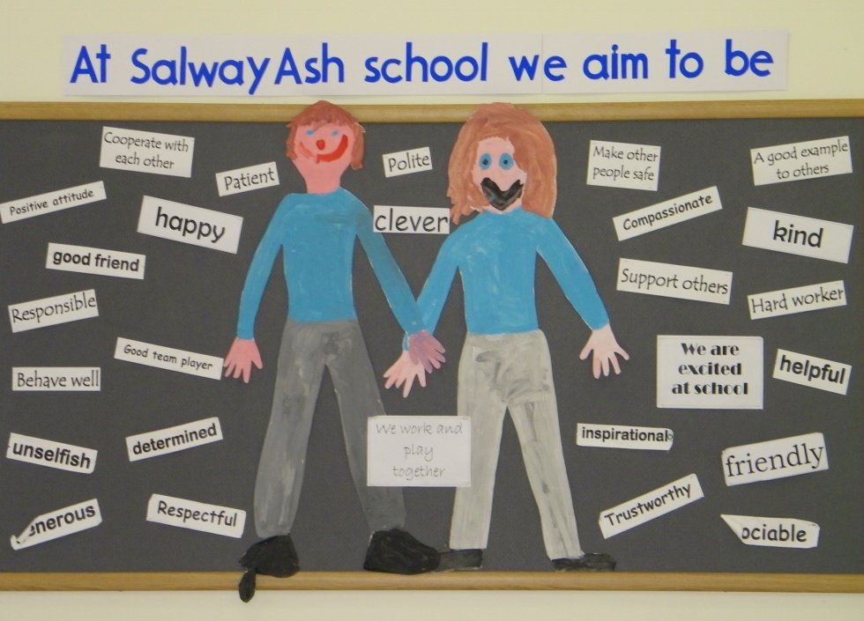
Sex Education and Personal Relationships
At Salway Ash pupils develop an awareness of self and sensitivity to others and acquire the confidence to make and hold moral judgements.

Personal and social relationships and health education are integral parts of day to day teaching. Children are encouraged in habits of self-discipline and acceptable behaviour within a family oriented and Christian framework.

Efforts are made to encourage straightforward discussion in order to develop constructive attitudes in these areas.
In Years 5 and 6 child development and puberty are discussed to prepare children to cope with the physical and emotional challenges of growing up and to give them an understanding of human reproduction. Through this programme children will explore how to make and maintain relationships with their families and peers, to learn respect for themselves and for others.
Parents have the right, on application to the headteacher, to withdraw their children from all or part of the sex education programme (but not from teaching of biological aspects of human growth and reproduction, which are required under the national curriculum for science).

HOMEWORK
The class teacher will set homework relating to a curriculum area or topic currently being studied within the class. In the first years, this is likely to be reading and letter recognition tasks. Later it may consist of an art and design task, reading, research, writing, spellings or a mathematics related task.
We hope that you will take an interest in the homework set and encourage your child to talk about the work they do in school. We always appreciate parental involvement in children’s learning.
PARTNERSHIP WITH PARENTS
It is very important to keep parents informed as much as possible on aspects of learning taking place in school. During past years we have run parent information sessions on teaching reading, writing, mathematics, internet safety and the School Development Plan. These have been well attended and feedback indicates that parents have found them very informative and useful.
SCHOOL LIBRARY
The school has a library situated in a quiet and comfortable area. The library is predominantly stocked with a wide range of high quality non-fiction books. A selection of fiction books are also displayed in the school library, however, these texts are mainly available in the individual classroom libraries. This compliments the ICT facility in the same area, providing a pleasant and easily accessible research resource.
STAFF
Teaching staff
Headteacher: Mrs L Crew Designated Safeguarding Lead, Co-ordinator for English, Assessment, Health & Safety.

Early Years Foundation Stage (EYFS)
Miss H Christopher Co-ordinator – Early Years, Physical Education

KS1:
Deputy Headteacher: Ms B Bell Deputy Designated Safeguarding Lead, Co-ordinator - Inclusion, Art, R.E, Collective Worship.

KS2:
Mrs K Taylor Co-ordinator – Science, Eco Schools, School Council
Mrs E Smith Co-ordinator - Mathematics, ICT, Music

Mrs L Parkes Special Needs teacher, Modern Foreign Language (French)

Learning support assistants:
Mrs H Aburrow, Mrs N Flawn,
Mrs V Julier, Mrs D Phillips
Miss J Frappart (Work Placement for one year)

ICT Technician
Mr. D. Harris

Administrative staff
Mrs J Boxall School Secretary & Finance Officer
Mrs J Huxter Admin Support

Playground & lunchtime supervisors
Mrs L Goodall, Mrs D Roberts, Mrs Huxter

THE GOVERNING BODY
School Governors are in place to act as a 'critical friend' to the school. The governors at Salway Ash are very committed and take great pride in their role.
Communication between governors and parents is valued and there is always an item on each meeting's agenda for items parents wish to raise.
Please contact the Clerk to Governors or a parent governor.

Category of Governor Number Name of Governor
Foundation Governor 7
Mrs N Bareham Chair
Mr P Grant
Mrs C Handford Parent
Mrs V Holland Parent
Mrs E Fraser Parent
Ex-Officio Rev'd J Neary Vice chair

Dorset LEA Governor 1 Mr P Catton

Parent Governors 2 Miss H Skelton Parent
Mrs C Murless Parent

Staff Governor 1 Ms B Bell

Headteacher 1 Mrs L Crew

The chair of the governing body is Mrs. N. Bareham.
Correspondence should be addressed to Salway Ash CE VA Primary School, Salway Ash Bridport Dorset DT6 5JE.
Clerk to Governors: Mrs J Huxter.- governors@salwayash.dorset.sch.uk

The Headteacher is the designated person for any issues relating to child protection.
Our first priority is your child’s welfare and we will usually discuss any concerns we might have about your child with you.
There may be occasions, however, when we have to provide information to or consult other agencies such as Children’s Social Care before contacting you.
Our responsibility to do so is outlined in the Sept. 2016 document ‘Keeping Children Safe in Education’ If you want to know more about these procedures, please speak to the Headteacher.
ORGANISATION OF CLASSES
With an age range of seven years (4-11 years) the children are taught in four classes.

Reception/Yr.1 4-5 and 5-6 years Miss H Christopher
Years 1/2 5-6 and 6-7 years Ms B Bell
Years 3/4 7-8 and 8-9 years Mrs K Taylor
Years 5/6 9-10 and 10-11 years Mrs E Smith

At the end of year 6, children transfer to secondary school. For our pyramid this is Beaminster Comprehensive School. However, parents can choose alternative
secondary school provision if they wish.

TIMES OF SCHOOL SESSIONS

Reception/Key Stage 1 8.55am- 12.15pm 1.25pm—3.15pm
Key Stage 2 8.55am- 12.30pm 1.30pm—3.30pm

As the school bell rings at 8.55am children should not be on the school premises before 8.30am.
Children will not be allowed to leave the premises at any time during sessions unless a parent gives written permission.

WEST DORSET COLLABORATION AND BEAMINSTER PYRAMID PARTNERSHIPS
Our school regularly joins with neighbouring schools within these partnerships and enjoys engaging in many activities with them. This includes professional development for staff, music and sporting events, as well as academic days on particular themes or curriculum subjects.

Partnership members are: Beaminster School Symondsbury CE VA Primary Powerstock CE VA Primary
Salway Ash CE VA Primary Parrett & Axe CE VA Primary Thorner’s CE VA Primary
Broadwindsor CE VC Primary Stickland’s CE VA Primary
Greenford CE VC Primary Beaminster St. Mary’s Academy
Computing At School
We have an ICT suite which has greatly increased the ICT provision for the pupils. Laptops and computers are installed in each classroom. There are also 32 ipads for the children to use.
We provide opportunities for all of our pupils to become computer literate and to use all available resources with confidence and understanding. The children are also encouraged to make contributions to the school website so that parents can share in the successes of our school.

Our hardware and software are updated at regular intervals and we are helped in this by the generosity of the P.T.A.
These combined resources provide an excellent bank of hardware for the children to work on. The computers in the suite are also available for parents to use, for example, in order to fill in applications for school placements, ordering school meals or adult learning courses etc.
Every class has an interactive whiteboard.

Located in the main corridor is a wide screen TV which keeps parents updated on past and future events coming up in school.

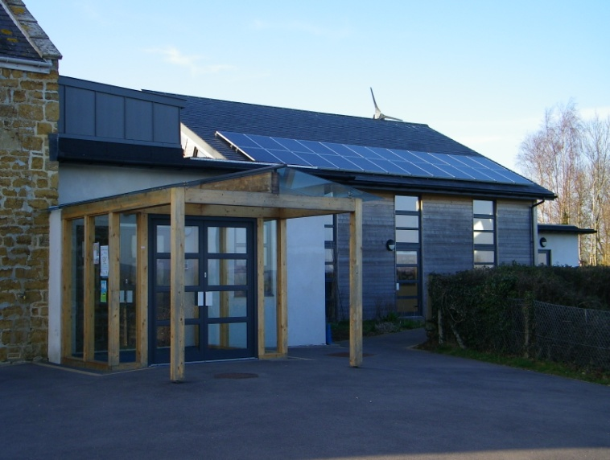
PUPILS WITH DISABILITIES AND PUPILS WITH SPECIAL EDUCATIONAL NEEDS
The school is committed to equal opportunities for all pupils and enabling those with physical disabilities access to the everyday activities in the school. The school is on a single floor for the pupils enabling access for pupils with a physical disability. Where there are particular needs, physical adaptations will be made to the school environment, as and when they arise.

Ms Bell is our special educational needs co-ordinator and our four teaching assistants support pupils in our four class bases.
The school has developed a comprehensive policy for special educational needs and our policies and procedures are subject to regular evaluation and audit. Parents are involved throughout and can see the policy at the school on request or via the website. Our SEN policy includes the current guidelines for identifying, assessing and providing for pupils with special educational needs. Information
about our ‘Local Offer’ is on Dorset’s Family Information Directory.
The school liaises with various support services through the Dorset Educational partnership, for example the Educational Psychology service and the Special Educational Needs Specialist Service (SENSS). Information regarding Dorset's funding and provision arrangements for children with special educational needs is available at www.dorsetcc.gov.uk/educ/sen.

PARENT APPOINTMENTS and REPORTING PROGRESS
We hope parents will feel comfortable to contact teachers and/or the Headteacher at any time, if concerned about their child’s progress.
Parents’ appointments are held in the autumn and spring terms to enable parents to discuss their child’s progress and future targets with the class teacher. In the summer term there is an open afternoon for parents to look at work and discuss progress.
This does not mean that teachers are available only at formal appointment times.

At the end of the school year each child receives a written report which highlights their progress over the year.
When a pupil finishes year 1 they receive a report on the phonics screening assessment.
At the end of year 2 and year 6 national comparisons are given to parents by the Department for Education in order to gauge their child’s and the school’s performance.

COMPLAINTS
The school will endeavour to satisfy any concerns or enquiries as soon as they are raised.
If a parent is not satisfied with the response that they have received, they may lodge a formal complaint.
The procedure will depend on the nature of the complaint and the headteacher will give advice about this on request.
A copy of the School Policy for Complaints Procedures is available on request from the school office.

BULLYING POLICY
In our school instances of bullying are rare.
Bullying in any form, whether verbal, physical, psychological or by using technology will not be tolerated and in cases where we know it to be happening, swift action will be taken. If as a parent you come to know of such matters or if your child appears to be unhappy about attending school, please let us know.
Bullying can only be tackled if someone else knows about it. All children are encouraged to tell us if they feel threatened or uncomfortable in any way. The headteacher will always be available to discuss such matters with parents should the need arise.
If further information is required please ask for a copy of the school’s anti-bullying policy

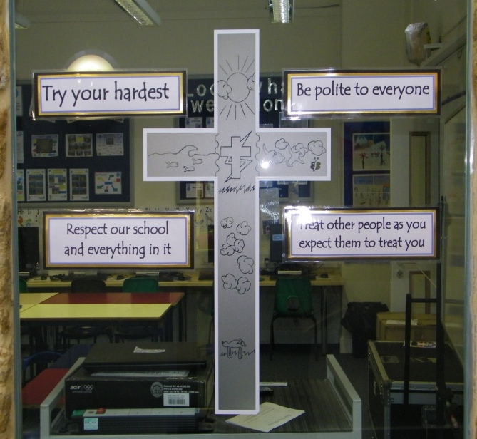
SCHOOL RULES
The school aims to keep rules to a minimum. The school council decides on the 'Golden Rules'
This year these are:
Respect our school and everything in it.
Try your Hardest.
Be Polite to everyone.
Treat other people as you expect them to treat you.

Our guidelines for acceptable behaviour are that children show respect, courtesy and kindness to all people at all times.
All children are required to behave in a sensible manner showing courtesy to everyone. No form of bullying will be tolerated and the school insists on the need for children to respect all property at all times.

This means that children are expected to:

1) respect everyone’s right to feel safe in and around the school environment,
2) make it as easy as possible for everyone to learn and for the teachers to teach,
3) have respect for other people’s property,
4) show respect to all staff carrying out their requests without argument,
5) be considerate and caring toward others.

Parents are asked not to allow their children to wear jewellery or to bring large amounts of money to school. Wristwatches may be worn at the owner’s risk.
Incidences of poor behaviour are very rare in this school. If sanctions are necessary, children may miss a playtime, or several playtimes — and parents would be informed.

SCHOOL UNIFORM
Boys - Grey trousers or shorts, white shirt, blue sweatshirt with school logo, grey socks
Black shoes — sensible shoes that provide good support (no trainers)
Girls- Grey skirt or pinafore dress, black/grey trousers, white polo-shirt, blue sweatshirt/cardigan with school logo, grey/white socks
Summer uniform - royal blue gingham (checked) dress (any style)
Black shoes — sensible shoes that provide good support (i.e. no wedge heels/jellies or trainers)

PE Kit - All children- Gym shoes (non-black soles), navy blue or black shorts, and pale blue T-shirts with school logo (in a named bag).
The football team will also need football boots and football socks.
Swimming — girls need a one-piece swimming costume.
Please note - All items of clothing should be clearly marked. Tracksuits are advised for winter outdoor sports.
NB - Those eligible for free school meals are entitled to a clothing grant equivalent to 2 sweatshirts every 2 years.

SCHOOL MEALS We have ‘Healthy School’ status and therefore encourage healthy eating.
We are very fortunate to be supplied with hot school meals by Local Food Links in Bridport.
They are delivered hot and served straight away with no reheating needed. The meals are sourced locally whenever possible and are of high nutritional value. All children in KS1 and Reception receive a free hot meal everyday with a choice from three available meals (vegetarian option available) .Parents of children in KS2 can order on-line from a four weeks menu, at a cost of £2.30 per meal.

Pupils can mix and match hot meals with packed lunches as suits. Packed lunches should be brought into school in a plastic container/lunchbox.
During the colder winter months the children may bring hot drinks in an unbreakable vacuum flask.
We prefer that no canned drinks, sweets, nuts or chocolate are brought into school.

Free school meals are available to the children of parents receiving certain benefits eg: Job Seekers allowance. Information can be obtained from the school. These children receive Pupil Premium Funding and there is more information about the benefits of this funding for the children on our school website.

Fruit is provided for reception and key stage 1 pupils as a mid-morning snack. There is also fruit for key stage 2 pupils for a nominal charge.

Children are encouraged to drink water during the day, jugs and cups in Key Stage 1 and water bottles in Key Stage 2.

TRANSPORT
The school buses serve the children from Melplash, Netherbury and Salway Ash.
No transport however is provided for children living outside the catchment area.
The basis for deciding a child’s entitlement to free transport is the distance from the child’s home to the school and varies with the child’s age.
In Dorset the qualifying distances from school for free transport are as follows:
Children aged 5-8 years 2 miles
Children aged 9 -16 years 3 miles
Children are not escorted on these journeys, it is their responsibility to behave sensibly and safely, and we ask parents to support and reinforce this.

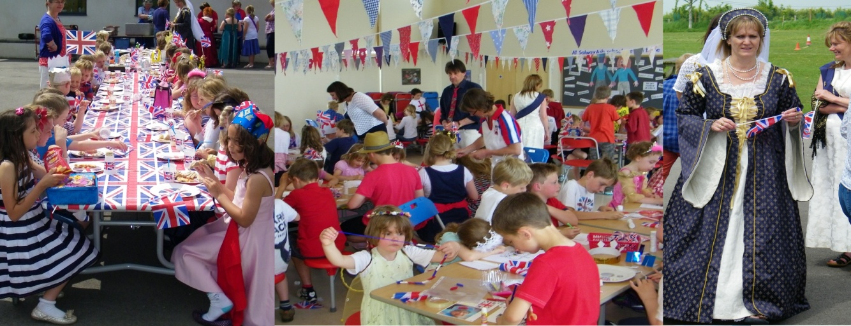
OPTIONAL EXTRAS
There are a variety of extra curricular activities available
to children during their time at Salway Ash School.
We hope that at least one of these will appeal to each
child. The clubs vary according to times of the year,
staff availability and skills. They often include; running, gym, art, gardening, band, football and dance.
Information via email, text and newsletters is sent out regularly regarding these.

VOLUNTARY CONTRIBUTIONS

Voluntary contributions may be requested in the following circumstances:

1. For board and lodging when children are taking part in residential visits. The school can advise about
exemptions for families in the receipt of certain benefits.
2. Contributions towards the cost of materials/ingredients needed for an item that parents wish their
child to take home and keep.
3. Trips arranged by the school. (Travel costs, board and lodging, materials, entrance fees to museums, etc.)

Participation in such activities is on the basis of parental choice.
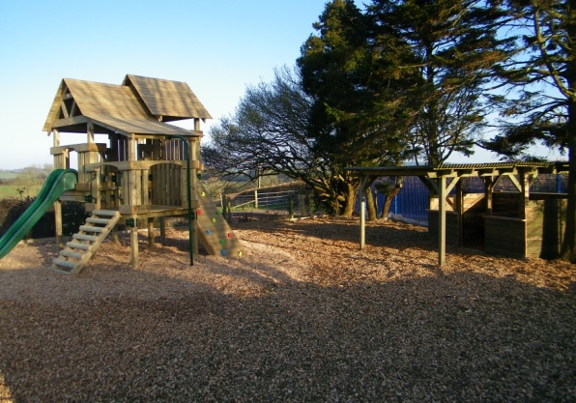
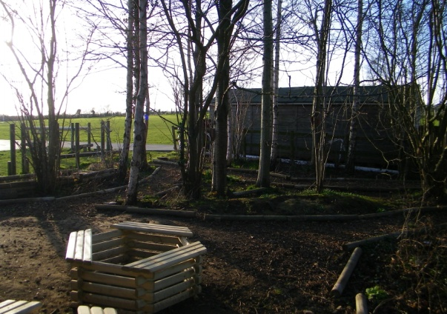
PARENT TEACHER ASSOCIATION (PTA)
Staff can always think of equipment they would like, but are restricted by the school budget. The PTA raises additional funds to enhance the children’s education.

All parents are automatically members of the PTA and meetings are open to all members. Events can only take place with the support of parents. The PTA hope that the parents of every child at the school will get involved with fund-raising events and offer support and ideas at PTA meetings.

The school very much values the PTA.
Please see the school website for further information.
Our outdoor play equipment and Conservation area were PTA projects.

HEALTH
The school nurse comes to school to complete various statutory NHS tests. These include height and weight screenings and hearing tests. Parents are always informed in order to give their consent..
Medicines should only be brought to the school if prescribed by a Doctor with a letter stating that the medicine is necessary. Such medicines should be clearly labelled with the child’s name, stating the dose and time of administration.
Children are not allowed to keep medications (except inhalers) in their own possession. If your child has to take a prescribed drug during school time parents should discuss the matter with the class teacher and/or headteacher and an ‘Administration of Medicine/Treatment’ consent form must be completed.

From time to time any school experiences an outbreak of head lice. We like to be very matter of fact about this and we do not regard it as anything unusual. In the event of your child catching head lice, and in the case of it being identified at school, you will be informed. Your vigilance will help to confine any outbreak.

We try to ensure that the children are supervised at all times but unfortunately accidents do happen. All injuries are recorded and dealt with appropriately. We have three trained first aiders, and all staff have basic first aid training. Unless the injury is very minor, you will be informed (and always where there has been injury to the head).
For this reason, it is important that we have a contact telephone number for reaching parents and that these are kept up to date.
Please make sure you inform us if you change your mobile phone number as we have a parent information service using this number.

NATIONAL CURRICULUM ASSESSMENT AT KEY STAGES 1 AND 2

Testing is a statutory requirement that helps the school to assess the progress each child is making.
Results from the tests will form part of your child’s record of attainment.

Each year all pupils who have reached the end of Key Stage 1 (Year 2) are teacher assessed in Mathematics, Science Reading and writing..
SATs tests for Year 6 are administered during a prescribed week in May.
Parents are requested to ensure that their children attend school during the week when the children are being tested. Dates of the tests will be sent out in newsletters during the year and parents may obtain this information directly from the school office.

We also test children in Years 3, 4 and 5 during May but this is not a statutory requirement.

At the end of year 1 the children are screened for their phonics knowledge. Below is a table to show 2016 percentage pass rate for the school compared to 2015 national figures. In 2016 there were 14 Year 1 Pupils.

 | Passed (%) | Did not pass (%) | Absent | Test not taken (%)
National | 77 | 21 | 0 | 2
Salway Ash | 57 | 43 | 0 | 0

Key Stage One Results

Below is the table of attainment following teacher assessment in 2016. In that year the number of eligible 7 year old pupils in the final year of Key Stage 1 was 20. No pupils were disapplied. The table shows the percentage of pupils reaching the expected standard and above and ‘Greater Depth Standard’ (GDS). For comparison the provisional national results are provided.

 | Salway Ash School |  | National Results
 | Expected Standard and above | Greater Depth Standard (GDS) | Expected Standard and above | Greater Depth Standard (GDS)
 | % | % | % | %
Reading | 100 | 55 | 74 | 24
Writing | 95 | 25 | 66 | 13
Mathematics | 95 | 20 | 73 | 18

Key stage Two Results

In 2016 the number of eligible 11-year-old pupils in the final year of Key Stage 2 was 15. The table below shows the percentage of year 6 pupils achieving the expected standard `and a ‘Greater Depth’ standard compared to provisional national end of Key Stage 2 figures. Please note writing and science are teacher assessed as there are no national statutory tests for these areas.

 | Expected Standard and above | Greater Depth Standard (GDS)
School English grammar, punctuation, and spelling | 73 | 33
National English grammar, punctuation, and spelling | 72 | 23
School reading | 100 | 47
National reading | 66 | 19
School mathematics | 73 | 27
National mathematics | 70 | 17
School writing (Teacher assessment) | 80 | 13
National writing (Teacher assessment) | 74 | 15
School science | 100 | N/A
National science | 81 | N/A
School Reading, Writing and Maths combined | 67 | 0
National Reading, Writing and Maths combined | 53 | 5
ABSENCE DATA

 | 2015/16 | 2014/15 | 2013/14
Total number of children of compulsory school age  (age 5 and above) | 117 | 115 | 115
Percentage of half days missed through absence that was:
Authorised: | 2.7% | 3.10% | 2.70%
Unauthorised: | 0.5% | 0.20% | 0.40%

EXCLUSIONS
No child has ever been excluded from the school.
This is an enviable record and one that staff and governors very much expect to retain.
COMMUNICATIONS WITH THE SCHOOL
As the School serves a scattered catchment area, newsletters are sent out, which inform parents of events that take place at the school.
Parents sometimes have problems or queries concerning their children and if these can be dealt with on the telephone the most convenient times to speak to teaching staff are 8.30am and 3.30pm.
The office also has an answer phone, which we hope you will use if necessary. Tel 01308 488302.
You may also contact the school by e-mail at office@salwayash.dorset.sch.uk.
Newsletters are also sent out via email.
Short messages and reminders are also sent to parents via text messaging.

The most convenient time to see the headteacher personally is before or after school, but please do not feel that you are restricted to that time.
The headteacher will always try to make time to see you.

You may also wish to visit our website which has a great deal of information for you about the school and your child’s learning. This can be found at www.salwayashschool.org

Schools and Academies which are own Admissions Authorities

2017-2018

Part 1– General Information

1.1 Introduction

This document sets out the 2017/18 Admission Arrangements for Salway Ash Church of England Voluntary Aided Primary School. The Governing Body of Salway Ash School is the admission authority responsible for the production of this document and for admission decisions in connection with the school.

Recognising its historic foundation, the school will preserve and develop its religious character in accordance with the principles of the Church of England and in partnership with the churches at parish and diocesan level. The school aims to support children and their families by providing an education of the highest quality within the context of Christian belief and practice. It encourages an understanding of the meaning and significance of faith, and promotes Christian values through the experience it offers to all its pupils. However parents have the right to withdraw their children from the daily Christian act of worship and from Religious Education.

1.2 Every year the governing body will review and publish admission arrangements. The admissions authority will set a Published Admission Number (PAN), which indicates the number of places available within the year(s) of entry. This information will explain how places will be allocated until the PAN is reached at which point the governors will consider whether the resources available at the time will enable additional places to be made available. If not, the decision will be to refuse all applications that would lead to the admission of a pupil above the PAN.

The PAN for Reception is set at 15 for the 2017/18 school year. If this is increased at any point in time, the revised PAN will be clearly advised on the school website. A non-statutory admission limit has been set for all other year groups. This may be increased or decreased from time to time according to the level of resource available at the school and the preferred year group/class organisation.

Part 2 – Aims

2.1 These admission arrangements have been designed so as to be simple to use and to assist parents/guardians when deciding on (a) preferred school(s) for their children.

2.2 The school aims to maximise parental preference as fully as possible. However, the number of places that can be offered is dependent on the resources available to the school, which will be reflected by the Published Admission Number set for the year of entry.

Part 3 – Starting School in Reception in September 2017

3.1 The procedure for applying to start school for the first time in Reception must be co-ordinated by the home local authority (the local authority responsible for the area in which the child subject to the application lives). Before applying for a school place, applicants are advised to refer to the 2017 Coordinated Admissions Scheme and Composite Prospectus (an admissions guide for parents) published by the ‘home’ Local Authority.

3.2 The application form (referred to as ‘the Common Application Form’) is available from the ‘home’ local authority. This must be completed and returned to the ‘home’ local authority, to arrive no later than 23.59 hours on 15th January 2017. This is available ‘on line’ or as a paper application form.

3.3 Full time or part time attendance below statutory school age
Parents may apply for their child to start school, for the first time in the September following his/her fourth birthday and where offered a place, may choose for their child to start school either full time from day one, or on a part time basis as preferred. However, a child becomes of statutory school age during the term following his/her fifth birthday and, where registered at a school, must be accessing full time education from this point onwards.
3.4 Deferred entry below statutory school age
Parents of children who have not yet reached statutory school age may choose to defer entry for their child until later in the school year, but cannot defer beyond statutory school age or the start of the last term in the school year.

3.5 Applications submitted on behalf of summer born children
In the case of children born between 1st April and 31st August 2013 (summer born), parents may choose to delay their child's entry to school until the following September (2018), but must still apply during the 2017 admissions round making clear on the application form the intention to delay his/her child’s entry to school for one year.

Where the parent states a wish for his/her child to be considered with the 2018 Reception cohort rather than to join year 1 at that time, he/she will be required to formally withdraw the 2017 application and to make an entirely new application as part of the 2018 normal admissions round. The offer of a place in 2018 will be dependent on the number of applications received at that time and the number of places available to offer.

If the school is oversubscribed, all applications (initially those received on time) will be assessed according to the published oversubscription criteria in order to determine a priority for the offer of available places. The availability of any place will depend entirely on the outcome of the 2018 application ranking exercise.

3.6 The ‘home’ Local Authority will forward details of any applications submitted for Salway Ash school to Dorset County Council. The Admissions Committee at Salway Ash Church of England VA Primary School will meet and consider all application forms that indicate a preference for the school and where oversubscribed with applications the committee will apply the oversubscription criteria in order to prioritise applications and so determine a priority for admission. Applications submitted before the 15th January 2017 deadline will be administered and available places provisionally allocated before the consideration of any later application.
3.7 Decisions will be notified to applicants by the ‘home’ local authority. A letter and/or email will be sent on behalf of the Governing Body on or around 16th April 2017 (dependent on the date published in the Local Authority Coordinated Admissions Scheme).

Part 4 - Waiting Lists

4.1 During the normal admissions round it is always necessary to complete a Local Authority Common Application form to apply for a school place. Registering interest with the school before the admissions round guarantees neither a place nor priority on any subsequent waiting list.

4.2 If the school is oversubscribed for children due to start in reception in 2017-2018 a waiting list will be maintained until 31 December 2017. The position on the waiting list will be determined by applying the published oversubscription criteria and not by date of receipt. Each name added will require the list to be re-ranked. The existence of a waiting list does not remove the right of appeal against any refusal of a place from any unsuccessful applicant.

4.3 Names will be removed from the waiting list ahead of the waiting list formally shutting down, if a written request is received or if the offer of a place that becomes available is declined. Looked after children and previously looked after children, as defined within these admission arrangements, or children who are the subject of a local authority direction, or who are allocated to a school in accordance with a Fair Access Protocol will take precedence over any child on the waiting list.

Part 5 - Applications outside the normal admissions round (In-Year Admission)

5.1 Applications for a place required during the academic year may be submitted to the LA at any time, but will not be administered more than six school weeks in advance of a place being required, except in particular circumstances applying for Crown Servant or Service family children (see section 9.3). The In-Year application form is available from the LA. A link is available to this on the school website.

5.2 The Admissions Authority will consider applications during term time only and strictly in the order (by day) that they are received. Applications that arrive during a school holiday will be held and processed when school resumes. If the governors receive more than one application on the same day for the same year group they must apply the published oversubscription criteria in order to determine a priority for admission where insufficient places exist within the PAN or admission limit applying at that time.

5.3 The non-statutory admission limits (applying to years 1 – 6) indicate the number of places available in a particular year group at a particular time. The governors are permitted to adjust these limits according to the level of resource available to support the year group concerned. If the Admissions Committee determines that the admission of a further child would impact on the efficient delivery of education or the efficient use of resources the application will be refused.

5.4 Applicants will receive a written decision by first class letter post within 10 school days of receipt of the In-Year application form or receipt of any supplementary information where this is subsequently provided in support of an application and is deemed necessary in order to determine the admission decision. If an application is refused, the decision letter will set out the reasons for refusal and explain how to appeal against the Admission Authority’s decision.

5.5 The applicant must confirm his/her acceptance of an In-Year offer within ten school days of the offer being made. The place will then remain available for the remainder of six school weeks from the date on the offer letter. If the child concerned is not on roll and attending before this deadline, the Admissions Committee will consider withdrawing the offer of a place.

5.6 Subject to the information provided on the application form and the circumstances at the school the Admissions Committee may decide to refer a refused application to Dorset Local Authority in order that the Fair Access Protocol may be applied. This would be where that child satisfies one or more of the criteria set out in the local authority Fair Access Protocol and is deemed to require a higher level of support than can be provided at the school. The Fair Access Protocol enables the local authority to engage, where necessary, directly with a family in order to help identify a suitable educational placement as soon as possible.

Part 6 - Oversubscription generally

6.1 The policy of Salway Ash School is to always offer a place, where one is available, irrespective of gender, religion, ethnicity or country of origin, disability or academic ability. However, where more applications are received than there are places available to offer, the oversubscription criteria set out in Part 7 will be applied for all applications received, in order to rank applications and so determine a priority for the offer of available places.

6.2 Education Health & Care Plan
A child who is the subject of an Education Health & Care Plan is admitted to school in accordance with a separate process managed and administered by the Local Authority in whose area the family lives. The Admission Authority must always admit a child to the school named in the Plan, irrespective of the Published Admission Number or any admission limit applying at that time and before the consideration of any other applications.
Part 7 - Oversubscription Criteria

7.1 Where more applications have been received than there are places available within the required year group, the following priorities shall apply in order:

1. A ‘looked after child’ or a child who was previously looked after but immediately after being looked after became subject to an adoption, child arrangements, or special guardianship order. For admission purposes, a looked after child is a child who, at the time of application, is (a) in the care of a local authority, or (b) being provided with accommodation by a local authority in the exercise of their social services functions (section 22(1) of the Children Act 1989 applies).

2. Vulnerable children, namely children of families with confirmed refugee status, or children with a medical condition or disability, or children where either parent has a disability which would make travel to a different school difficult. This must be confirmed in writing by the Local Authority within whose area the child lives.

In the case of children with a medical condition or disability written evidence must be made available from a senior clinical medical officer and/or the child's general practitioner or specialist showing that it would be detrimental to the child's health not to admit him/her to the school rather than any other. This information must accompany the initial application.

3. Children with a sibling (see section 7.2) living within catchment area (see section 9.8) at the time of application who will still be on roll at the time of admission and who lives at the same address

4. Children living within catchment area (see section 9.8).

5. Children living outside catchment area (see section 9.8) with a sibling (see section 7.2) on roll at the time of application who will still be on roll at the time of admission and who lives at the same address

6. Children living outside catchment area (see section 9.8) not satisfying a higher criterion

7.2 Siblings
A child is considered in this category if an older sibling is attending the school at the deadline date, and will still be attending at the time of admission, and lives at the same address as the older sibling.

Sibling refers to brother or sister, half brother or sister, adopted brother or sister, step brother or sister, or the child of the parent/carer’s partner where the child for whom the school place is sought is living in the same family unit at the same address as that sibling.

7.3 Tie breaker
If the school is oversubscribed within any criterion above, the straight-line distance from the child’s home address to the school will be used as the determining factor. Distances will be measured according to the Ordnance Survey eastings and northings for the child’s home address and the school. Those living closer to the school will be given priority.

If two or more children with the same priority for admission live an indistinguishable distance from the school but cannot all be admitted then the available places will be decided by the casting of lots supervised by someone independent of the school or the Local Authority.

Once an offer of a school place has been made it may only be lawfully withdrawn in very limited circumstances, which include an offer of place based upon a fraudulent or misleading application. Where an offer of place is withdrawn the application will be considered afresh and a right of appeal offered if an offer of place is refused.

Part 8 - Appeals Procedure

8.1 Applicants whose school place application has been turned down will have the legal right to appeal against the decision of the Admissions Authority, providing a formal application for a school place was submitted and a decision letter received. Full details explaining the appeal process will be set out in the decision letter.
8.2 An appeal timetable is published on the school website by 28th February every year. This sets out the timeframe for the various stages in the appeal process and includes statutory dates by which appeals must be heard. The Admissions Authority does not organise appeal hearings during school holiday periods and any appeal received when the school is closed will not be administered until school resumes.
8.3 There is a link to the appeal form on the school website. This must be submitted directly to the Local authority.
Part 9 – Further General Information
9.1 Applications for children to enter a year group other than chronological age
The governors will consider applications on a case by case basis for retained or accelerated entry in cases where parents would like their child to be admitted to a year group either side of the chronological age year group. The reasons for the request must be fully explained in writing and included with the school place application form.

9.2 Multiple birth applications (for example twins)
In the case of multiple birth applications the Published Admission Number or admission limit will be exceeded, or increased, at the point of allocation in order to ensure that multiple birth siblings (applying the definition of siblings in section 7.2) can be allocated places at the same school provided it is practicable.

9.3 Children from Overseas
The Governors will process admission applications for children living overseas providing they have European Economic Area (EEA) citizenship, are United Kingdom (UK) citizens returning to the UK, or they hold an appropriate Home Office Visa at the time of application. All overseas applications will be considered according to the child’s home address at the time of submission unless proof of the child’s future UK address is provided with the application (see section 9.5 Home Address). The only exceptions are children of UK Service personnel and other Crown Servants (including Diplomats) returning to the UK with a confirmed posting within the area.

9.4 Parent
A parent in education law includes natural parents, whether they are married or not and a person other than the natural parent(s) who has parental responsibility or care of a child or young person. Having care of a child or young person means the person who looks after the child and with whom the child lives irrespective of what their relationship is with the child.

9.5 Home Address
For the purposes of school admission, the governors’ definition of a child’s home address is considered to be where the child resides for the majority of their time with the person(s) who legally have care of the child. Documentary evidence of house ownership, or a minimum six-month rental agreement, may be required together with proof of the child’s residency at the property concerned. Places will not be allocated on the basis of a future house move unless this can be confirmed through the exchange of contract or a signed formal lease agreement in place at the time of application. An address used for childcare arrangements cannot be used as a home address for the purpose of applying for a school place.

9.6 Withdrawing the offer of a school place
In the case of In-Year admissions, the child must be attending school within six school weeks of the date of the original offer letter. The governors reserve the right to withdraw the offer of a place if this condition is not met and to reallocate the place as necessary. The governors may also withdraw the offer of a school place if the child’s home address is subsequently found to be fraudulent.

9.7 Catchment Area Map
A map indicating the catchment area of Salway Ash School is available to view on the school website.

9.8 Relevant Documents
Important information published by local authorities applies to some areas of school admissions procedure. If you are considering submitting an application for your child to start or transfer school, you are advised to refer to your local authority’s website. Documents of particular importance include:

- The Local Authority Coordinated Admissions Scheme
- The Composite Prospectus ‘Primary Admissions Guide for Parents’ (this will include detailed information about how to apply for a child to start school for the very first time in the Reception year group)
- The Local Authority School Transport policy
- The Local Authority Fair Access Protocol (this document applies only for applications made in connection with a place required during the academic year)

9.9 Enquiries about these arrangements

These Admission Arrangements reflect the statutory requirements of the Department for Education 2014 School Admissions Code and the 2012 School Admissions Appeals Code www.education.gov.uk.

Please contact the school office if you have any concerns about the content of these admission arrangements, or would like to discuss your particular circumstances in more detail. Where matters concerning the Admission Arrangements cannot be resolved locally, you may raise a complaint with the Office of The Schools Adjudicator.

Salway Ash Church of England VA Primary School
Salway Ash
DT6 5JE
Admissions contact: Lisa Crew
Tel: 01308488302
School website: www.salwayashschool.org
School Office: Email: office@salwayash.dorset.sch.uk

Home School Agreement - SALWAY ASH CE.VA.PRIMARY SCHOOL -Together we will succeed!

SCHOOL RESPONSIBILITIES
• To ensure that children receive an excellent education.
• To ensure that the school provides a safe, secure and sound learning environment.
• To provide a caring Christian ethos.
• To listen to both parents’ and children's concerns and be responsive to those concerns.
• To encourage children to do their best.
• To inform parents of their children’s progress, school activities and developments.
• To encourage a high standard of discipline. Signature (Headteacher)………………………..

PARENTS RESPONSIBILITIES
• To ensure that the children arrive on time, ready to learn and are collected promptly at the end of the day.
• To encourage children with their homework and help whenever possible.
• To send children to school in an appropriate uniform.
• To ensure that children return school property.
• To liaise with teachers regarding any of their child’s concerns. To encourage full time attendance and avoid holidays during term time.
• To encourage children with their school work.
• To attend open evenings and other meetings to discuss progress and to support events run by both the school and the P.T.A.
• To reinforce the school’s responsibilities and encourage a high standard of discipline.
Signature (Parent/Guardian) ………………….
CHILDREN’S RESPONSIBILITIES
• To do my best at school.
• To take care of all school property.
• To be helpful, kind and respectful to all children and staff.
• To do my homework on time.
• To keep the school free from litter.
• To behave sensibly on the school bus. Signature (Child)………………………….......

Please note. This is a voluntary agreement and you are under no legal obligation to sign.
However it would be helpful to all involved in school life if you do. Thank you in anticipation.
TERM DATES FOR THE ACADEMIC YEAR 2016/17
Autumn Term 2016
Term begins: Thursday 1st September
Half Term : Monday 24th October – Friday 28th October (inclusive)
Holiday begins : Monday 19th December

Spring Term 2017
Term begins :Tuesday 3rd January
Half Term : Monday 13th - Friday 17th February (inclusive)
Holiday begins : Monday 10th April

Summer Term 2017
Term begins : Monday 24th April
Half Term: Monday 29th May- Friday 2nd June (inclusive)
Holiday begins : Monday 24th July

Staff Training Days
Thursday and Friday 1st/2 nd September 2016
Monday 31st October 2016
Tuesday 3rd January 2017
Monday 5th June 2017
Bank Holiday 1st May 2017

KS2 SATs Week
(year 6 pupils) 8th – 12th May 2017 (inclusive)

The Dorset Family Information Service

The Family Information Service providing information to parents, carers and professionals on:-
• Registered before / after school clubs and childminders
• Registered childcare for under 5’s
• Activities for 0-19 year olds
• Parent and toddler groups / activities for pre-school age children
• Information on help with costs of childcare
• Play parks / skate parks
• Local and national support groups

Contact Details
• Tel: 01305 221066 Helpline open 8am – 7pm, Monday to Friday

• Email: familyinfo@dorsetcc.gov.uk

• Website: www.dorsetforyou.com/fis
Then

