Skill 2E
Composition

We are getting better at:

New National Curriculum Objectives:
* Writes about real events
* Write for different purposes
* Plans in note or pictorial form, or says out loud, what they are going to write about before beginning
* Chooses appropriate words (related to topic), maybe from a word bank
* Ideas and content generally relevant to task – possibly repetitive and sparse with limited awareness of the reader
* Writes a simple opening and ending (once upon a time, Dear Santa, yesterday we, at the end we went home)

Examples:
- Early one dark morning . . .
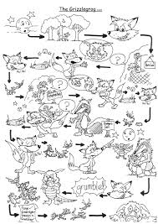
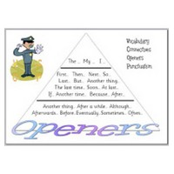
- Dear Santa,
- In the end we all went home.

